Octavio & the Lotus

N. Pojk
Copyright © 2018 Nicolai Octavian Pojk
All rights reserved.
ISBN:
ISBN-13:

DEDICATION

I wrote this one for the child in me, who never grew up. It is more than fair to dedicate it to that child inside everyone else as well. I hope you all realize that he / she is still inside you and you never stop wondering

CONTENTS

 | Acknowledgments | 7
 | Preface | 9
 | 1 Dougie | 11
 | 2 Petunia | 27
 | 3 Fleur de Lys | 69
 | 4 Re-United | 83
 | 5 Nick Carter in the 20th Century – pt. 1 | 91
 | 6 Barbeque Time | 95
 | 7 Ripples | 101
 | 8 The Wanderers | 117
 | 9 The Legend of the Wanderers  10 Dahlia’s Tears – pt. 1  11 Barbeque Time Once Again  12 Dahlia’s Tears – pt. 2  13 The Battle of Doodletown  14 Attack of the Monghouls  15 An Imaginary Train  16 Nick Carter in the 20th Century – pt. 2  17 The Longest Baseball Game Ever  18 The Money Tree  19 Tuscan Wine  20 The Pipes of Exile  21 Lilia Meets Elvis  22 Nazi Spies & Chocolate Fondue  23 The War to End All Wars  24 Loose Ends  Epilogue | 129  139  141  145  151  175  185  203  219  227  241  263  277  285  301  321  327

ACKNOWLEDGMENTS

Special thanks go to my wife Deveka for allowing me to spend uncountable hours in front of my computer undisturbed, while she was running the rest of the household and feeding me once in a while.
Thank you to my grandson Aiden for suggesting that I add images to my story and my granddaughter Emma for requesting fairies and helping me create them.
A big thank you to pixabay.com for their large collection of royalty free images.

preface

I love circular stories. I have started some others and will hopefully finish them someday. This one just popped into my head and it just wouldn’t let go. Didn’t quite turn circular but more like a spiral – that’s fine. Since I intend to make this story readable by young adults, I have decided to use a pseudonym in order to separate it from my more adult writings. I kind of like it and think it is a clever one, though certainly childish. For those who are somewhat more curious about it, here’s a clue: think Swedish.
***

1 Dougie

Somliga går - med trasiga skor
Säg, vad beror det på?
Gud fader som i himmelen bor
Kanske vill ha det så

Somliga Går Med Trasiga Skor
Cornelis Vreeswijk

Some people walk - without any shoes
Pray tell me, why is that?
Almighty God who is in heaven alive
Maybe he wants it so

Some People Walk Without Shoes
Ernest Samuel Llime

Dougie was nine years old. It was August 28th so just as in other years his mom had baked him a birthday cake. She decorated it with berries and slices of mango and pineapple and wrote on it ‘Happy 9th Birthday Dougie’. It was a Saturday and his daddy was home as well, so the two of them sang him the birthday song and asked him to make a birthday wish and blow out the candles. He thought that birthday wishes were quite silly, but he made one anyway. What he wished for, more than anything was to have a girlfriend.
Some people may think that nine is too early for a girlfriend but Dougie had been raised on faerie tales and heroic fantasy. He had started reading at a very early age and he wanted to be like The Dread Pirate Roberts, or Tarzan, or maybe John Carter. But The Dread Pirate Roberts had Princess Buttercup, Tarzan had his Jane and John Carter had Dejah Thoris. So he wished for a girlfriend and blew out all the candles. The cake was quite tasty but somehow, it did not sweeten Dougie’s day.
His mom put on a vinyl LP record and the uniquely sarcastic voice of Cornelis Vreeswijk filled the room. Mom was a Swedophile, with a nostalgic streak dating back to when she was five years old and still living in Malmo where she was born. Her parents had left Sweden for a better life in America on that year. Dougie did not speak Swedish though his mom had tried to teach him. He did however know what Cornelis was singing about and every time he heard this song he wondered why God would want anyone to walk without shoes? Didn’t he have more important things to worry about? It probably contributed a lot to Dougie’s healthy skepticism towards the God concept.
Most afternoons his mom would curl up on the sofa with a book and Dougie would pick one from their overstuffed bookshelf and sit in the rocking chair with it.
There was a little table on which his mom would put a pitcher of ice cold lemonade for him and he would get lost in some imaginary world for a few hours. On this day he didn’t find any book that would make him want to open its covers and besides, by now he had already finished most of them at least once. His dad had poured himself a large glass of cold beer and he went to sit on the porch, puff on his cigar and daydream. Dougie told his mom that he was going out in the back and walked out the kitchen door.
His parents were not quite your regular kind of American citizens. Big city life had never appealed to them, so they had somehow managed to purchase a little house on a large plot of wooded land, in Craftsbury, VT. They had a nice little vegetable garden that supplied most of their green stuff and veggies. There were also quite a few fruit trees and in the back their property was bordered by a happily bubbling little stream.
Some fish would actually swim by once in a while, but they were quite safe because no one in their household ever got into fishing. Dougie loved to just sit and watch the water flow, so he walked over to his favorite observation point and sat down on a nice, warm, flat rock. On this day however, he felt quite restless, so he decided to just walk around a bit. Downstream following their little stream, seemed as good as any direction, so that’s the way he went. The stream was becoming slightly wider before it continued into the neighboring property. There was no fence dividing the properties, only a line of maple trees. He felt that, it being his birthday and all, perhaps he should do something daring, so he walked through the maples until he could see the other side.
The neighbors were an old crusty couple that had lived there for many years, so he was quite surprised to see a young red headed girl walking towards the stream.
He was in the shade of the trees’ ample foliage and keeping quite still, so she did not notice him at all. The stream was opening up into a little eye a bit further and that was where she was heading. She stopped by a big rock a few feet away from the water and in a very quick motion she slipped out of her bib overall shorts and jumped into the water. Dougie was so surprised he had to quickly cover his mouth with his hands so that he wouldn’t make any give away sounds. It was only for a few seconds, but the impression was imprinted on his eyelids.
Dougie had never seen a naked girl before. She was mostly submerged by now, so he couldn’t really see what she looked like, but in his mind he was still picturing her back. Actually, it was somewhat disappointing. She didn’t look any different than the boys he’d seen when changing in the gym locker area at school. He watched her splash around for a while and then she just walked out of the water. He could now see what her front looked like. Again, not that much different than a boy except for one area that he did not want to concentrate on. She put her overalls back on and made her way back to the house.
He went back to his rock to contemplate the river and think about what had just happened. He had no idea who that girl was, but somehow he decided right there that she was his birthday wish come true. He resolved to find out more about her and talk to her. He also wondered if The Dread Pirate Roberts had ever seen Princess Buttercup naked, or was that a forbidden thing? Did Jane ever take her clothes off and bathe somewhere where Tarzan could spy on her? And was there enough water on Mars at all for that kind of scenario? Back at the house he made some inquiries and found out that the old couple had moved away and one of their children with their children had moved into the house next to theirs. The children were actually three girls, but in the days to come, he did not see any of the other sisters. He did however manage to spy on the red head a few more times before the school year started. Once school started, he would see her every day in the hall. Apparently, she was two years older than him so where he was in third grade, she was in the fifth. At that age, that was an insurmountable gap, so he decided that he will take a different approach to the problem. If he could not have a real girlfriend, he will have an imaginary one. The first Saturday after the school year started, he sat down on his favorite rock by the stream, with a fresh notebook and a pencil. He opened the notebook to the first page and wrote the title in large block letters and under that in a smaller script he added his name:

OCTAVIO & THE LOTUS
By
Douglas Sturmeyer.
Octavio was the eighth son of a Frankish knight. For some reason, his father had decided to name his sons after the Roman numbers, so there was Primo, Secundus and so on up to the eighth one: Octavio. The father’s Latin was not really that great so the names did not all follow the declension of the numeric. His father, Romulus had actually gone all the way to Jerusalem in his youth and was part of a cavalry unit that had played a minor role in the last defense of Jerusalem. He was severely wounded during the fighting but he eventually found his way back home, were he wouldn’t stop talking about his major role in the holy war. Apparently, he had been in a unit commanded by Richard the Lion-Hearted for a brief span. He also claimed to have been personally wounded by the commander in chief of the Muslim forces, Salah-El-Din himself.

His first seven sons aged 13 to 18 were well versed in the arts of war and were constantly training in swordsmanship, archery and all of that kind of stuff. His wife Laura, was a strong beautiful woman but Octavio felt that having that many children had taken a toll on her. For the first 6 years that she was married to his father, she had a son every year except in the fourth when she had twins. There was a four year gap between Septimus and Octavio, but even that was not quite peaceful enough. Laura gave birth to a beautiful and only daughter in the brood. Lilia was two years older than Octavio but being the closest to his age, she became his friend and closest playmate.

On Octavio’s ninth birthday, his father wished him a happy birthday and presented him with a beginner’s sword. His mother baked him a fruit cake and put an expensive candle on it. They sang the happy birthday song and his mom told him to make a birthday wish and blow out the candle. It was a new custom to him, but he decided to give it a try. All of his brothers had girlfriends and they kept talking about how great a thing that was, so he wished that he could also have a girlfriend so that he can find out for himself.

A year earlier, a travelling minstrel had passed through the neighboring village. Romulus, seeing an opportunity to make a splash with the neighbors, had decided to throw a party to which he had invited the most important villagers in his Tuscan valley. The minstrel was, of course. the featured entertainer. Octavio had enjoyed the party, especially the minstrel’s tales, poems and songs. At some point, when the minstrel was taking a break, Octavio brought out his tar. It was a Persian instrument that, strangely, his father had brought home with him from Jerusalem. Nobody knew how to play it and no one was interested in it, so on Octavio’s seventh birthday, it was given to him as a present. He loved the shape and beauty of the instrument, but had no idea how to make it sound good. Every time he tried to play it, he got in trouble with whoever heard that cacophony. The minstrel was quite surprised to see such a treasure in that remote village, but he offered to teach Octavio a few things. He was happy to do that in return for food and lodging, which Octavio managed to cajole his mom into providing. Out of respect or possibly fear of people’s reactions, Octavio and the minstrel would walk to the back of their vineyard out of earshot of the rest of the world where they would have their lesson. This went on for the course of one entire summer, after which the minstrel couldn’t resist his wanderlust and he bid everyone goodbye and left. Octavio was left with a good understanding and a greater love of the instrument. He now knew how to tune his tar and where to place his fingers for the best results.
On this, his ninth birthday, he took his tar to his favorite spot in back of the vineyard, sat down on his preferred flat rock and played for a while. He knew that having been given a sword, he would be expected to start his training on the next day. He did not look forward to it.
He stood up and decided to go for a little walk. He left his tar on the flat rock and started following the little stream as it made its way down. The border of his father’s property was marked by a line of olive trees. He walked through them to stand in the shade of one of them, checking out the neighbor’s place. From his spot he could see that the stream formed a little eye in which two girls were chatting and splashing each other once in a while. He stood quite still and being in the shade probably helped because they did not notice him. After a little while the girls got out of the water and he saw that they were stark naked. One of the girls was his sister Lilia, so he did not know what he should do. He wanted to avert his eyes, but he could not. He did not know the other girl, but she looked to be about his sister’s age and had fiery red hair. She was the most beautiful thing that he had ever seen. He could not imagine that anything in the world could be any more beautiful. He understood now why his brothers were always talking about their girlfriends and he resolved that now, he also had one. The red headed girl was to be his. The two girls put on their clothes and walked away, still without noticing him. He walked back to his rock, picked up his tar and for the first time ever, he started singing:
Oh my red,
My glorious amazing red
I think I have fallen for you
And there is nothing that I can do
But wait.

He thought it was not very good, but then he thought that if he kept practicing, it might get better.

That evening after supper, he asked Lilia if she would take a walk with him. While they were walking he confessed that he had seen her and her friend bathing. She smacked him around a bit making him promise to never do it again, while he was swearing that it was all by accident. After she had calmed down a bit, she told him that the girl’s name was Myrtle and that her father had been granted the estate next door after returning from the crusades himself. Apparently, they were originally from Scotland.

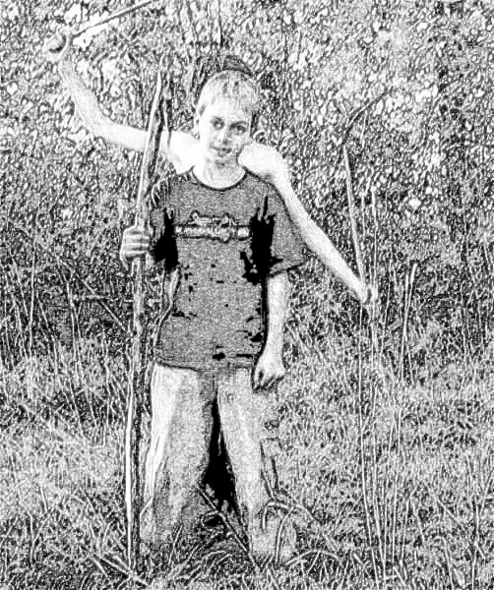

Octavio started training in swordsmanship on the next morning. It was a lot of work and he didn’t seem to have much talent for it. But his father insisted, so he had to keep working at it. Luckily, since he was just starting out, his training was over before lunch. After lunch he would take his tar and walk to his favorite flat rock. He would sit and try to come up with new songs about Myrtle. For quite a while nothing came to him other than Myrtle rhymed with turtle, but he could not come up with any flattering lines that involved the two of them.

Part of Octavio’s tutoring involved the arts, so after a while he decided to bring some of his drawing materials and try to draw her. Lilia had not told Myrtle about her brother’s spying and in spite of his promise he would still spy on the two girls bathing but he made sure that they could not see him. He would take out his notebook and make sketches of Myrtle, trying as much as he could not to look at his sister.

Autumn followed summer and winter followed that as it usually does. Octavio’s sword training made his muscles start to develop and he was getting a bit better at it. Better muscles, also gave him a more powerful grip on his tar, so his playing was becoming quite good. By spring he had grown a couple of inches and by summer, he was ready to start his drawing again. He kept walking to his hidden post, but for a while, nobody came – the weather was still a bit chilly. He had to wait ‘til July, when he finally got lucky. The girls have changed quite a bit during that winter and when he spied them again, some things had grown on their bodies, that made them look very different form boys. He finally understood some of the other things that his brothers had been talking about all the time. Still, he did not think it was right to draw those things. He had once seen a painting of an Indian lotus, so he decided that he would paint Myrtle coming out of a lotus flower. His first sketches were not too good, but eventually, he came up with one that pleased him. In it Myrtle was rising naked out of a lotus flower that floated on a quiet lake. The way he executed his idea, made her body seem to be concealed by smoke and flames. The only things that were in focus were her head, her shoulders and her arms. Her flaming red hair made a fitting crown for the burning lotus.

He so was pleased with the way his painting was shaping up that one day he failed to notice that the two girls had left their water hole earlier than usual. He became aware of that only when his sister slapped the side of his head painfully. taking him totally by surprise.

“You promised not to do this again” she said.

“I’m sorry, I just cannot help myself.”

Myrtle, who was hiding behind a bush, walked into view. On a closer observation, she did not seem to be quite as attractive as he thought. Her face was covered in freckles, that were covered in pimples in quite a few spots. He was trying to hide his drawing, so of course that was the first thing she wanted to see and she grabbed it right out of his hand.

“Hmmm, not too bad” she said “I might even consider not telling my father about this.”

“Really? What can I do to make that thing happen?”

“You will have to give me a kiss,” she replied.

“I don’t know. I have never kissed a girl before.”

“Don’t worry, it is not going to hurt.”

-%-

2 PETUNIA

Petunia was a top student. By sixth grade all the teachers had become aware of her talents and they were already grooming her for a college education. She enjoyed studying and she didn’t have any kind of interest in boys, which made it a lot easier. The fact that her face was covered in freckles and seriously pimpled made the boys ignore her as well which was fine by Petunia. There was however one little boy who seemed to always try to find a seat next to her in the lunch room or library and always tried to get involved in all kinds of projects that she was a part of. She didn’t quite understand how he managed it, but in that year he was actually skipped a grade, so she realized that this kid might turn out to be her competition. At first she did not mind and though he was two years younger than her, she found that he could be a good companion. After realizing that he was also living next door to her, she started hanging out with him after school occasionally. His parents were becoming a bit friendly with her parents, so they started having joint back yard picnics and barbeques. Dougie’s parents seemed a bit quirky, but then everyone thought that of her parents as well. After all, living in the country, especially in a place with harsh winters was not necessarily a very popular thing. Strangely enough, though Petunia had two other sisters that she considered much more attractive, Dougie appeared to be paying a lot more attention to her, than to her sisters. Granted, Bryony at fifteen was much older, but Begonia was just about his age and as a matter of fact she had been in his class last year, before he was skipped.

Summer had come quite early that year, so she started her bathing routine sometime in June. The Fourth of July weekend was especially hot so she spent most of it in her private waterhole. On the third of July, which in that year fell on a Sunday, she noticed that someone was spying on her from the neighbors’ place. She was not sure how to proceed, but not being too shy nor afraid of anything, she decided to sneak out to the other shore of the little stream. She was going to catch that peeping Tom and give him a good yelling. Coming out the usual way and putting on her clothes might spook the person, so she made her way a bit further upstream and crossed back. The great thing about living in Craftsbury was that everyone could easily own 50 – 60 acres of land. Her parents acreage was quite woody, and easy to sneak around in. She made her way unobserved to a point where she could see that the spy was none other than Dougie. He was apparently writing something, though once in a while he would cast a look towards the stream, presumably looking for her. She decided to force his hand, as they say and she walked a bit closer to where she could talk to him without shouting.

“Why do you keep looking that way, Dougie? Are you expecting to see a naked girl?”

Dougie was quite obviously taken by surprise. He turned around and though he couldn’t really see her, his face was turning a bright red.

“I, I, I, I...”

“Never mind that, show me what you were writing.”

“I, I, I, I...”

“Show me, or I will tell!”

“Oh O.K.”

“Walk towards me and stop in front of my tree.”

Dougie did as directed.
Petunia stuck her head from behind the tree saying:

“Give me the notebook, and walk back to your perch.”

Dougie did just that. Petunia turned the pages back to the beginning.

OCTAVIO & THE LOTUS
by
Douglas Sturmeyer.
She started reading the story. By the time she got to the song that Octavio was singing she had a strong suspicion that this story was also a little about her. When she got to the part where Myrtle was looking at the sketch, she was absolutely certain.

“I am not quite sure how to react to this. Tell you what, I will go get dressed and I will come back here so that we can talk about it.”

With that she snuck away the same way that she had come. It did not take long before she was back.

“Here’s what is going to happen Dougie. I will help you write that story. But there will have to be some changes made. Also this is not a negotiation. My terms are absolute.”

“I guess I have no choice then.”

“Now you’re just trying to be cute. I will think about your story this evening – let me have that notebook. Meet me here tomorrow at 10 am and we will continue writing it.”

They met again in the morning and Petunia continued:

“Your story so far is going to stay the same. The only change I made is to the title page.” She showed it to him – it now said:

OCTAVIO & THE LOTUS
by
Douglas Sturmeyer
and
Petunia McTavish
ACKNOWLEDGMENTS

Special thanks go to our parents Popi and Gerald McTavish and Margareta and Jonas Sturmeyer for their support and suggestions. An extra thank you goes to Margareta McTavish for her excellent edit job.
We also have to mention the grilling expertise of Gerald McTavish, the pickling and cider making skills of Popi McTavish as well as Jonas Sturmeyer’s mastery of salad making.
One more very big set of thanks goes to Petunia’s sisters Bryony and Begonia. In addition to some very useable suggestions, they put in a lot of work transcribing and formatting our scattered manuscript.
Thank you mom, thank you dad and thank you mom, thank you dad. And thank you so much sisters.
Petunia & Dougie.

“Turn to the last page and I will tell you how it is going to continue.”

Dougie did that and started writing what Petunia was telling him.

-%-

Myrtle actually found Octavio’s painting quite flattering. She was not sure if she wanted to be his girlfriend, but she was also not sure she did not want to.

He was a little younger, but there seemed to be something special about him. What with Lilia being her best and only close friend, they would run into each other quite often He was always very attentive towards her and it did not take long before everyone noticed. His brothers started teasing him about it and he would blush and start stammering every time they mentioned Myrtle. That was probably also the cause of his rapid improvement in the arts of war. He took to shadow fencing in his little clearing by the olive tree line and by the time he was thirteen he could hold his own against most of his brothers. The exception was Primo, who was the best swordsman of them all. Myrtle watched his progress with mixed emotions and she would spy on his solo exercises quite often. He noticed her one day and he invited her to come out into the open and watch. By that time he had graduated to a full size sword, so one day he brought one of the lighter ones with him and invited her to train with him. Shortly after that Lilia joined their training as well. By the time he turned fourteen Myrtle was almost sixteen. Her face had cleared up and she was turning into a ravishing beauty. Octavio had actually become so accustomed to her many freckles that by now he thought that girls without freckles were too plain. Some days she would not show up and on those days, he would practice his tar playing and try to come up with poems about Myrtle, but that was not to be. His skill with words was not too good. His painting skills however were improving a lot and he kept making various portraits of Myrtle from memory. His favorite was one in which her face was taking up most of the canvas. He had emphasized some of her freckles making them seem like celestial constellations. Myrtle had confided in Lilia early on and Lilia was happy and hoping that one day she would be able to call Myrtle her sister. She would of course promote that idea and no one actually objected. And so it was that on his eighteenth birthday in the middle of the birthday party, Octavio and Myrtle announced their betrothal. The wedding date was set for the fall of that year.

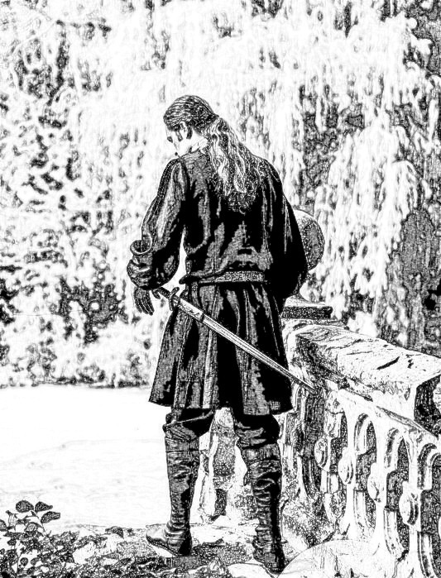

No one would have expected the nine year old Octavio to turn into the fierce eighteen year old warrior that he had become. He had surpassed even his oldest brother Primo in swordplay, though the older one was still a better strategist.
Somehow, the brothers did not begrudge their little Octavio his skills. They remained a tight and loving family and they rejoiced at the prospect of his coming wedding. Sadly, the best laid plans collapse in the face of a harsh reality. The day that they were all training for arrived much too soon.

Though the pope had been talking about a new crusade, that did not happen until many years later. There was however a menace that would rally the Christian world once more and it was politically more in keeping with the Papal ambitions of conquest. The northern land of Vallonia had been used as a scare prop for Tuscan little kids for a very long time. When the Pope declared that the time has come for another holy war against the elves who lived there, there was no choice. They had to go. Everyone put on a brave face and commented on the skills of the eight brothers and how they will distinguish themselves in the coming campaigns. Secretly, most of them did not give the new effort much of a chance. Lilia and Myrtle were in reality already in mourning for the brothers. No one had ever returned from the previous wars against Vallonia and they knew that the Pope was just trying to weaken the strength of his knights. Everyone knew that the Frankish king had been inciting him to perform this move for quite a while.

They only had one month to prepare and they would have to leave just a day before the planned wedding. Octavio thought that they should postpone the wedding, but Myrtle would have none of it. She was so fierce in her convictions that no one dared resist her and the wedding happened, though with a lot less fanfare, only a week later. On the original wedding date, Romulus and his eight sons had already joined the main corps of the Christian army. Just as in the previous attacks on Vallonia, no one returned and no messages were received of their fates. The only evidence of their existence was to be found in the memories of those who were left behind, as well as in Myrtle’s belly, who in due time gave birth to a boy that she named Nikolaos after the ancient bishop of Myra who was also known as the Wonderworker.

-%-

“I think we can stop for the day,” said Petunia. “Same time tomorrow?”

“O.K . Good night” replied Dougie.

-%-

The previous year Dougie’s parents had sent him to a summer camp and they intended to do the same this year. He managed to convince them that he was involved in a very important project that necessitated his staying at home. They pressed him about it but he would only say that he will show it to them when the time was right. Petunia didn’t have that problem, as her parents were happy to let her make her own decisions.

On the next morning Dougie had some things to say to Petunia before they continued with the story.

“Look, Petunia – I like what you’re trying to do with the story, but if this is supposed to be a collaboration, I feel that I need to be a part of it. So, I have come up with some ideas that we should incorporate into the story.”

“What kind of ideas will those be?”

“Well, for a start, Nikolaos is a good strong name, but everyone is going to call him Nick Carter. Also, the nameless minstrel is going to come back and teach Nick Carter some stuff.”

“O.K., let’s see how you are going to accomplish this. You talk and I will scribble.”

-%-

In Romulus’s absence, Laura was in charge of managing the estate. She was quite skilled at delegating tasks and bartering with merchants when necessary. Right away she started showing Lilia and Myrtle how things were run. It was surprising in those times, to find an estate that was as prosperous and peaceful as the one that they were in charge of. Granted, Romulus had been a very understanding Lord and he had treated all of his servants fairly.

Their wines were acquiring a good reputation in the surrounding areas and some had even been sampled by the Pope with a very positive response. They also produced a very tasty olive oil, which they managed to sell quite profitably. Everyone involved in the wine and olive oil production was rewarded handsomely. The servants were likewise recompensed generously, and the few poor souls who could not manage to take care of their lives would always find something to eat by the back of the kitchen. It was not surprising that Romulus’s family was beloved by all of their vassals and servants.

Lilia and Myrtle were getting more and more involved in the affairs of the family. Laura as well as Myrtle’s mom had tried to get Myrtle to relax and rest at least until the end of her pregnancy, but she wouldn’t hear of it. The two of them were slowly taking over the bartering and dealing with the itinerant merchants. One day, they had the cart prepared, loaded with as many casks of olive oil and barrels of wine as it would bear and drove it into town. According to the town midwife, Myrtle could have had the baby anytime. Everyone tried to have her stay home, but again, you could never win an argument against Myrtle. Not only would she not stay home, but she insisted that she had to drive the cart.

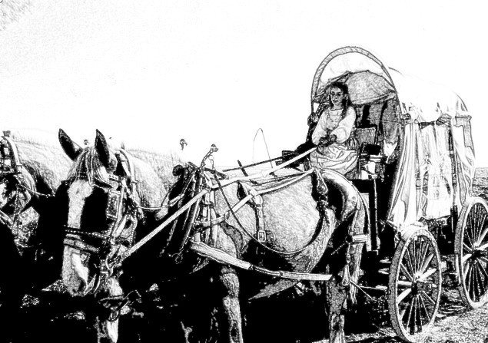

It was not a very long drive, but right about the middle of the return leg, Myrtle told Lilia that she was going to have that baby right away. The way Lilia told that story later, Myrtle pulled the cart over and had that baby right then. That is why, the healthy, somewhat larger than usual baby was nicknamed Carter even before he was baptized as Nikolaos. Carter of course means cart driver. In the years to come, that baby will proudly wear that nickname and always introduce himself as Nick Carter.

Nick was slightly larger than the other kids his age and he showed a talent for fighting quite early on. His mom did not really appreciate that and she tried, mostly unsuccessfully, to teach him some restraint.

“Nikolaos, one day you are going to be the Lord of this castle. You need to learn how to deal fairly with all of your underlings.”

“One day, I will go and bring back my father, my grandfather and all of my uncles. I need to be the best fighter ever, so that I will be able to return home with them. I also have 21 cousins who should become the Lord of the Manor before me”.

Perhaps, he did need to become a fierce warrior. Most of the kids that he used to fight with were the sons of his uncles. There were twenty-one of them. All somewhat older than Nick, and they were all in agreement that someday they will go and find their parents. Myrtle realized that it might be fated and that she needed to bow down to it and give Nikolaos the best start that she could give him. At the age of five Nikolaos was a lot larger than other kids his age, so she brought out one of his father’s childhood swords and started teaching him as much swordsmanship as she could.

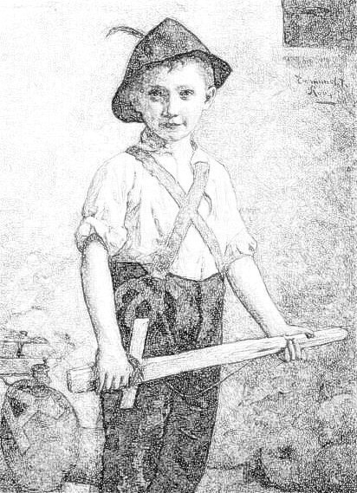

By the time his seventh birthday came, Nick Carter was a very good swordsman. He would prevail in any fight even against his oldest cousin who was almost eleven. That was the day that the nameless minstrel returned.

When Nick was a baby, he would sleep in his mom’s bedroom in a crib. As he was growing, the crib was replaced by a little bed, and then somewhat larger beds but this had continued only until his fifth birthday. Still, he remembered the picture of his mom coming out of a flaming lotus and the one of her face filled with stars. Together with the tar hanging over the fireplace, these were the most treasured memories that his mom had of his father. On his sixth birthday, his mom allowed him to take the tar off the wall and attempt to play a tune on it. After all these years, if was badly out of tune and nobody knew how to fix that so it was a very short attempt at making music come out of it.

When the minstrel showed up in the middle of his seventh birthday party, his grandma Laura remarked that the minstrel appeared to have been untouched by the years. That may have been true, but there is a period in the life of a man, let’s say between 40 and 60 years old when he does not seem to age very much. Still, in the eighteen years since he had first visited them, many tales had been told and re-told about the nameless minstrel. He had become a mystical, mythical character and everyone was happy to see him again. They expected his stories and songs to be magical – and so they were. He sang and told of many distant places that he had seen since the last time he’d been there. Laura reminded him of the time that he had tutored Octavio and she was wondering if perhaps he could do the same for Nikolaos, her grandson. The minstrel accepted the assignment. On the next day, they took down the tar from its hanging place and walked over to the little stream in back of the estate where Octavio had learned how to play. Nick Carter did not have the same amount of patience that his father did. The minstrel tuned the tar for him, but Nick wouldn’t touch it.

“They say, that you are Taliesyn. Is that true?” asked Nick.

“No, but I have met him. I am certainly not him.”

“But, if you have met him, you must be as ageless as they also say.”

“I am indeed very old. I do not know exactly how old.”

“What is your name then?”

“I do not really know. I have been called by many names, but none of them ring a bell with me. My early life is covered by a mist that I cannot penetrate.”

“I also heard that you were a berserker”.

“Yes, I’m afraid that is quite true. But I gave up killing a very, very, long time ago.”

“Teach me.”

“Why would a young boy such as yourself want to become such a terrible killer?”

“I am going to look for my father, my grandfather and my uncles. Surely you know that they have gone without a trace.”

“I heard about that, and I might teach you a few things, but there is a price to pay.”

“Name it and it is yours.”

“How do you talk like that? You are just a little boy.”

“I do not have time to be a little boy. Whatever time I have, needs to be spent in training, so that I can become the first warrior to ever return from Vallonia.”

“Well then, here is the price. You need to become as good at playing the tar as you are good at playing the sword.”

“If that is what needs to be done, then I shall do it.”

“Very well, pick up that tar then. We will not talk about swordsmanship until I decide that your tar work is as good as your sword work.”

For three months, Nick was not allowed to touch his sword. In the beginning he complained a lot, but he was being reminded of his promise and he eventually decided to accept his training. After three months the minstrel decided that his proficiency with the tar was matching his learning of the sword. That was when his real training started. At first he did not understand why so much time was spent sitting and doing nothing. The reply that he got to his inquiries was that becoming a true swordsman was as much a thing of the mind as it was of the body. Nick was actually only seven years old, so he did not understand, but he followed instructions all the same. The minstrel told him that as his skill with a sword was now deemed equal to his skill with a tar, his training would be twofold: tar in the morning, sword in the afternoon. Strangely, the tar lessons were no different that the sword lessons. They consisted of the two of them sitting cross legged facing each other, while the minstrel was reciting all kinds of poetry, mostly in languages that Nick did not understand. After three months of these strange sessions, Nick thought he was starting to understand some of those languages. He told that to the minstrel, and when asked for a translation, the minstrel smiled at him saying:

“You do not need to understand the language in order to understand the message. You are doing well, my little friend. Tomorrow we will proceed to the next step.”

The next three months, were equally as mystifying to Nick as were the previous three. Only this time, the minstrel would tie a dark cloth around his eyes and make sure he could not see anything. He would then proceed to describe some faraway places and urge Nick to imagine that he could actually see them. On the morning of the sixtieth day, Nick had a strong vision of a market place that the minstrel was describing. It was so strong that he could actually smell the fruits and fish that they were selling and he could see the colors of the cloths in the bazaar as well as everything else around. He told that to the minstrel who was very pleased. He then placed the tar in Nick’s hand and bid him sing about what he was experiencing. Nick found some words in his mind that he did not remember knowing before. The minstrel was pleased enough, so that on that afternoon, they started blind sword exercises. Those involved various fruits tied on a rope and swinging in front of Nick. He was to try and slice the fruit in half with his sword. He failed to do that for the next three weeks. He was listening for some kind of sound but whatever he heard did not help him slice the fruit. The minstrel kept insisting that what he needed, was to try and see it all in his mind. On the twenty-first day of attempting this feat, he finally seemd to grasp the teaching. He sliced the apple into perfect halves and succeeded in all of the following attempts.

The minstrel stayed with them for almost a year during which time, Nick became a master swordsman as well as a master tar player. His skill was much more advanced than his young age would have led one to expect. One day however, the minstrel bid everyone farewell and left. His final advice for Nick:

“Keep up the practice. Both sword and tar are going to help you understand how and why you will become a berserker. I will be back some day and you will need to show me that you have kept up your training. It is then that I will teach you the final secrets. I know that nothing will stop you from going to look for your family, just wait until after I come back. It will be before you have turned eighteen.”

-%-

It was getting kind of late so Petunia and Dougie bid each other good night and went to their respective homes for supper and then bed. On the next morning they were back at their spot and before Dougie could say a word Petunia jumped right in.

“Not a word my little friend. Today it is my turn. Listen and learn.”

Dougie was not too happy, but he had to admit to himself that if this was to be a collaboration, they would have to take turns, so he took out his pencil and opened the notebook to the next page.

-%-

There were a few years of unrest in the family. Some of the cousins were not willing to accept that Nikolaos was the best warrior amongst them. He got ambushed by teams of them a few times, but even when they were in groups of three and eventually five, they could not prevail against him. By his tenth birthday they had to admit that the lessons he had learned from the minstrel were partially responsible for his fighting abilities. The oldest of them was by then fourteen and he was the one who approached Nikolaos:

“We talked it over amongst ourselves and all of us have agreed that you are the best fighter. Nikolaos, we ask that you become our leader and furthermore, that you teach us the things that you have learned from the minstrel. After all, we are going to search for our parents together and we wish to be the best possible fighters.”

“Very well. Bring the others in the morning”.

“I will be your leader and I will teach you” he told them. “There are only two conditions:

1 From now on you will call me Nick Carter.
2 You will obey all my commands and follow my instructions without question.

Some of the things that the minstrel has taught me, may seem to be unrelated to fighting. You will find out that is not true. And one more thing. The minstrel has not taught me everything yet. He promised to be back before I turned eighteen and teach me more. That means that we are going to go on our quest eight years from now. During that time we should become the most fearsome warriors that anyone has ever known.”

The cousins agreed and their training was started the very next day. They enlarged the clearing in which Nick Carter had been training by himself, but they were quite baffled when their first sessions involved learning meditational techniques. It took six months before they could all slice a swinging apple while being blindfolded. Everyone knew about the training sessions, but surprisingly, the only two who decided to come and train with Nick Carter were Myrtle and Lilia. Some of the boys grumbled a bit about it especially after realizing that Myrtle was very good with a sword and they lost some fights to her. Nick Carter put an end to all of that quite quickly. Of course eight years is a very long waiting period so there were little incidents amongst the cousins as well as some fights with some of the servants’ kids. Nick stepped in and gave them a short speech:

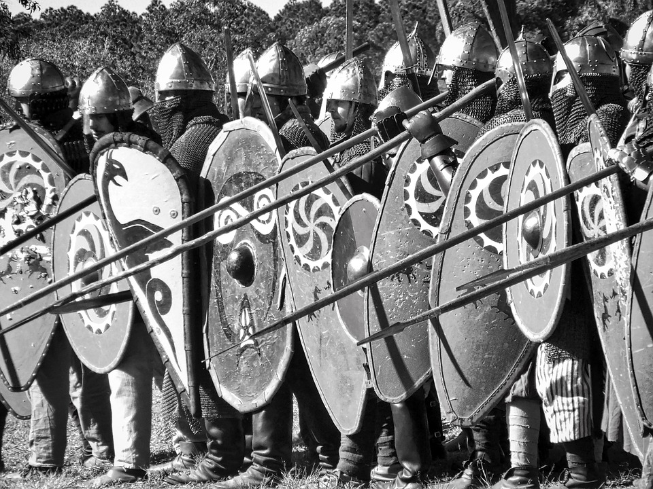

“I am not training you to fight against servants and peasants. The training is preparing you to face enemies whose strengths and numbers are unknown. From this day on, anyone who fights outside our group is going to be cast out. One fight with the servants and whoever is involved, will not be riding with us when we commence our final quest.”

Apparently the speech worked because there were no more incidents like that.

On Nick’s sixteenth birthday, the minstrel showed up again. This time he didn’t make a production of it. Instead he showed up during training and watched unobserved for a little while. During a break he revealed himself.

“Not bad Nikolaos” he said. “I have come to set you on the path to the ultimate goal. I see that you have taught your cousins everything I showed you, so we will all train together for a while.”

“Thank you minstrel, that will be an honor, however I will be thankful if you would address me as Nick Carter, like the rest of the men.”

“That will be fine Nick Carter. Now, if you show me to my lodging and feed me, we will start bright and early in the morning. I am also happy to see Myrtle and Lilia amongst your pupils.”

Myrtle and Lilia took care of the arrangements and in the morning they were all back in the clearing.

“The first thing that I want you to do, is divest yourselves of your weapons and your armor. For the next three months, all the fighting will be done using only your bodies. This is for the times when you may not have a weapon within reach, or perhaps it would be lost or broken in the melee. In addition, even when you do have a weapon, learning the things that I will teach you will make each of you much more formidable.”

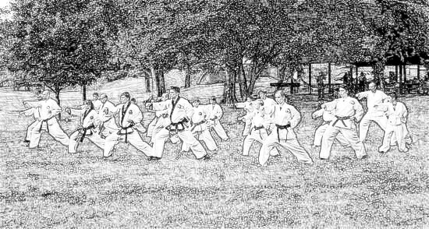

In his very long life, the minstrel had picked up a knowledge of many martial arts. He showed the fighters the basic forms of Kung-Fu, Karate, Aikido and Judo. In addition, every morning they would start with one hour of Tai-Chi. After three months, he showed them how to combine all the arts as necessary, including one hour of weapons training. He had shown the blacksmith how to make various Eastern weapons that were not known in the West at all in those days. There were nunchakus, wooden staffs, various sickle and scythe shaped knives and even throwing stars. This stage of the training lasted for an entire year. What followed was an intensive six month course in archery and ninja stealth exercises. A year and a half later, the minstrel pronounced them ready for the final stage. He gave them a little prep speech in the morning:

“You have worked very hard for the past year and a half. The time is approaching when you will be called to put all this training to work. Ten years ago, Nick Carter had asked me to teach him how to become a berserker. In the next six months I will turn all of you into berserkers. There is however one important difference between the berserkers of old tales and the berserkers that you are going to become. The meditational and mind exercises that we have practiced for so long, will make it so that you will have control over your berserk entity. To start with, for the next three months, you will learn the practice of Yoga.

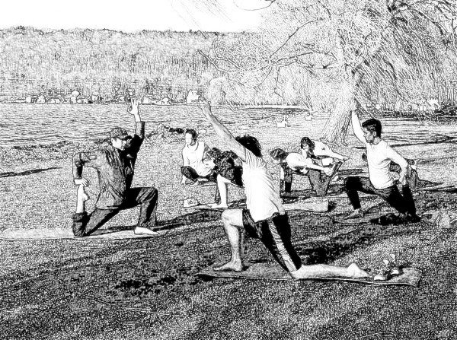

We will spend four hours every morning in Yoga exercises. After lunch we will pair up and fight each other. Everyone will have to find a straight tree branch, strip it and use it as their only weapon. I want you to try and inflict the most painful, non-lethal blows on your opponent. You all need to learn how to deal with pain.”

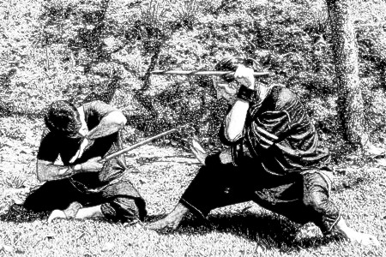

For three months, everyone learned how to live with constantly bruised and pained bodies. They also had to accept once again that Myrtle and Lilia were to be treated as equals. Women were not usually supposed to be warriors and the fact that Myrtle was better than some of the men, was upsetting to some of them. The minstrel noticed and at some point he paired Myrtle with himself. Everyone watched as she inflicted a lot of blows on him, as well as received at least as many

“I saw how some of you look at Myrtle and Lilia. Instead of being jealous, you should be happy that they are here. A lot of men fall apart when faced with a female warrior, so this is also part of your training”.

At the end of that period, the minstrel showed them that they could now walk on live coals and lie down on a bed of nails without their bodies or minds being affected by that.

“I have given you, everything you need, to become berserkers” he told them. “The final secret is now in your own minds. When you get into a fight, you will be able to enter a trance that will make you capable of resisting any amount of pain and continue fighting unto your death if necessary. You will have the strength of seven warriors inside you and you will be able to fight for days on end without tiring. Nick Carter is going to be eighteen years old on the morrow. We will celebrate his birthday and on the next day, we will ride.”

-%-

Petunia and Dougie called it a day. Dougie admitted that he liked the way Petunia continued the story. It actually seemd to follow his thinking very nicely.

The next morning, Dougie wanted to continue with the story, But Petunia told him that there was one little detail that she must add before that happened. Dougie tried to fight that.

“There needs to be a balance and one thing is missing from this part of the story. I think you know what it is.”

“I have no idea” replied Dougie.

“I’ll tell you what – I will start the first sentence and if you cannot guess right away what it is all about, we will erase it and you will continue.”

“O.K. I’m game.”

-%-

“Dahlia turned fifteen years old on the same day that Nick Carter turned eighteen.”

-%-

Apparently Dougie, guessed what it was all about because he turned a little bit red in the face while writing the sentence. Petunia smiled at him:

“Yep. It’s payback time” she said.

-%-

Dahlia was a beautiful teenager with strawberry red hair, green eyes and a creamy complexion. She was Bryony’s sister in law. Bryony was the only daughter of Romulus’s oldest son, Primo. Dahlia’s brother, Hubert, had successfully captured Bryony’s heart and they got married. Hubert and Dahlia were orphans, so when Hubert moved in with Bryony at her parents’ large castle, Dahlia had to move with him as well. She had been spying on the neighbors’ training for many years without anyone noticing her.

Nick Carter’s birthday was a very big event, so they were all invited. Dahlia was somewhat upset that they were not making a bigger thing of her turning fifteen, but she had to admit that the other birthday was a lot more significant for the family. She woke up early on that day and decided to see if anyone was training next door. Nick Carter had spent a restless night thinking about what tomorrow may bring. He got up at dawn and knowing that there would be no more training, he walked out to the little stream. The day was already promising to be a hot muggy summer day, so he took off his clothes and walked into the water. Dahlia had trailed him unseen and when he took off his clothes her heart skipped a beat. She had never seen a naked boy before and this one was like an incarnation of a young Hercules. She later on thought that he was so built that even his muscles had muscles. She made her way out of there quietly and ran back to the manor, her heart beating in her chest like a hammer.

The party was a great affair and everyone tried not to think about the possibility that the little fighting group may never come back again. There was no way that anyone could imagine a situation in which they would not go on their quest. It was like carved in stone. The minstrel played some tunes and told a few stories after which he was joined by Nick Carter with his dad’s tar. They made some very beautiful music together. The celebrations went on well into the evening, and at one point Nick Carter walked out to get some fresh air. He walked back to the training clearing thinking that he was all alone. He stood there contemplating the future. Slowly he noticed that he was not alone anymore. It was a full moon so he recognized Dahlia at once.

“Hello Dahlia, how are you?”

“I’m fine Nick Carter, just came out for some fresh air.”

“Yeah, me too” he replied.

“Actually, I followed you. I saw you this morning when you bathed in the creek.”

“Oh” he realized what she had seen.

“In all this hullabaloo, everyone kind of forgot that today is my birthday as well. I am fifteen.”

“Happy birthday, then. I wish I could do something to make it memorable for you.”

“You can” she replied.

“How?” he asked.

“Have you ever kissed a girl?”

“Actually, I know how it’s done. I’ve seen some of my cousins doing it, but I was too busy training.”

“Well, that is my birthday wish. I want a kiss from you.”

He felt cornered, but he’d already promised so he walked over to her. He was much taller, so he had to bend down, and then they kissed. If there was ever going to be a First Kiss Hall of Fame, this kiss would absolutely make it there right next to Romeo and Juliet’s, Anthony and Cleopatra’s and Samson and Delilah’s first kisses - it was that strong.

“I know, of course that you are leaving tomorrow” she said after getting her breath back “but you will be back and when you do, I will be right here waiting for you.”

“You know, I may never be back” he said.

“I know of no such thing. You will be back and I will be here!”

That night, Nick Carter slept very well. He did however have this dream in which he could see his father’s drawing of his mother coming out of the flaming lotus. Only in his dream it was Dahlia who came out of the lotus. The lotus painting turned into a real lotus and a real Dahlia came out of it and kissed him. On the following nights that dream kept haunting him, but he did not mind.

-%-

“What’d you think” asked Petunia.

“I guess it’s O.K. – even Princess Buttercup kissed The Dread Pirate Roberts.”

“Well, do you want to take it from here?”

“Yes, here’s the notebook” replied Dougie.

-%-

Early on the next morning, the company of twenty three got on the road. Everyone came to watch them ride away. The Minstrel and Nick Carter with his twenty-one cousins looked brilliant in the morning sun. Still, there was a nostalgic feel to everything when Myrtle and Lilia came to kiss Nick Carter good-bye. Some of the wives and girlfriends of the cousins started crying, but the thing had to be done. Nick Carter took everyone by surprise when he got off his horse and walked over to the back of the crowd where Dahlia was trying to appear inconspicuous. He bent over and kissed her saying:

“Wait for me. I will return to you.”

His cousins cheered while he walked back and jumped onto his horse and they were on their way. They did not encounter any kind of resistance or trouble and they crossed the border of Vallonia with ease. The border was in a thick pine forest, which they managed to traverse without any problem. On the other side, they came to a plain that stretched as far as the eye could see. A huge army could be seen in the middle of the plain. They could not see any details from this distance, but they were not to be intimidated by those numbers. After all that was what they had trained for. They took a few minutes to enter their berserker trance and then they charged an army that seemed to be 10,000 strong. As they got closer, they noticed that the entire army was facing the other way. They were actually attacking it from the rear. Getting closer still, they realized that no one in that huge army was moving at all. They rode in and through the ranks of that multitude of soldiers. It was as if the entire army had been turned to stone except that they all looked quite alive. The company rode through the army ranks slowly, and they noticed things that were even stranger. There were cooks who were roasting pigs on spits, but the spits were not turning and though the flames looked real enough they were frozen and cold. A dog was stopped in a mid-air jump for some morsel that someone was holding up, and at some point they ran into Romulus.
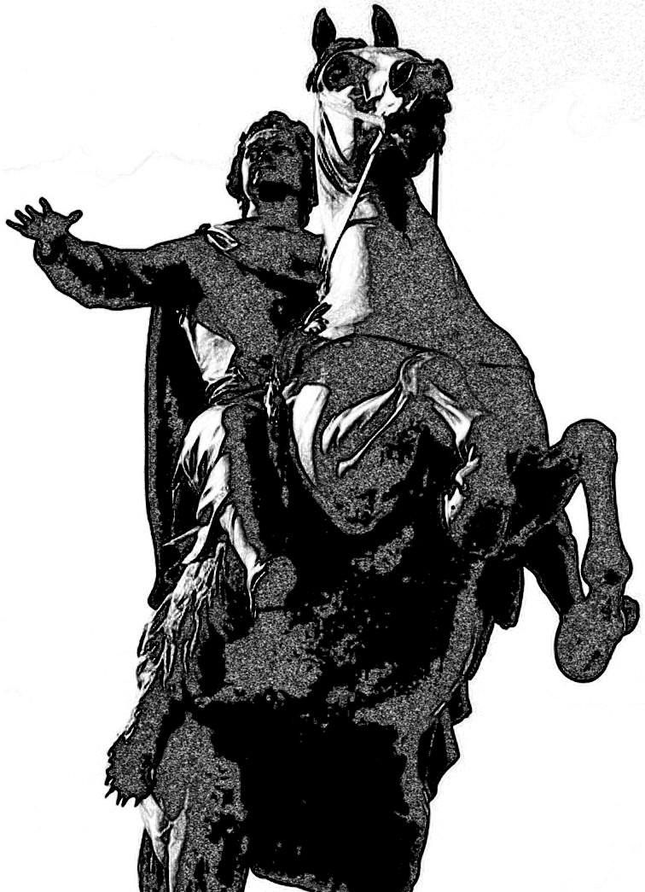
He was frozen in a pose that seemed to lead a charge. His horse was up on its hind legs and his hand was raised up high. His eight sons were right behind him.

“What do you make of this?” Nick Carter asked the minstrel.

“I don’t know, never seen anything like it. It is however good to know that they are not all dead. I think we should press on forward, we might find the answers.”

“But what about our parents?” asked one of the cousins.
“Well, they seem to have been here for the past nineteen years. I think, they will be just fine until we figure this out.”

-%-

“All right, I’m a little hungry,” said Petunia “let us continue tomorrow.”

“O.K.” replied Dougie, have a good night.”

The next morning Petunia insisted that she had a very nice way of continuing their story, so Dougie agreed to listen.

“I think we need to start a whole new chapter for this one” said Petunia, “we will call it:”

3 FLEUR DE LYS

Fleur de Lys was very, very old. She had stopped counting her age when she had become one thousand. It did not seem that important anymore. She still enjoyed having birthday parties, it was just that it didn’t seem to matter so much, how many of them she had celebrated before. The Principate of Vallonia was governed by a loose group of elves who elected a leader every one hundred years. Fleur had been elected some eighty years previously, and she was looking forward to a time when she wouldn’t have the fate of the entire realm on her shoulders.

There was a time when Vallonia’s borders were impenetrable. Armies that tried to penetrate into the realm were transported to far away locations, never to be heard of again. Some eighteen or so years ago, that ancient spell had stopped working. It was only through sheer luck that Fleur had become aware of the Christian army that had crossed their borders. She managed to cast a temporal spell on them before they could cause any harm. The elves were a peaceful ‘live and let live’ kind of people. The fact that they would not accept the Papal version of Christ into their hearts, was a sore issue with the greedy popes. They had tried to enforce their religion on the elves a few times without any kind of success.

Being made aware of the latest group of outsiders that had crossed into Vallonia, Fleur rode out to the border at once. There were only twenty-three of them so she decided that perhaps she should talk to them. That was especially so, when she saw that the one who seemed to be their leader had a sword crossing a tar hanging on his back. She rode towards them as they were nearing the edge of the plain. They stopped and so did she.

“What is it that brought you into the land of the elves?” she asked “and why is one of you carrying a tar on his back?”

“I guess that will be me” answered Nick Carter. “My name is Nick Carter, and I am here with my cousins looking for our parents and our grandfather. We found them in the yonder plain and we would like an explanation. The tar belongs to my father.”

“I am Princess Fleur de Lys, the ruler of these lands. If you give me your word that you will behave in a civilized manner, I will take you to my palace where we can figure all of this out.”

“You need to know that we are 23 berserkers and if you try to betray us, we will destroy everything and everyone in your realms.”

“There has to be a point where we can honorably talk, before we try to kill each other. I will offer this as a token of peace: my people and I are immortal, so your threats are extremely immaterial. In spite of that, I will deal with you in good faith.”

“I thank you for your honesty. Let us parlay then.”

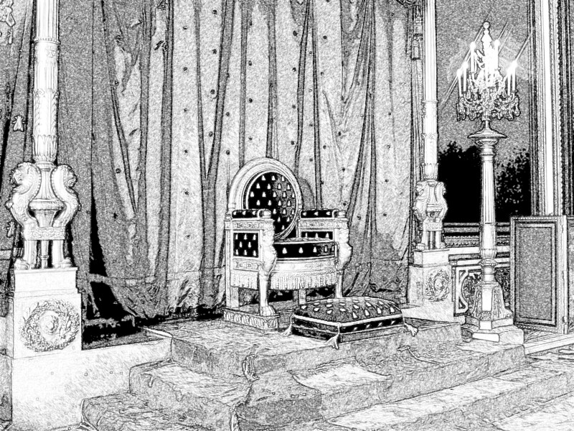

She led them to her main hall. Opposite the huge doors, there was an elevated platform on which was placed a comfortable looking throne. On the wall behind it, a tar was hanging. It looked very much like the one that Nick Carter carried, with only small design variations.

Princess Fleur led them to a huge round table and bade them be seated. In a short while a bevy of serving girls laid a modest feast in front of them. It consisted of fruits, nuts, legume soups and vegetable stews. Flagons of tasty mead and cider were available to quench their thirst.

“I must say that the soup and the stew were absolutely delicious” said the minstrel.

“Chef Tony, our resident cooking fairy, is indeed an amazing Chef. In all the years that he has been cooking for us, he has never created anything that was less than spectacular” replied Fleur.

“Why is there a tar on your wall?” asked Nick Carter.

“We will get to that in a little while” answered Princess Fleur. “I will first give you the explanation that you have previously asked for. It has been almost one thousand years, since your Pope started sending his emissaries and missionaries into our realm trying hard to convince us that we need to worship his God and the crucified son.

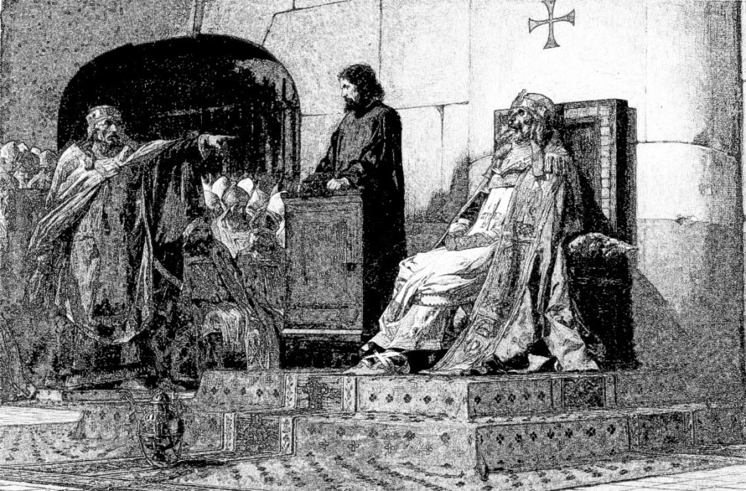

Most of the Popes are greedy men intoxicated by the power they have over people. They would love very much to extend that power over the elves and fold our realm into their Christian kingdom.

The main problem with that is that some of us have actually met this Christ that is said to have been the son of God.

He was a very wise, peace loving man and a great teacher who would be appalled at the things that have been done in his name.

Every hundred years or so, one of your Popes decides to send an army to try and subdue us and turn us into Christians. Human armies had been trying to besiege us for thousands of years. We are a peaceful race and do not wish to harm any human nor any animal, so a long time ago, one of the science fairies has manufactured something that you might call a spell and we placed it around our borders. Any army that tried to march across, was whisked to a faraway, unpopulated, land across the ocean. It will be many hundreds of years before another human sailor finds his way to that land. But, nothing lasts forever, so our spell has failed to stop the last army that was sent our way. Newton, our current science fairy managed to freeze them in time. They are still alive, but for them no time at all has passed since the day they have decided to charge our realm. There didn’t seem to be any urgency, so we just left them there while we were re-building our border spells. Almost nineteen years have passed since they showed up, so in the meantime a new Pope has come to power. We think that this one is a lot more benevolent and considering that you are now here looking for your fathers, I am willing to release all of them from the time-spell. It will have to be done in a gradual manner, and we need to plan it carefully, so as not to hurt any of your fathers nor any other soldiers.”

“What is it that you want in return?” asked Nick Carter.

“Only a small thing. Tell me, who is the older man who came with you? Is he also a relative.?”

“He is our teacher and a minstrel by avocation. He taught my father and me how to play the tar and then he instructed us in the martial arts.”

“Well then, what I want in exchange, is for your minstrel and you to play me a few tunes.”

She walked over to the wall in back of the hall and took down the tar. She walked back and handed it to the minstrel. The minstrel hadn’t said a word since complementing the chef, but some kind of confusing storm seemed to be brewing behind his eyes. He took the tar from Princess Fleur’s hand and caressed it automatically as if it was a familiar old friend. He appeared to slip into a trance, but his hands knew exactly where to go and a sad tune in a minor key started its way out. Nick Carter picked up his father’s tar and joined in. After a few more notes were played, the minstrel opened his mouth and proceeded to half declaim, half sing his story:

The Minstrel’s Saga

“Since the dawn of time
You’ve promised to be mine
As I too, promised to be yours.
The happiness I knew since I met you
Was absolute and true and everlasting
As I forsook the warring of my brothers
I swore that before you there won’t be any others.
Forever yours, forever and a day
Forever yours, I have embraced your way.

Time has no meaning when you are alive forever
For others it keeps flowing but for us
It is like measuring the twelfth of never.
Still, when my brothers came and stole me
I could not renounce my love of them
I could not refuse to go when
They told me of the perils faced by father’s realm
So when the ship they rode in turmoil sailed
It was I at the helm

We sailed a sea of stars
We braved the tides of time
To get us to the battlefields of yore
The twelve of us were match for thousands
And for many thousands more.
We battled all and they could not prevail
We raised mountains of corpses
We lived covered in gore
And they would still come on

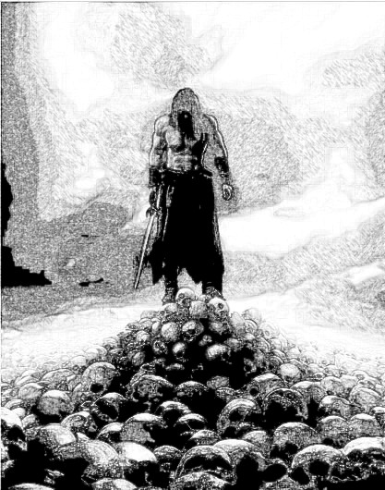

For days and nights and weeks and months
We slaughtered wraiths and ghouls and demons
But they did not have any end
After the year was gone
We lost our brother number one
And every year another
And so after eleven there I was
Alone, alive but so, so far from home
I, Waldencraft, invincible berserker

For twelve more years they came at me
They hit me with their hammers
And I felt nothing
They raked me with their claws
And I felt nothing
They cut me with their scimitars
And I felt nothing
No matter how deep their cuts
I would not even bleed.

Twenty three years later, they ceased
My father’s realm was safe again
But what the cost?
My brothers were all gone
And though I stayed alive
I may have lost the most.
For how could I come back to you
With so much blood on my hands?
Forgive me, for I have sinned

I could not face you while I’m wallowing in sin
I could not face myself in this shape I was in
So I would leave my memories a-dangling in the stars
Though it would mean that I’d forget
Just who you are
Please keep this poem for me and my beloved tar
I’m sorry, it may not mean that much
But it is all I have.
I’m gonna miss your touch

For centuries I’ve wondered
I travelled near and far
I’ve been to Hindu-Kush
I sang in Katmandu
I went to unknown lands
That one day may be called Peru
Though I’ve been known by many names
There was none that I knew.
My memories were buried deep and true.

I’ve played a hundred instruments
I’ve played them good and true
And I have sung a thousand, thousand songs
Some happy, some sad, some blue
But though I’ve been around the world
So many times and others too
Nothing had touched me ‘til I touched Octavio’s tar
It made me want to watch over his family
Though I just couldn’t tell what they all meant to me.

And now we are about to close this circle
Somehow this long part of my saga
Is coming to an end
I feel that my old memories are just around the bend.
I hope they won’t be painful
Or why would I have left them all behind.
Still I feel eager to recover
The lost part of my mind
But, here we are and what will be will be.

-%-

4 RE-UNITED
The minstrel’s performance had apparently sat very well with the Princess, because she was trying surreptitiously to wipe a tear from her eye.
“I hope you will accept my hospitality” said Princess Fleur “It is getting a bit late and I think we should all retire for the night. In the morning we will release your fathers and plan our next steps. Have a good night.”
Some of the serving girls returned and showed everyone to their sleeping quarters. A few of the cousins seemed unhappy with the situation and voiced the opinion that things are moving too slowly and they were not sure if they could trust the situation. Nick Carter defused the thing:
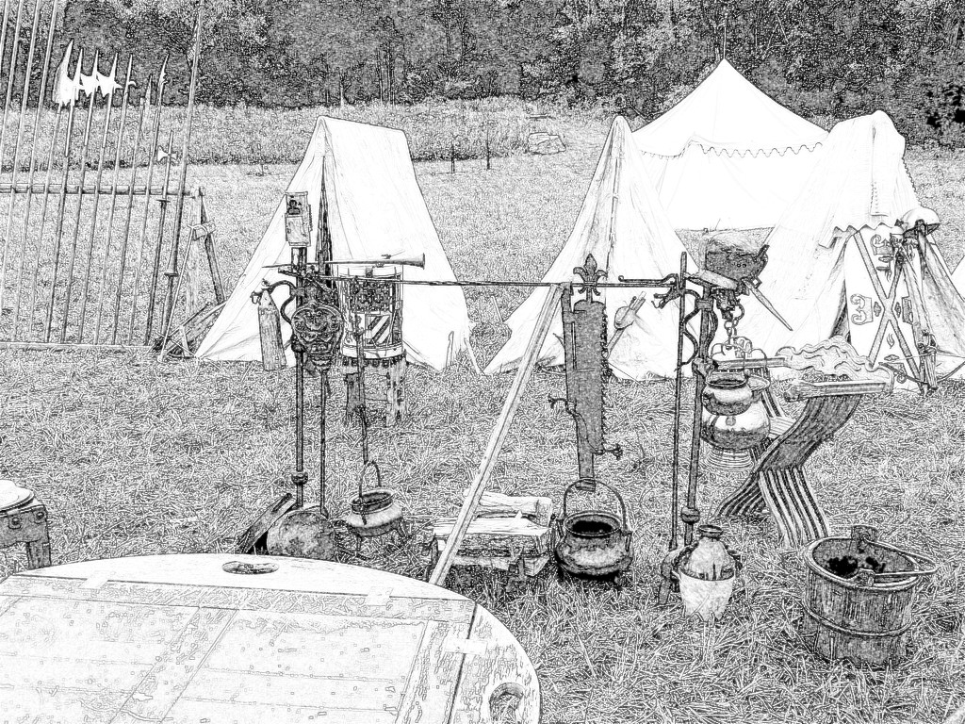
“Princess, we appreciate your hospitality, but, we’d rather camp out for tonight. I noticed a large grassy plain in back of your palace, so if you don’t mind that is where we will set up our tents.”
“Suit yourselves” replied the Princess.
They were shown to their horses and they set up camp complete with a night watch. The Princess showed up as they were getting organized and asked the minstrel to walk with her for a bit. They walked to a little gazebo where she bid him sit next to her. She produced a furled up scroll that she handed to the minstrel. The last light of the summer sun was still lighting up the skies, so that he could easily read the writing. It was the exact poem that he had declaimed / sang for her earlier.
“I guess you have some really good scribes. That was a very fast transcription.”
“Then, I guess your memory is still quite addled. This scroll and the tar have been in my possession for a very long time. As you sang earlier, it was sent to me by Waldencraft. I think you know by now that you are Waldencraft, don’t you?”
He unfurled the last part of the scroll to see the tail end of his earlier verses.
“The only thing is, I only made up the last verse tonight. How could it be on this ancient scroll?”
“The scroll is somewhat magical. It was made to record every story, sonnet, lyric and tale that you told. If you start again from the beginning, you will see that.
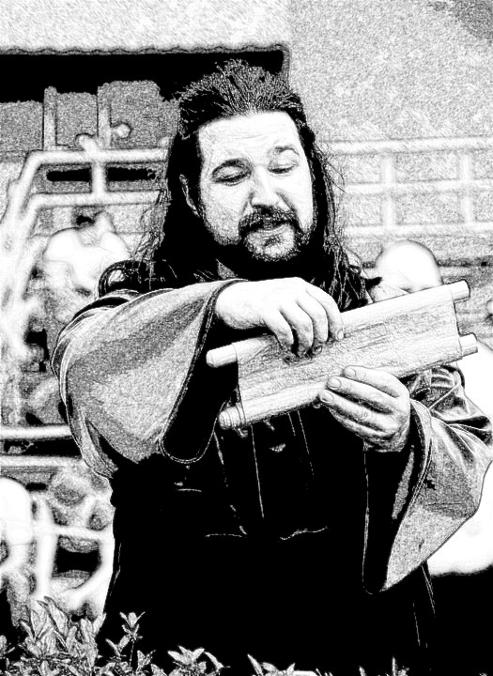
He unfurled the front again, and indeed, after the first part of his saga, he could read many more of his words. He kept unfurling and sure enough it appeared that there were thousands and thousands of his stories and songs, so he stopped after a while.
“This is how I knew that you were still alive somewhere in the world. I kept hoping that you would come back to me someday – and here you are.”
“This is all somewhat confusing. I need to think on it for a while” said the minstrel.
“Walden, I have waited for so long, I think I can bear to wait a little longer. All you need to know is that I have accepted your nature ages ago when you first came to me. Please try to remember who we were, and believe that we can be that once more.”
He gave her a long look trying to resolve his feelings.
“Let us talk about this again, in the morning” he said, kissing the back of her hand.
-%-

“That’s all I have for now” said Petunia “do you like it?”

“Not bad” answered Dougie “but I’m not sure about that poem. I think maybe we should write some more about Waldencraft fighting the wraiths and ghouls and demons.”

“No. This part is just trying to explain the minstrel’s past. What we need to do is find a new and scarier enemy for the berserkers to fight. They should get the elves to help them”

“But the elves are peaceful. That is what you said. I don’t think we should change that” responded Dougie

“True, they are peaceful, but they have some kind of magic that they can use when they are being threatened. We need to come up with some kind of reason that will cause the elves to become involved in the fighting” said Petunia “but it is getting late. Let us sleep on it.”

“O.K.” replied Dougie “good night.”

-%-

The next day after breakfast, Dougie and Petunia met again by his favorite flat rock. On this morning, Petunia was wearing a bathing suit.

“Did you come up with anything?” she asked.

“No. You?”

“Me neither. I think maybe we could take a break. It‘s why I’m wearing a bathing suit. I thought maybe we could just cool off a little and chill. The weatherman said it is going to be a record hot day today. So, go get your bathing suit and meet me at the eye.”

Dougie went and got his bathing suit. His mom stopped him on his way out.

“You’ve been spending a lot of time out back. Does it have anything to do with your project?”

“Yes, it does” replied Dougie.

“So, when can we find out about this mysterious project of yours?” asked his mom.

“Soon” answered Dougie.

He went out to the eye and they just swam around for a bit. Petunia had brought a large beach towel on which they lay down when they got too tired.

“So, Fleur and Walden have found each other again” said Dougie. “I guess we could drag that out a little bit longer. Then we can write about how Fleur is releasing Romulus and his sons and the rest of the Christian army. They go back home and then there is a whole chapter about the sometimes funny and other times sad things that have been caused by the fact that this entire army has not aged at all for eighteen years. And then what?”

“I was thinking that Romulus and his family are descended from Fleur de Lys and Waldencraft. So they are also immortal” replied Petunia.

“That’s another thing. Walden is not an elf so how come he is immortal? I think we need to explain that somehow. And one other very important thing. It’s O.K. that they are immortal, but what about their wives and girlfriends? I always hated those stories like Highlander. I mean I love that story, but I hate the part where he has to go through life suffering the loss of numberless wives. Why is it always the guy who is immortal? I want a story where that does not happen.”

“This is our story, so we can do whatever we like with it. I like your points, let me think about it a little. In the meantime, I’m going home for lunch. Let’s meet again tomorrow morning and bring some new ideas. O.K.?”

“O.K.” replied Dougie “see you.”

-%-

The next morning Petunia was quite enthusiastic.

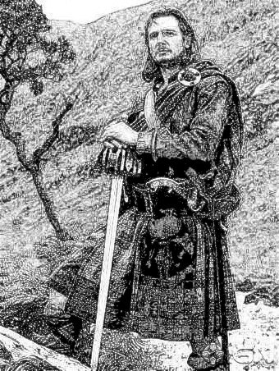

“I watched a great movie last night called ‘Angels Over Broadway.’ Made me come up with this storyline:
5 NICK CARTER IN THE 20TH CENTURY – pt. 1

Nick Carter walked into the speakeasy at precisely 8 o’clock in the evening. It was the day before Christmas in the year 1928. He looked pretty sharp in his tweed suit and Borselino hat. He spotted Mike the Gumshoe sitting in a booth in the back and walked over. He took off his hat, placed it on the table and sat down across form Mike. The waitress showed up at once asking what he’d like.

“I’ll take whatever’s top shelf tonight and don’t you bring me none of that bathtub gin stuff..”

“Thanks for meeting with me Nick” said Mike the Gumshoe.

“Yeah, sure, why don’t you get to the point. I don’t have all night.”

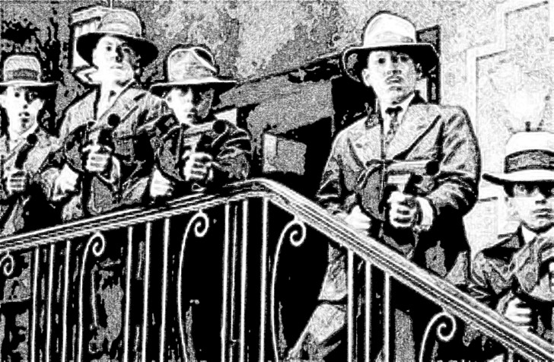

That was when Tony Albano and ten of his goons broke in.

“Nobody move” said Tony “or else things will get ugly.”

Nobody moved except Nick Carter. I guess no one in the 20th Century has ever seen a berserker. It took Nick all of 45 seconds to disarm and disable all of Tony Albano’s men.

“So, you were saying?” prompted Nick.

-%-

“No” said Dougie “you cannot just jump from the 12th to the 20th century just like that. You have to have some explanation. And don’t think that I forgot where we ended up yesterday.”

“I was going to explain it later” answered Petunia.

“O.K. so what will it be?”

“Well, there was a real Nick Carter character in the 20th century. He was tough and there were comics and movies about him, so it could be a strong connection” replied Petunia

“Nice, but how did Nick Carter get there again?”

“ I am not sure yet, but it will come to me.”

“I don’t like it. Up till now we had a story that was going from one place to another. This thing makes it skip without any explanation. I do not want the story to go that way.”

“So, we can just end it with Walden and Fleur being re-united” said Petunia.

“No! I need to know if Walden really got back his memory. Also, why was he coming back to teach Octavio and Nikolaos. We cannot leave everything just dangling like that. And one more thing, when I first started writing this story, I wanted to have berserkers, elves, minstrels and immortals, which we have done well so far. But I also wanted astronauts, robots, cyborgs and aliens. I love what we wrote so far, it is excellent, but I have no idea how to get from here to there. Nick Carter in the 20th Century could be fun, but I don’t think we can go that way and get to where I want to go.”

“So,” said Petunia “what’s your idea?”

“I do not have one” he replied “but I think it might be time to talk to my mom. She keeps asking about my project and I keep telling her I will tell her soon. You know my mom is a writer, so maybe she can help us. Also, I think my dad is a very inventive person.”

“Pretty good timing” replied Petunia. “I mean we can talk to them at the barbeque. It would be even better, because some of the others might also have suggestions.”

-%-
6
6 BARBEQUE TIME

Dougie and Petunia’s parents had actually turned Saturdays into barbeque day. They would get together in one of the back yards, light up the grills and roast a variety of foods. It was grills because Petunia’s mom as well as her two sisters were vegetarian. Petunia and her daddy were omnivores, but somehow, they seemed to be able to co-exist peacefully. Life is strange like that sometimes, but that is why they needed to light up two separate grills. Dougie’s mom, Margareta was a successful romance writer with more than one hundred published novels. It brought a nice and steady income, though she was much happier with her science-fiction novels that she would publish under a pseudonym. His Dad, Jonas was a games designer. Petunia’s father, Gerald (Gerry) was a web designer and her mom Popi, was a musician with a moderate following on the public radio stations. They were certainly not your average 9 to 5 office people and it was not surprising that they had become close friends.

So, when Dougie and Petunia showed up together, Bryony and Begonia started making all kinds of silly comments the way young kids would.

“Girls, let’s not get too silly,” admonished their mother.

“Sit down and have a bite kids” she said, addressing Dougie and Petunia.

Gerry was a really great grill master so they enjoyed their crackling pig skin and pulled pork platters for a bit. There was always great stuff to go with the grilled meats. Popi was an expert pickler and Jonas was a really good salad chef.
On the second grill, Gerry had roasted corn, potatoes, sweet peppers and eggplants. Jonas had used some of the eggplants and roasted peppers to create a tasty salad. Margareta loved to bake so on this day there was some kind of Turkish style pide to dip into the eggplant salad.

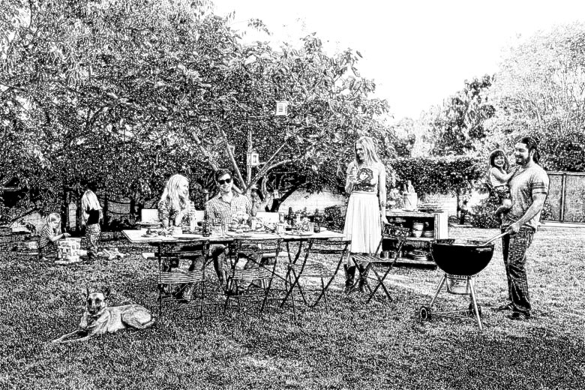

They all enjoyed the food, making small talk until Dougie asked a sensitive question:

“Mom, can I have a glass of cider?”

In addition to making pickles, Popi would also make some really tasty apple cider. The adults enjoyed it a lot, but as it was a hard cider, the kids were always drinking lemonade and/or seltzer.

Margareta gave Jonas a questioning look.

“Please mom, it is a special occasion.”

“Does this have anything to do with that secret project you and Petunia have been working on all this time?”

“How did you know this mom?” asked Dougie while turning a little red.

“Oh, come on, we’ve all noticed that you and Petunia disappear somewhere in the back at the same time.”

She poured about half a glass of cider and gave it to him.

“Go on” she said “we’re all ears.”

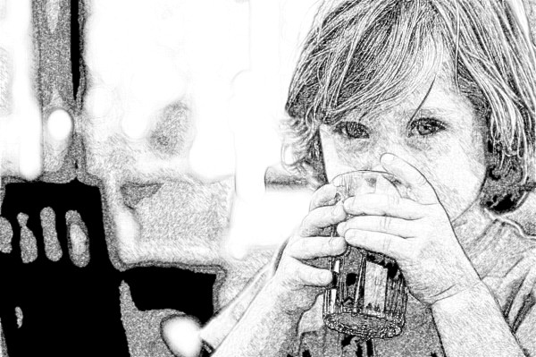

Dougie took a sip from his glass and saud “it’s not as tasty as it had always seemed. Remember, on my last birthday, you said that I should make a wish?”

“I guess so,” replied his mom “it is a custom you know.”

“Well, anyway I did make one. I wished for a girlfriend.”

Bryony and Begonia started some silly chants again:

“Petunia has a boyfriend.”

“He’s not my boyfriend, stop this” jumped in Petunia.

“Well, we are friends, no?” asked Dougie.

“We are friends, but can you just get on with it?”

“How did all of this happen?” asked Dougie’s mom.

“Please mom, that is a story for some other time. Can I just go on?”

“Sure Dougie, let’s hear what you’ve got to say.”

“Me and Petunia”

“Don’t you mean Petunia and I?” interjected his mom.

“Yes Petunia and I have been working on a story. We are kind of stuck and I was hoping that you might help us. Petunia thought that everyone might have some ideas.”

“O.K. let us hear what you have so far.”

“I will start and we will take turns, just the way we wrote it.”

Dougie read the first part up to the point where Myrtle busted Octavio. Petunia took over and they continued taking turns up to the end of Nick Carter in the 20th century.

“I didn’t like that too much” said Dougie. “If we put that into our story, then Nick Carter has been alive for almost a thousand years. What has then happened to Dahlia? What about his father and his uncles? If Nick Carter has lived this long, did they also live that long? Is it a family thing and does it only work for the men?”

“I thought we could figure that out later” jumped in Petunia.

“I am actually quite impressed” said Margareta. “It is a very good story so far. It is however still very short. What else was going to happen?”

“I thought maybe Nick Carter would have a son who would go to some magical realm. And then, maybe that son will have a son who will travel to the stars.”

“I have an idea” said Jonas. “You already used a temporal spell on that army, so you can easily use a space-time gate that will take any of them to wherever and whenever you decide.”

“Wait, did Romulus and his sons just spend nineteen years in stasis?” asked Popi.

“Yes mom” responded Petunia.
“So, They all get back to the castle and Romulus is maybe forty-five and his wife is like sixty-four and his sons are all nineteen years younger than their wives. I really do not like that part.”

“And why did Myrtle and Lilia learn to fight so well, but never used it. Is Myrtle just going to be there to be Octavio’s wife and Nick Carter’s mom? And what about Lilia, why is she even in the story?” asked Bryony.

“And Dahlia, she cannot just be a girl waiting for some guy” jumped in Begonia. “Also, how come you used Bryony’s name in your story? What about me?”

“O.K. I am glad that we decided to ask for help. Thank you daddy. I think that gate will solve all of our problems. It is really good.” Said Petunia.

“We are going to have a Begonia, O.K.?.” Added Dougie.

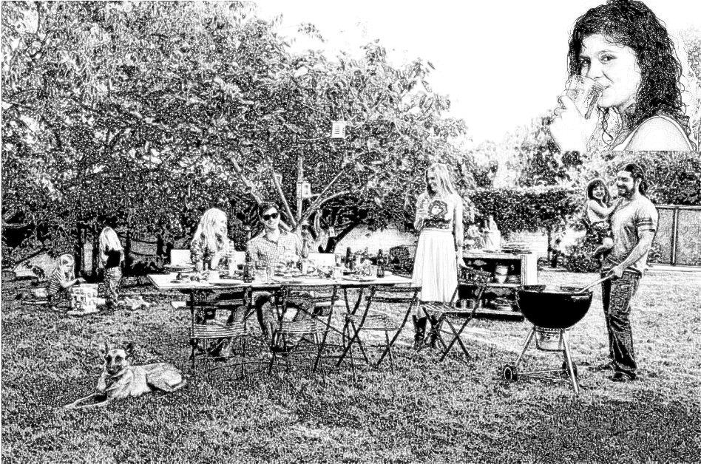

“Actually, I have to say that the story so far, is really cool.” Said Margareta “Keep working on it. You need to get to somewhere between sixty and eighty thousand words. Once you get there, I will edit it for you and I will get it published.”

“Then I shall also have a little cider to mark the occasion” said Petunia.

Her mom poured her half a cup and she drank it all.

“I actually like it.”

-%-

7 RIPPLES

Fleur, Walden, Newton and Nick Carter with all his cousins rode out to the frozen army the next morning.

“I could do it myself, but Newton is the true master, so I prefer that he performs the release spells” said Fleur.

At first they released Romulus. His horse continued to charge from the point he had been stopped eighteen years ago. Romulus noticed at once that nobody was following, so he reined him in and turned around. He stopped for a moment to take in the frozen camp. He noticed the smaller group of soldiers and rode back towards them.

“I recognize you minstrel. Pray can you tell me what is the meaning of all this?”

“Well met Romulus. But first, let me introduce you to Fleur de Lys, Queen of the elves and Newton, her science fairy”.

Romulus had apparently kept his manners because he dismounted and offered her a deep bow.

“Your majesty.”

“And this,” he continued “is your grandson Nick Carter. He is leading all of your other grandsons – twenty one of them to be precise . They have come looking for you.”

“How can I possibly have a grandson this old? My oldest grandson should be only about eight years old.”

“You have been frozen for nineteen years” said Walden.

“If you give me your parole, I will ask Newton to release your sons and we can all plan our next moves” inserted Fleur.

“Yes, of course, I promise that no one will try to harm you or yours while we have a parley.”

At that, she gave Newton a nod and he released all eight of his sons from their spell. They all seemed a bit confused.

“We will get an explanation very soon my sons” told them Romulus

Nick Carter rode over to his father and taking the tar off his back, he offered to him.

“I believe this belongs to you, father.”

Octavio was obviously baffled, but he recognized the tar.

:”Good one pal, so tell me how did you come by my tar?”

“Take it easy Octavio,” jumped in Walden “everything will be made clear quite soon.”

“Why minstrel, it’s nice to see you too.”

Everyone tried to explain everything to their fathers while they rode on to Fleur’s castle. It was a strange situation – Nick Carter was actually the same age as his father Octavio and all of the others’ fathers were much too young to have such old sons.

-%-

“I once read a story where the writer was comparing something that someone did, to a rock thrown into a pond. Just like the rock created a lot of ripples, so did this action affect many other people. When Octavio and the others return home, Myrtle will be nineteen years older than him. His mom Laura will be sixty-four while her husband Romulus will have remained forty-five. And there are a few thousand more soldiers out there, each of them with a separate story” said Petunia with sadness in her voice.

“We are not going to tell everyone’s story. Just that of a few of them and I have an idea, so have a little patience” replied Dougie.

-%-

Fleur thanked Newton who bowed and went back to his lab. The rest of them had a good meal and drank some more mead while trying to adjust to the new situation. There was not much they could do about it and Romulus agreed to talk to General Lafayette, the supreme commander of the entire army, and explain the situation to him. Going back to their homes sounded like a good idea, especially when he found out that there was a new pope who was not interested in making war against the elves. In due course General Lafayette was released and convinced that there was no need to proceed with the war. After the rest of the army was released, General Lafayette instructed his captains to explain the situation to the troops as well as they could. He also released everyone from their obligations and allowed them to make their own way home as they wished. Most of them chose to stay with their units and return to their bases together. A few hundred chose to make their own way. Romulus and his family were amongst those few hundred.

It was quite late in the afternoon, so Romulus and his crew were making preparations for an early morning departure when Walden showed up.

“Hey Octavio, I just came to play with you one more time. Not sure when I’m going to see you again and I was wondering if you still remember how to play.”

Octavio was happy to oblige. The evening was getting a bit chilly so they gathered up some wood and built a nice camp fire. In addition to his tar, Walden had also brought a large keg of cider, so everyone was feeling quite happy by the time they finished their first duet. They only had two tars so they kept talking turns. It was Walden and Octavio, then Octavio and Nick Carter, followed by Nick and Walden and so on. It was a nice evening gathering that lasted well into the night. Eventually, Walden bid everyone good night and left.

Bright and early the next morning, he showed up again.

“I just wanted to ride with you guys to the border” he explained.

Vallonia’s border was only about a half day’s ride from there, so they expected to get there by noon at the latest. They managed to cross the border without any problems, but once they were across, a strange thing happened. The mostly wooded area that they were riding through, gave way to a grassy plain that stretched as far as the eye could see. Turning around they could not see those woods anymore, only more of that grassy plain. The plain did sport a few trees, but nowhere near as many as before.

“I think we have a problem” said Walden.

“Do you have any idea what this might be?” asked Romulus.

“Not even a clue” was the reply.

“Well, it is nearly lunch time and I’d say most of us are out of that dry beef jerky we brought along” said Romulus. “We need to try and hunt something for supper, as well as find some drinking water. I think any direction is as good as any other one, so let us just ride forward and look for some kind of water source.”

No one objected to the idea, so they did that. While riding along they encountered a large herd of some kind of bovine looking animals grazing. They looked a bit like a bison but more wooly and with differently pointed horns. Romulus and Primo, the best archers in the group, shot a couple of these beasts. The rest of the herd ran away.

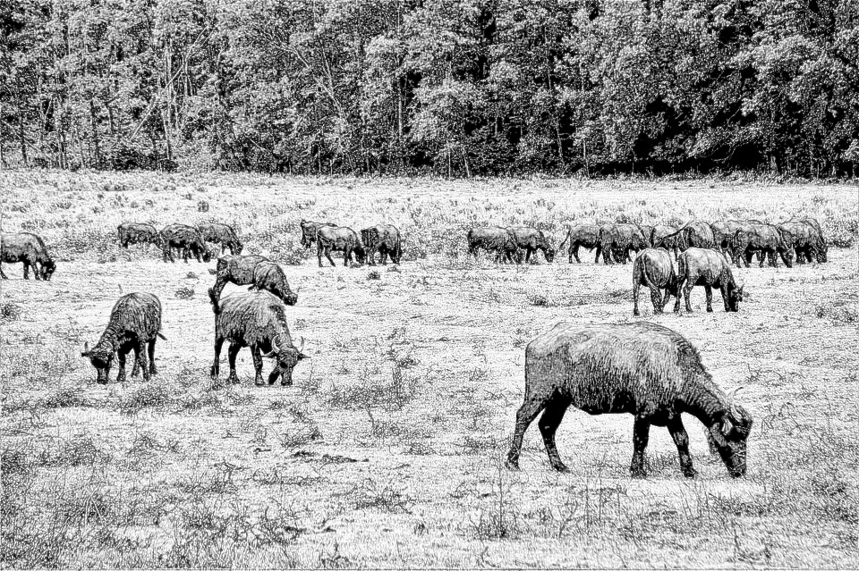

“We’re going to strike camp here and cook our meat” said Romulus.

It was nice that no one disputed Romulus’s right of command. Even Walden deferred to him out of respect. Anyway, they went on to build a large roasting pit where they proceeded to cook the two animals. It took quite a long time, but eventually they had some nice steaks that everyone agreed were very tasty. They had more meat than they could eat at one time, so the fire was kept on all night while they smoked whatever meat was left over. Romulus assigned sentinel and fire watch duty to four of his grandsons. The smoking process made the meat dry and cooked enough by morning, so it was equally divided and they rode on. From the way the grass looked as well as the well fed animals, it was obvious that there was some water around there. Sure enough, long before noon, they reached the banks of a very wide and lazy river.

-%-

“Are those buffalo?” asked Petunia.

“You bet” answered Dougie.

“So they somehow got to New York or maybe even Canada?”

“Good guess. Actually, I was trying for somewhere along the banks of the Hudson, because I once went there on a school trip.”

“How did they ever get there?”

“Patience, Petunia.”

“You know, I remember reading Rob Roy one time and I was always wondering, how come all the knights never seemed to need to wash up.” Said Petunia.

“Yes that is a good point, so the first thing they did after reaching the Hudson, is take off their clothes and wash them as well as wash themselves. Can I go on with the story now?”

Petunia just nodded so Dougie kept dictating.

-%-

The land that they had found themselves in had so far seemed deserted. There were no people in it. Still as they hung their various clothes on the bushes, Romulus assigned a lookout. The day was nice and sunny and there was only a very slight breeze blowing, so most of them were snoozing when the Mahican warriors came upon them. They snuck up on the lookout and overpowered him without a blow being struck. The rest of the men only became aware of the problem when they were awakened by the Mahicans.

“Grandpa, there are only about fifty of them. Me and my cousins could kill them before they even realize what is happening.” Said Nick Carter.

“That is absolutely true,” added Walden “but maybe we can just wait and learn some things from them before we do that.”

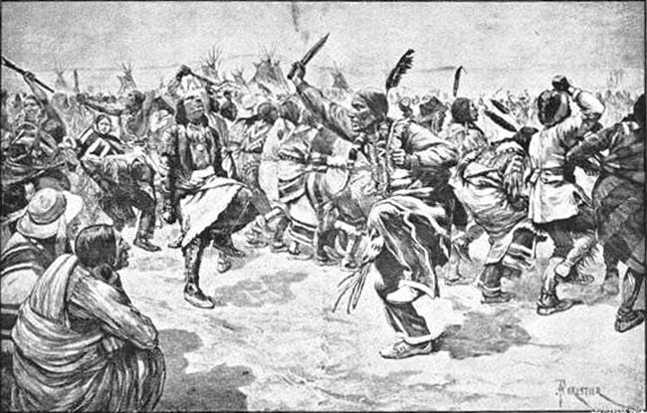

“We will wait” said Romulus.

-%-

“Why are they not killing the Indians?” asked Petunia.

“You know, I have not made any friends in school” told her Dougie. “I think it is mostly because I do not like all the games everyone loves to play. I do not understand why killing is so important. So far, we got through the story without killing anyone and I still like it a lot. I would like very much to keep it like that.”

“But Nick Carter and all his berserkers are the best fighters in the world. What is the point of that?” asked Petunia. “Also Walden and his brothers had killed thousands and possibly tens of thousands of ghouls and wraiths.”

“Oh, I forgot about that. But anyway, it happened hundreds of years before our story.”

“That maybe so, but it is still in our story” responded Petunia.

“Well, I guess you are right. Don’t worry, there will be plenty of fighting. I like fighting, it is just the killing that makes me unhappy. One more thing, I looked this up on Google and they are not even Indians. It is just because Christopher Columbus was a confused person who thought he was in India when he got to the American continent.”

“O.K. I will keep it in mind when I continue with the story. I think I can live with that.”

-%-

Fleur de Lys waited an entire day for Waldencraft to return. On the next morning she wondered what could have gone wrong. He had recovered his memory and the two of them seemed ready to pick up from where they had left off so many hundreds of years ago. She went to her room to do some reading. Newton came to see her later and told her that something had gone wrong. The bulk of the invading Christian army had made it across the border without a problem. It was only that by the time Walden, Romulus and the rest got there, the shield had partially repaired itself and it had whisked them away to the lands across the ocean. Perhaps it was just because this group was so much smaller and the shield did not need as much energy.

For some reason, Walden seemed to care more about these mortals than he did about any others, so she thought that she needed to try and help them as well. Unfortunately, there did not seem much that she could do immediately.

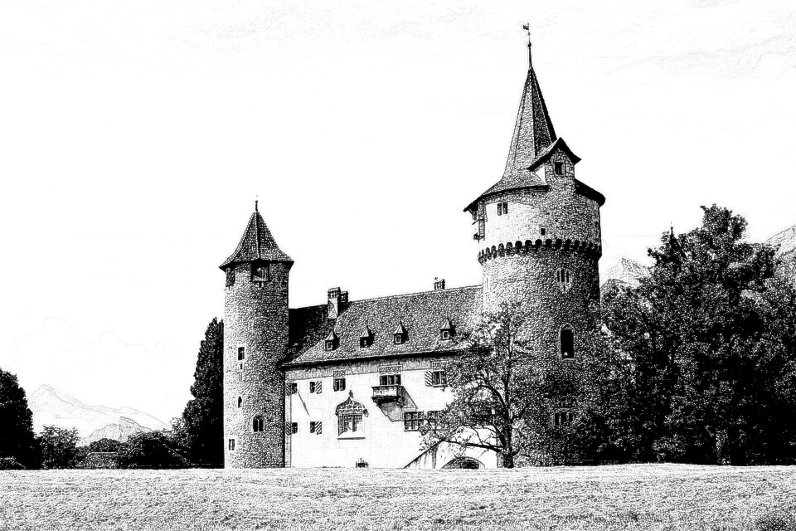

Figuring out how to fix the problem would take a long time. She thought that one thing that might help would be placing their original castle into stasis.

Thus, when they eventually made it back home, they would at least have all of their loved ones awaiting them and if she did it all correctly, the time difference between, might also be gone. Newton did not much like to travel, but he gave her the necessary tools. She packed a few things and off she went. It took her a bit less than three days to get there and only a few minutes to place a stasis shield around the castle. She was sitting on her horse thinking about her next move when a cart came down the road and stopped not too far from her. The woman who was driving the cart addressed her:

“Good day to you traveler. My name is Myrtle and this is Lilia” she said “what brings you to our castle?”

“Would you happen to know a knight that goes by the name Nick Carter?”

“Nick Carter happens to be my son. Do you bring some news of his whereabouts?”

“Then you must be the wife of Octavio, son of Romulus.”

“That I am and who might you be?”

“My name is Fleur de Lys and I am the queen of the elves. I came here to discharge an errand, but perhaps this was meant to be. I’m afraid I have some disturbing news. Your husband and your son as well as the rest of your family that went away with him, might take a lot longer before they get back home.“

“A little more of an explanation, might help.”

“To start with, let me just say that we, elves, are a peaceful kind of people. Your popes have tried a few times to, I think ‘gather us into their flock’ is an expression that they use a lot. We are not, have never been nor will we ever be interested in that kind of stupidity. Your popes do not want to accept that, so they keep sending armies to try and subdue us by force. In the past, we have managed to transport any army that crossed our border to some faraway land. Unfortunately, the spell that we had cast on our borders had failed just before the army that your kin were a part of, crossed our borders. I managed to avoid killing them all by casting a spell that has kept them frozen in time for the past nineteen years. When your son Nick Carter showed up, he was accompanied by my fiancé Waldencraft. You know him just as the minstrel, but we have been engaged for many, many centuries. I have been waiting for him to return to me and I was very happy to see him again. Partly because of that, I have released your father, brothers, husband and so on, as well as the entire Christian army. They were all supposed to go back to their homes, which is what has happened with the majority of the soldiers. Sadly, as Romulus and his children and grandchildren crossed the border, the spell that I thought was broken, became active again. As a result, all of them, as well as my beloved Walden, were transported to a far and distant land. Most of them are trained berserkers, so there is no danger to their lives. I have waited for Walden to return to me for such a long time – I can wait for the same length of time again. However, he seemed to care a lot about Octavio, Nick Carter and the rest of your family, so I have decided to try and help. I felt that having Romulus and his sons come back to friends and wives that have suddenly become eighteen years older, may be very unfair. Besides, I am not sure how long it will take me to find and return them. So, I have placed your castle into a temporal time freeze. The two of you should have been in there with everybody else, but maybe it is better this way.”

“Of course it is” inserted Lilia “we have been taking care of most of the castle affairs for nineteen years. And now there may be as much as nineteen more years during which we will not have to worry about anyone in the castle. The three of us will go look for our missing family and we will find them and bring them back.” Said Lilia.

“If I understood this correctly, you have some kind of way to control time. Obviously, it would be difficult to turn everything back to where it was before that idiot pope sent my family to a very probable death. I am very thankful to you for not killing them. With the power that you are talking about, it would have probably been very easy for you. Still, if we are to do this thing together, would it be possible for you to at least stop time for me and Lilia? I mean the part of it that makes us get older and die. When I am finally reunited with my husband Octavio, I do not wish to feel like I am older than his mother” said Myrtle.

“I can do that” said Fleur “but then your son may turn out to be your age and who knows, perhaps even older than you.”

“I understand from what you have told me so far, that he is aware of these time stoppages and other weird things. I think he will be fine with that and so will I.”

“Interesting” replied Fleur “but I am still trying to figure out why I would need the two of you. How could you possibly help?”

“Let me ask you this” said Myrtle “just how old are you?”

“ I am not exactly sure” answered Fleur “I stopped keeping track when I reached one thousand.”

“And your subjects, are they just as old?”

“Some of them are even older.”

“Now, you did not ask any of them to come with you, and none of them offered. So here you are, you may be immortal, but if it wasn’t for Lilia and myself you would be all alone. Doesn’t companionship matter at all to you and your people?”

“O.K. that could be a valid point. Do you have any others?”

“Well, both Lilia and me are very good negotiators. That might come in handy in some situations. Also, I happen to be a very good cook. That might also come in handy if you still eat sometimes.”

“Actually, I do not eat animal flesh, so I am not sure how good you might be with other dishes” responded Fleur.

“She is totally going to surprise you” interjected Lilia “and then of course there is the other point: don’t you ever get lonely? I think you will find that we can be very good companions.”

“O.K. we shall give it a good try then. I have a way of tracking Waldencraft, so we can leave right away.”

-%-

“That’s it. It’s getting really late, but I wanted to get these things down. Have a good night and I’ll see you tomorrow morning” said Dougie.

-%-

“Good morning Dougie” said Petunia when they met the next morning “you know that it is now my turn. I looked up a few things yesterday evening and I have some ideas, so you write.”

-%-

8 THE WANDERERS

Romulus and the others listened to Walden. They allowed the Mahican tribesmen to herd them into their camp. It was a strange day for the Mahican. People. They had never seen anyone with so much hair all over their bodies and skin that was so white. Their shaman said that they were some kind of strange animals before he saw their steel weapons and armor. The horses were another very strange thing that had never been seen before. The shaman tried to talk to them but realized quickly that they spoke a different language. He used sign language and slowly, they managed to have some kind of understanding.

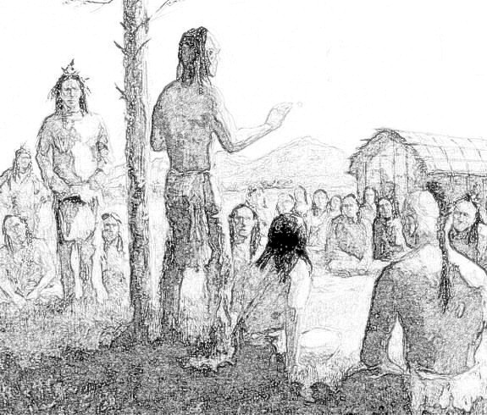

The shaman was trying to figure out what exactly these white pale beings were. The Mahican prided themselves as being some of the best fighters in their area, so the shaman invited the champion of the white beings to fight their best warrior. Nick Carter offered to fight, but Octavio overrode him.

“I am your father, right? So I will have that respect.”

“You have not trained with the minstrel the way that we have” said Nick Carter.

“We’ll see about that” answered his father.

It was a three round match and Octavio lost two of them. He was not too happy, but the Mahican champ strutted around inviting anyone else, so he gave Nick Carter a nod. That match was pretty unfair. Nick Carter was trained in martial arts that no one in that part of the world had ever seen or heard of. He defeated the Mahican champion in every round after which he invited three braves to face him at the same time and he defeated all three with ease. Over the next four weeks the berserkers earned the respect of the native warriors. They won every challenge that was presented to them. The greatest of them was when Waldencraft faced ten warriors and defeated all of them. It became obvious to Romulus and his sons that there was something different about Waldencraft and the grandchildren. Nick Carter told them about the berserker training that they had all undergone. Octavio and his brothers wanted to learn how to fight like that as well. Waldencraft promised that they will at a later time. At the end of each day, they were led into the three large cages were they were being kept prisoner. It soon became obvious to everyone that they could not be forced to do that if they chose not to do so. Romulus even suggested that they just leave, but Walden asked that they wait a little bit longer.

The natives started to believe that they were being visited by some Gods. The elders had a pow-wow at which the shaman said that they had to let the white ghosts, as they were now called, just take their animals and their strange artifacts and leave. That was the day that everything was returned to them and that evening the doors to their cages were left wide open.

“I think that means that they are politely asking us to leave. We should accept their invitation and get moving first thing in the morning” said Walden.

Everyone agreed that it was the right thing to do, so in the morning they saddled up their horses and left. The entire village watched as they rode away. The shaman had tried to figure out what the saddles were actually for and he told the others they were probably for carrying things. So, this was the first time they saw people riding horses. Actually, horses had not even existed in the American continents for a thousand years. It would be a few hundred years more, before the Spanish explorers brought the horse back to the new world. The companions rode away, but after about two miles, while riding on the crest of a hill, they saw about two hundred painted warriors loping towards the village that they had just left.

“I think we should go back and help these people. I feel sorry for them” said Nick Carter.

“I’m in” said Lucius. Lucius was the one always ready for a fight which had gotten him in trouble before.

“Boys, I think we should help. But I made a promise to myself never to kill another human being again.” Said Waldencraft. “I will ride with you, but only if you all leave your swords behind. We can beat these warriors and make them turn tail and run. There is no need to kill any of them.”

Romulus was not very happy about that and neither were his sons.

“Look, you have seen us wrestling with those native guys from the village, but you have no idea what we are truly capable of. As I promised I will help you acquire these skills, but for now, I beg you to stay out of our way and just watch.”

They all agreed although somewhat reluctantly. The plan was to ride around the attackers who were on foot of course, and get to the village before them. Romulus and his sons were to stay with the horses while Walden and the berserkers, wearing only light chain mail, would face the attacking force. Obviously they could not stop the villagers from defending their village, but without the berserkers they had no chance against the large number of attackers.

And that was how they proceeded. Romulus however, intended to watch from closer up, so Octavio being the youngest, was left to watch the horses while his brothers and his father took a position that allowed them to observe the fight.

The villagers had apparently spotted the attackers because they were ready and waiting. The warriors were standing in a loose line facing the direction that the attack would come from. Their only weapons were long stone tipped spears. It was sad to see that they did not even possess any bows or arrows. Their chances against the invading force were just about zero. The berserkers came as a surprise and the tribal champ who seemed to be in command, signaled to his men to let them through. They formed a widely spread semi-circle slightly in front of the village warriors, who moved to form two flanking lines.

The attackers came in at a very fast trot and threw their spears at the defenders. The defender villagers threw theirs. Some of the spears found their targets and a few defenders as well as a few attackers fell down wounded, or dead. One spear went through Lucius’s biceps and another one through Nick Carter’s thigh. It didn’t seem to bother them at all and they advanced into the melee with the rest of the guys. The berserkers, using only their hands and their feet were cutting a furrow through the attacking enemy. Most of the time, it seemed that each one of their blows was felling an enemy. At one point Nick Carter appeared bothered by the spear that was stuck in his leg, so he broke it and pulled it out. Lucius did the same with the one in his arm. Romulus had seen those kinds of wounds before and he was afraid that Nick would collapse. He was surprised to see that it did not bother him at all. Also, he thought there was supposed to be a lot more blood. At the end of maybe 20 minutes, perhaps twenty of the attackers were still standing and seeing that the berserkers were getting closer they turned tail and ran. It was over.

The warriors who were still alive knelt and bowed their heads as the berserkers made their way back to their horses and rode away.

As they kept riding it seemed as if something had changed. The air was somehow wetter and warmer than before. The berserkers were still kind of pumped up from the fight and when Octavio made a comment about that, everyone said they noticed nothing. They rode in a leisurely manner for a few hours when Romulus decided that they could stop and make camp. It was on the side of a gentle hill which would allow them to see if anyone was approaching. They could also see that the river was not that far away, so there would be plenty of water. They did not have any tents, but it was still light out so Walden instructed everyone on how to build some kind of shelter out of leaves and branches. They built a fire and munched on some of the smoked buffalo that they had left. No one was going to catch them unawares again, so they divided the night amongst eight of themselves. There would be two awake lookouts, a hundred or so feet in opposite directions from camp. Walden produced an hourglass at which everyone marveled. He gave it to one of the watch guards. The guard was to wait until the sand poured into the bottom glass, turn the hourglass around and wait for it to run down again. At that time he would wake up the next two guards who would make their way to the agreed locations and repeat the whole thing. That would give everyone else a good eight hours of sleep. The next night, eight other guys would take over.

In the morning, Romulus approached Waldencraft asking for an explanation. He could not quite understand what had happened to his grandsons. They had become amazing fighting machines who did not seem to feel pain and not even bleed very much when wounded in battle.

“Look Romulus” told him Walden “the human mind is an amazing machine. It can do so much more than most people know.”

“So, there is nothing magical about what they are and what they can do, or is there?” asked Romulus.

“No, there is nothing magical. All that it takes is a lot of work and very strong discipline. Not everyone can master these teachings. Actually I was amazed that everyone of your grandsons was capable of learning these things.”

“So, then you could teach me and my sons and help us become like them?”

“I can try, just like I have promised. You do need to understand that Nick Carter studied and practiced for nine years. The rest of them studied with Nick and later myself for more than eight years. I do not think that we have that much time to spare.”

“We will take every minute of the time that we do have and use them to learn how to fight like you” replied Romulus.

“Romulus my friend, I have been alive for a very, very long time. In my younger days, I have killed uncountable beings. It made me lose the one thing that I cared about more than anything else. I have just found her, when I came looking for you and I do not want to lose her again. So I will train you and your sons if you will swear to me that you will never again deliberately take the life of another human being.”

“Seeing you and my grandsons in battle made me realize that there is no need for that. I will swear to that and so will my sons.”

A rigorous day long training program was started on the next day. Romulus and his sons were not very happy with the mind exercises. Sitting zazen and meditating for a few hours seemed to them like a waste of time. However after Walden paired each of them with one of their sons, it became a matter of pride. Their sons could sit for hours, so no matter how stiff the fathers would get, they were determined to match their sons’ abilities.

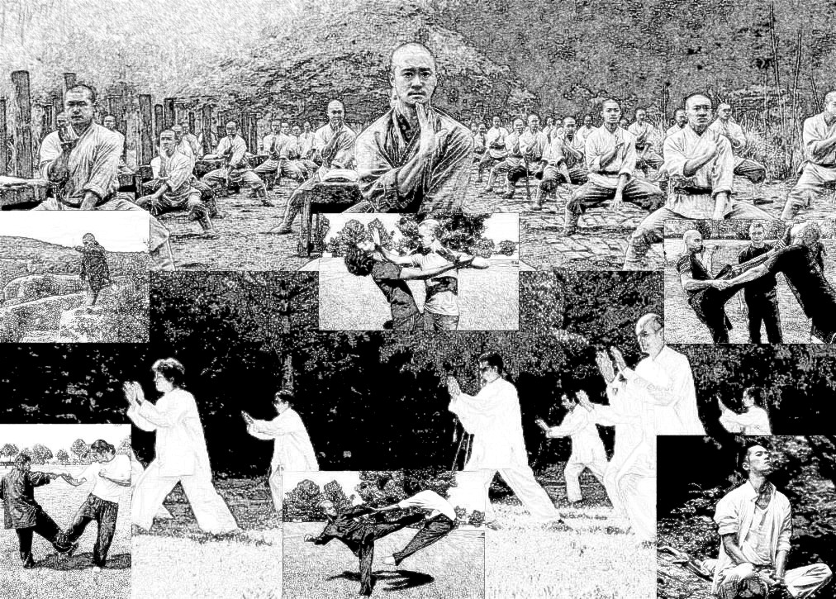

There were twenty-two grandsons so they rotated their training with hunting and exploring expeditions. Hunting was quite easy – there were plenty of stags and buffalos around, so they had plenty of food. The exploring however did not get any results. No matter how far they roamed, they did not run into any other people.

The training went through the same stages that Walden had put Nick Carter through when he was just a kid, but at a somewhat faster pace. After all there was not much else to do, so they trained from dawn to dusk. Octavio was the one who was learning faster than everyone else, and not surprisingly, Romulus was the slowest. They were however all making real progress, and the day came when Romulus finally managed to slice a swinging apple in half while being blindfolded. The training went on for almost a year, but some of them were getting kind of impatient with the waiting. Romulus approached Walden one day about this problem.

“It is not I who controls our fate” said Walden “though I am almost sure that I know why we are here. It is probably that border spell that the elves had created. When you crossed the border with the Christian army, the spell failed. But when our group that was so much smaller crossed back, I guess it worked and it sent us away to here. Fleur de Lys and I have been separated for hundreds of years. I know that now that we have found ourselves again, she will do everything she can to find me. And so, I will wait and the rest you should have faith and wait with me.”

“Well, I sure hope, she is going to hurry up because some of us are getting really impatient.

-%-

“That’s it for now: said Dougie “it’s getting late and I’m getting hungry. Let’s call it a day”.

-%-

They met again the next morning and Dougie wanted to continue his story, but Petunia wouldn’t have any of that.

“We are writing this together and it is my turn” she insisted.

Dougie had to agree that it was fair, so he took the notebook and started writing what Petunia was saying.

-%-

Fleur, Myrtle and Petunia arrived at the Mahican village shortly after the battle had ended. A lot of the attackers had only been knocked out so the village braves were tying them up. A lot of the others had various wounds and the shaman was passing among them, packing the wounds with a yarrow powder and tying leaves around them. Interestingly enough, he was treating everyone equally, friend or foe. At some point his supply of yarrow powder ran out. Fleur reached into one of her saddle bags and pulled out a bag filled with a different kind of powder. This one had been prepared out of a mold that would hundreds of years later be turned into penicillin. Myrtle and Lilia got off their cart and helped as well. After a while, all of the wounded were treated and the prisoners were placed inside cages. The few dead bodies were taken down to the river to be washed and prepared for their journey to the afterlife.

After it was all done the shaman tried to talk to the women and reverted to sign language when realizing they did not understand. He thanked them for their help and explained that some men riding animals similar to theirs had helped them fight off the invaders. He then pointed to the path of trampled vegetation that their horses had left behind. The three women thanked him and followed the tracks. After about two miles, the tracks disappeared. It was as if the riders had vanished into thin air, which is exactly what had happened.

-%-

9 THE LEGEND OF THE WANDERERS

Everyone woke up when the first sunrays tickled their eyelids. They would usually all walk down to the river and splash some water on their faces even when the weather got cold. The lookouts would wait until everyone got back to camp, but on this particular morning, they came back hurriedly announcing that they had seen ten canoes going up the river. The river was wide and peaceful so the canoers didn’t have any trouble paddling their little boats. Romulus assigned two scouts to follow the canoers. The rest waited until the canoes were out of sight before going to wash up. A couple of hours later, the scouts returned, reporting that the canoes had pulled to shore further up the river and the paddlers got out and spent the time spear fish hunting. Apparently, the bend in the river was a very good fishing spot because by the time they started their journey back, the canoes were riding a lot lower in the water, because of all the fish. The canoes continued down the river for a little while and the scouts followed them. The second time they returned, they reported that the canoers had pulled their canoes ashore, loaded the fish onto a pallet and dragged it all the way to their village. The village looked a lot like the one that they had helped defend the previous year. Romulus, Waldencraft and Nick Carter had a little conference and they decided to go and pay a visit. By this time, it had become obvious to Romulus that he could not claim to be the main boss of the whole group. Walden and Nick had to be included in the decision making process.

Just outside the village, they tethered their horses and left a very unhappy Lucius to guard them. When they got to the village, it was obvious that they had been seen. Everyone was waiting outside their tepees cheering them on to the chief’s dwelling. The chief and the shaman were waiting in front of the largest tepee. Three women were behind them, very likely the chief’s wife and his two daughters. Romulus, Waldencraft and Nick Carter were leading the group, so they stopped and bowed their heads in greeting. The chief and the shaman did the same, after which they indicated that the group should follow them. On the other side of the village, a strange sight greeted them. Apparently, someone had spent a lot of time building a group of statues that looked a lot like thirty-two men riding horses. They seemed to be made of dried twigs and straw. To make sure that they got the idea, the shaman kept pointing to the statues and back to the visitors. They all nodded and some even said:

“Yes, we get it. It is us of course.”

At first they had thought that this was a different village, because they did not recognize any of the warriors that had fought beside them. But now, it was obvious that it was the same village.

“What is this all about?” asked Absalom. It was of course the question that was on everyone’s mind.

“I guess, what is happening is that a lot more time has passed in this village than in our training camp. I am not sure how this is happening, but the elves have some very strong magic” answered Nick Carter.

While the men were thinking about it, the shaman motioned that they should walk around the statues. A little further behind the group of thirty-two there were a few more statues. There was a woman on a horse and two others sitting on a cart driven by two horses.

“I guess someone is looking for us” said Walden. “I would bet that the woman on the horse if Fleur de Lys, but I don’t know who the other two might be.

“I think I have a good guess” said Nick Carter “My mom and my sister Lilia always went to town in a cart pulled by two horses. I was born in it, which is why they call me Nick Carter.”

“I kept wanting to ask you about that name, but somehow, I never got around to it” said Octavio. “So, now I know.”

The village was basically a lot of tepees arranged in a circle. There was a large empty area in the middle of them all. Someone had drawn a circle on the ground and one of the village braves dressed in a short leather skirt was standing in the middle of it. The rest of the villagers were squatting around, but they had left enough space for the guests. After everyone was seated, another brave jumped into the circle and the two began wrestling. Only this time it was less wrestling and more of a strange kind of fight.

“Looks like they are trying to imitate some of our moves” said Walden.

Sure enough, everyone could soon tell that they were using some kind of martial arts moves. Apparently the match was over when one or the other of the opponents was thrown out of the circle. A champion emerged eventually and no one got up to challenge him. He stood in the middle of the circle and bowed to the guests invitingly. Octavio accepted the challenge. He took off his shirt and boots and entered the circle. He bowed to the champion and apparently that was a new idea, but the champion bowed back. They sped towards each other and in a classic jiu-jitsu move, Octavio grabbed his opponents arms, and lying on his back he helped him continue his motion throwing him right out of the circle. The champ didn’t seem too upset, he was apparently happy to learn a new move, so he bowed and sat down.

“Hey Nick” said Octavio “I like these people. Let us put on a show for them.”

Nick Carter got up, stripped to his britches like his father, and entered the rink. They stood opposite of each other and bowed. Facing each other they lifted their right arms and touched the backs of their hands. They looked each other in the eye and without any visible signal, they erupted into a flurry of Karate blows that did not seem to find any target. After perhaps thirty seconds, Octavio switched to Kung Fu and Nick Carter followed suit. It seemd that they anticipated each other perfectly because every blow was parried by the other. After thirty seconds more, Nick switched to Aikido throwing Octavio clear across the circle and almost but not quite out. Octavio summersaulted clear over Nick switching to Capoeira. They danced around the circle for a bit ending up facing each other again. Nick stood still with his arms at his side while Octavio started raining some serious punches to his torso and stomach. The blows became so fast that it was hard to follow them. After twenty seconds they switched with Nick raining similar blows on his father’s torso and stomach.

”You did good Father. You are now a match for every one of us.” Said Nick Carter.

They bowed to each other and to the audience that was cheering and voicing coyote barks and yowls. They put back their shirts and boots and sat down again. It was starting to get dark, but some of the women had apparently gathered a lot of wood earlier on because they built and lit a bonfire in record time. Some also brought out a large pot with what they eventually learned was succotash and filled out bowls that they offered to the travelling companions.

“Hey Absalom” said Romulus after they finished eating. “Go relieve Lucius so that he can have a bite as well.”

Absalom came back in a couple of minutes.

“Is everything all right?” asked Romulus.

“Just fine. Lucius didn’t want to come. Some young woman actually brought him some food and was waiting for him to finish eating.”

The women picked up the bowls and the large pot and left. At some point, only a few of the native wrestlers were left, together with the chief and the shaman. The shaman produced a pipe that he lit up with a twig from the bonfire. The pipe was passed around in the circle and everyone took a puff. That was something that had never been seen in Europe, but the berserkers watched and tried to imitate what their hosts were doing. A few of them started coughing, so the rest were very careful while pulling on that pipe. In later times, they found out that smoking that pipe with the natives was a great honor as well as a significant spiritual event. After the smoking was done, the shaman knocked the pipe on his palm and threw the ashes into the fire.

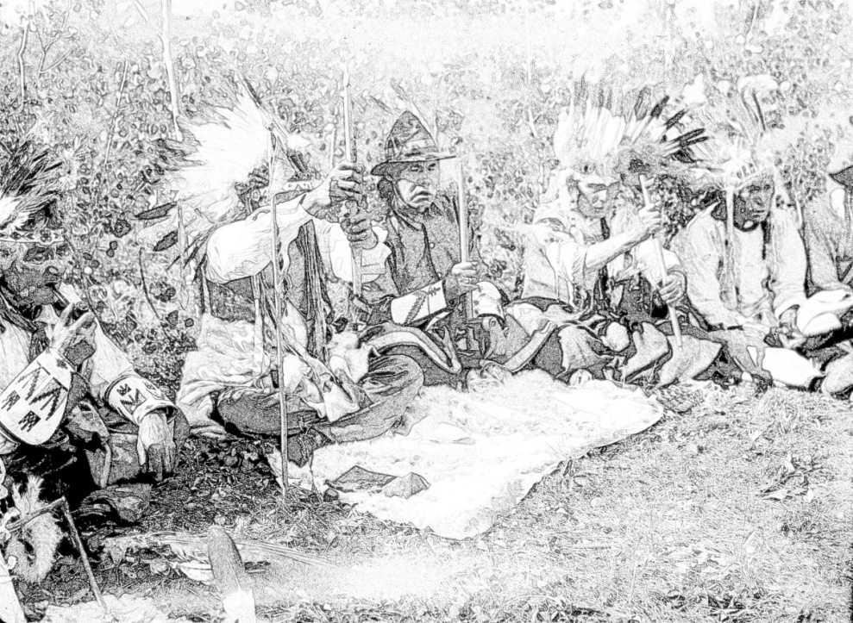

He then presented the pipe to Romulus who seemed to be the oldest of the group as well as their leader. Romulus got up and bowed to the chief and the shaman. He then took the silver cross from around his neck and placed it around the chief’s after which he then motioned to the others that it was time to leave. Waldencraft gave the hourglass to the assigned guards and they all turned in. It was a clear warm night so everyone just found a soft spot on the ground somewhere next to their horse and lay down to sleep.

The next morning they decided to ride on, but first they went to say goodbye to the natives. The village was not where they had left it the previous night. They had shifted again to some other place and/or time. They went back to their horses and got ready to leave when the chief’s daughter showed up. She had fallen asleep hidden behind some bushes. Romulus tried to explain to her that the village was not there anymore, but she did not seem to understand, so he walked with her and pointed that out. She was surprised, but did not seem too upset. They tried to figure out what to do about her and she seemed to understand because she walked over to Lucius and took his hand.

“Well, I think that leaving her alone in a place that we don’t know would be a cruel thing to do” said Romulus.

“Maybe things do happen for some kind of reason” interjected Lucius. “I am the only one of us who is not married or have a fiancé waiting for him back home. Algoma is nice, young and strong looking. It looks like she likes me. I like her too, so she should just come with us.”

-%-

Fleur, Myrtle and Lilia rode into the village on the next morning. The shaman greeted them just outside. It was almost as if he had been waiting for them. They left the cart and Fleur’s horse and walked into the village. All the villagers were out to greet them, but they did not stop until they got to the chief’s tepee. The chief was outside and he greeted them before going back into his tepee and taking the shaman with him. The chief’s wife and other daughter motioned to them to follow and took them to the clearing with the statues. It didn’t take them long to understand that Walden and the others had been there. They sat down for a bit and the chief’s wife took out two straw dolls which she cradled. She pointed to her daughter and to one of the dolls and then she pointed to the other doll and to the thirty-two horsemen.

-%-

“That’s it for today” said Petunia. “Let’s continue tomorrow.

On the next day, Petunia realized that they had hit another little snag and she mentioned it to Dougie.

“You know I like Nick Carter, but I just realized that all of the main characters are from Tuscany which is in Italy, so none of them speak English. How do we explain this name?”

“Good question! I was wondering when you’d figure this out. Actually, you may have forgotten but Myrtle, who is Nick’s mom, was originally from Scotland. I looked that up before I came up with the name. Some English speaking people started moving into Scotland as far back as the 7th century. So, obviously, Myrtle had been speaking English to her son and he became quite fluent in the language. We didn’t cover that before, but Walden is also obviously fluent in many European and Asian languages.”

“Makes sense. Actually, there will be more language issues as we keep writing. Maybe we should give them another year of catching up while they learn some other languages”.

“That’s a good idea” interjected Dougie.

“I guess writing a book makes you learn so many new things. I mean like the medicinal uses of yarrow, the way penicillin was discovered and martial arts and other things” said Petunia.

“Yes, that’s true and it makes it more interesting. But we will still have problems. I mean what about Myrtle, Lilia and Fleur de Lys? How will they communicate?”

“O.K. how about this: Fleur has been alive for a very long time so she managed to learn a lot of languages. Also I think we should send them to Latin America where they can learn Spanish quite quickly because it is so much like Italian”.

“That’s very nice, but it doesn’t help Dahlia at all” replied Dougie.

“Dahlia? Didn’t she stay in the castle under the time freeze spell”?

“Well, we cannot leave her there. If Nick gets back after eighteen years, he will be thirty-six and she will still be fifteen. That’s not fair”.

“Good point, so what happened to her”?

“A new chapter, that’s what happened. Please start writing”.

-%-

10 DAHLIA’S TEARS – pt. 1

Against the wishes of her brother, Dahlia had become one of the best archers in the castle. Since she had turned eleven she would sneak out and follow the huntsmen when they went deer hunting. Gabriel, the head huntsman discovered her only the second time she followed them. Gabriel was turning forty-five that year and somehow he had never had time for courting, getting married and all those other normal things. Seeing how he did not have any children and Dahlia did not have any parents, he kind of took her under his wing. For the next four years, he taught her everything he knew about tracking, hiding and shooting a bow. She also learned how to clean, cook and cure venison as well as other skills needed for wilderness survival. When she moved with her brother, she convinced Gabriel to move with them.

After Nick and company departed, Dahlia kept herself busy for a few weeks. She would ride out to the forest, tether her horse and go trekking and tracking. She would spy a daino, which is a kind of deer and send an arrow into a tree trunk next to it. She did not need to hunt for food and she did not feel like she needed to prove anything to anyone. She would ride back home in time for supper after which she would retire to her room and cry herself to sleep. She kept telling herself that Nick Carter was the strongest warrior anyone had ever known, but she knew that no one had ever returned from Vallonia. One day, she decided that she needed to do something about it and not just wait patiently at home. She put together a bag of provisions, got her bow and a bunch of arrows, her hunting knife and off she rode after leaving a note for her brother.

-%-

“It’s funny” said Dougie. “Tomorrow it is going to be one year since I started writing this story. I don’t know how the time went by so fast. Of course I remember the day, it was on my ninth birthday and tomorrow I will be ten. We’re having cake and stuff, can you come?”

“Yes I guess so”.

“Good, bring your parents and your sisters please”.

-%-

11 BARBEQUE TIME ONCE AGAIN

It was actually a Monday, but Dougie’s parents decided to have an extra barbeque to celebrate Dougie’s birthday. It was the usual kind of affair with the two separate charcoal grills. After they all finished eating, they sang that happy birthday dear Dougie song and got him to blow out the candles.

“Make a wish Dougie” yelled Bryony and Begonia in tandem.

He thought that his last birthday wish had turned out quite well, so he wished once more. ‘Petunia says she’s not my girlfriend, but I think she looks like one. I just wish for this to go on’ and he blew out the candles.

Dougie’s daddy considered this a special occasion. Not only did his son turn ten, he was also going to be skipped a class again. School was starting on the next day and Dougie will now be in the same class as Petunia. It was funny to think that his ten year old son had a girlfriend, but life is kind of like that. You can never tell what to expect. He brought out the bottle of Johnny Walker Blue that someone had gifted him that past Christmas. It was definitely a proper occasion to crack that cork. He was going to have a nicely sized Romeo y Julieta Cuban cigar with it. He passed the humidor around and Gerry declined but to his surprise, Popi took one. He passed her the clipper and they both lit up.

“So, how’s that book coming along”? He asked.

“We used some of your advice and we are going to use more of it, but so far we only have about 25,000 words so we need a lot more. But, since school is starting tomorrow we will have to take it easy with the story for a while” answered Petunia.

“O.K. can you read us what you have so far?” asked Dougie’s mom.

“Hold on a second” jumped in Begonia “I don’t remember where we left off”.

Bryony replied before anyone else:
“Nick and his cousins found the army frozen in time. They met Fleur de Lys and she helped the minstrel remember his name. They released Romulus and his sons and then the entire army. Petunia wanted to write a piece about Nick Carter in the 20th century and Dougie did not like it. We talked about it and daddy suggested a time portal. I think that’s about it”.

“Pretty much” replied Dougie “here’s where it went after that”.

Dougie and Petunia took turns reading the next installment of their story.

“Not bad at all” praised Margareta “I can hardly wait to read the rest of it”.

“And where is Begonia, you promised” inserted Begonia.

“Not done, have a little patience”.

-%-

Petunia and Dougie got to see each other a lot during the school year. They did not however have much time for writing. They met on most weekends, but somehow not much writing happened. They were kept quite busy by the various scholastic projects they had gotten involved in. They did exchange some ideas about their book and some of the things they were learning about in class, eventually found their way into the story. On the last day before December recess, Dougie got into some kind of trouble. This kid named Ralph, seemed to think that he could have anything he wanted. Apparently, he wanted Petunia to be his girlfriend. Petunia was not interested, but that did not bother him. He noticed that she spent a lot of time with Dougie and that bothered him so he gave Dougie a bloody nose and warned him to stay away from his girlfriend.

-%-

Dougie did not want to make an issue of it, but the next day when Petunia came over and she mentioned the incident. Jonas decided that this was unacceptable and he enrolled Dougie into an Aikido project at a local dojo. The sensei, Michael, was a local boy who had studied martial arts in Japan for a few years and had a couple of black belts in various styles of fighting. Well, he was not really a boy anymore, but a man in his fifties. After a career in the contact sports circuit, he had retired to his home town to open a dojo. His son Lemuel was one of his first students and though still in high school he helped run the dojo. Michael was a little on the slim side but he topped six feet and he was a very agile competitor. Petunia had actually modelled Gabriel the huntsman on him. Come summer, the Aikido instruction sessions were moved to the Sturmeyer back yard three times a week. The reason was quite simple – the Sturmeyer and the McTavish families had all joined in the training and Michael’s dojo was not large enough to accommodate that many new students.

Craftsbury is a small community and everyone pretty much knows everyone else’s business - like when Lemuel and Bryony went to the movies together. It was Petunia’s turn to heckle her sister. The funny thing was that Ralph didn’t quite believe the rumors so sometime in February he tried to hit Dougie again and found himself flipping through the air and on his ass when Dougie twisted his palm in a classic move. But, back to December recess. Petunia, had some great ideas about the direction of the story.

“I want to take over Dahlia’s Tears, Dougie. I hope you don’t mind”.

“Go ahead, let’s hear what you’ve got to say”.

-%-

12 DAHLIA’S TEARS – pt. 2

The tracks were a few weeks old, so she did not think that she could use any of that. She knew the general direction that they had all travelled in, as well as the location of the nearest Vallonia border, so she started that way. It took her only a week to reach that border. She crossed over and not long after that she could hear a large group of horse riders passing the other way. She turned her horse around and tried to get closer to them. When they were close enough to discern, she could see Nick Carter, the minstrel and the rest of the group that had ridden away from the castle. There were some other men that she did not recognize, but she was guessing that they were Nick’s father and his uncles She spurred her horse on to a faster gallop gaining on the group until they just disappeared. Her horse stopped abruptly and she flew right over its head. The fall knocked her out.

-%-

Goro and Ayaka had a little 2 acre piece of land on the island of Hokkaido. They could not afford to hire any helpers, but together with some of their neighbors, they could, by helping each other, cultivate rice. It didn’t make them rich, but they could take care of their expenses and they never complained. They had stopped complaining and stopped caring too much after the death of their only daughter. She had been a beautiful and very bright young woman who got drafted to help the war effort for reasons that they never quite understood. What they did understand was that she was killed in Nagasaki by a kind of devilish bomb that had just been invented.

Two years had passed since the terrible day that the A-bomb had been dropped on Nagasaki. Goro and Ayaka were only in their forties, but they felt so much older. Shuffling their feet on the footpath leading to their home, they were very surprised to see a young girl sitting in the middle of the path crying. She looked very strange – green eyes and red hair. What could that mean?

“Goro, I think Amaterasu has sent us a daughter. She cannot be the same as our daughter, but maybe we can be her parents for just a little while”.

“That is quite a silly idea, but she looks like she could use some help, so perhaps we can help a little”.

They went over to the crying girl and Ayaka knelt down and put her arms around her.

“I am sorry that you are sad today daughter. We will try to drive away that sadness from you. Come home with us and let us have a little rice, it will make you feel better”.

Dahlia just looked at her with confusion in her eyes, but she did not resist when Ayaka pulled her to her feet. They walked on home where Ayaka warmed a pot of rice and spooned some into a few bowls flavoring it with a couple of drops of soy sauce.. The taste was very new for Dahlia, but she really liked it.

Japan in 1947 was a country in the process of becoming a different kind of country. In the rural parts of Hokkaido, those coming changes were not making any difference as of yet. Dahlia started working in the rice patch with Goro and Ayaka. It was peaceful and she slowly learned how to speak the local language. Dahlia could not remember her own mother so she was quite happy with the attention Ayaka was giving her. The first words that she uttered in Japanese were to Ayaka and they were:

“Thank you mother!”

It brought tears to Ayaka’s eyes which in turn made Dahlia start to cry again. Rural life in those days was quite simple. It was working in the fields and trying to survive. Once in a while they would have festivals honoring the kami. In the beginning she did not understand what they were about. There was one however, that she really liked. There were drums, fires, dancing and martial arts demonstrations. The one that caught her interest was an archery contest. Her Japanese was still kind of limited, but she made her intentions quite clear when she picked up a bow and wouldn’t let go of it. They let her shoot an arrow and then another one and another one and every one of them went straight into the heart of the target. The cheering put a smile on her face and Ayaka was very happy to see that.

Takahashi-sensei, the master who had put the archery exhibition together, had a dojo in the village and he convinced Goro and Ayaka to let him. train Dahlia. Thus for the next two years, her remaining time in Hokkaido, she trained for four hours every day. The dojo made her feel that she belonged somewhere and her crying fits disappeared just as suddenly as they had gotten started. Takahashi-sensei was practicing a form of ninjutsu that belonged to the Togakure-ryu which had roots that went back to the twelfth century. Over that two year span. Dahlia acquired the skills as well as the tools of a shinobi. It was somewhat unusual for a girl to have that kind of training, but somehow her strange looks and mysterious appearance had worked in her favor.
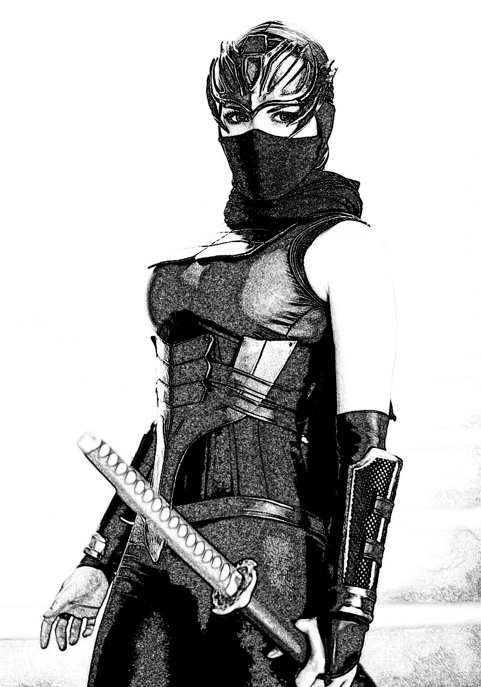

By the end of that period the sensei gifted her a very valuable katana. The katana is a sword made of a million layers of steel and it is given only to the most skillful sword masters. One day when she was walking home from the dojo, the path shimmered in front of her and looking ahead she could not see Goro and Ayaka’s dwelling anymore. She sat down on a tree stump and for the first time in two years she let the tears flow from her eyes. This time she was crying for the loss that Goro and Ayaka must feel when she didn’t come home anymore.

-%-

“That was a cute and clever interlude” said Dougie “when did you learn all that stuff about Japan and martial arts?”

“I googled all of it. I figured, if Dahlia ends up in Japan, I need to know at least a little bit about that”.

“Well done, but I am getting a little hungry. Let’s call it a day and get something to eat”.

“O.K. see you tomorrow”.

“No, don’t go yet. Mom gut some fresh baguettes today so I’m having some peanut butter and strawberry jam sandwiches. I could make you one”.

“Sounds good why not”?

By the time Dougie made the sandwiches it was already six o’clock so they sat down in the living room and turned the TV to the Jeopardy show. Dougie’s parents showed up and Margareta told Petunia that her mom had called and that she told her that the kids just finished working on their book and they were having a snack. After Jeopardy, Jonas was going to drive her home.

“But it’s just a five minute walk and there’s a full moon tonight” protested Petunia.

“There’s also a rumor that we have a hungry bear prowling around the area. Also all the roads got plowed today, so it will only take a minute to get you home”.

“O.K.” agreed Petunia “though I’ll have to say that I do not believe that rumor. Bears hibernate in winter”.

So, they finished their sandwiches, about the same time that Jeopardy ended. Jonas drove her home and was back in time for the end of Wheel of Fortune.

-%-

On the next morning, Dougie walked over to Petunia’s place and as soon as she opened the door, he announced that it was his turn. Petunia did not dispute it so he started right away with a new chapter.

-%-

13 THE BATTLE OF DOODLETOWN

They have moved again, obviously. By now they were almost getting accustomed to it. The terrain looked very much like it did in the previous location, so they found a plain at the foot of a mountain and set up camp. They continued the routine that they had established previously, setting lookouts and sentinels. They sent out scouting parties which encountered no one and saw no settlements within a ten hour walk of their location. There was plenty of wild life and they found some kind of large chicken that was quite tasty. There were also deer and buffalo which satisfied their hungers readily. They kept up their exercises and fight practices, but that left half a day for other things.

Some of the guys developed all kinds of interests to keep them busy. Absalom for example became interested in preparing pelts and furs for use as hats, clothing and shoes. Algoma had some knowledge of cooking as well as the kind of herbs that were edible so she became the head cook. In the mornings Algoma would join in the meditation and Tai-chi exercises but she had no intention of learning how to fight so she would forage around the area eventually discovering some patches of maize with beans climbing all over them. She also found some wild squash and potatoes. Most of these were brand new to the Europeans, but they really loved the new tastes. Lucius would help her a lot of times, teaching her Italian and learning Mahican from her. There was a nicely sized lake not far from their camp and Quintus started spending a lot of time fishing. Turned out that Algoma knew quite a lot about cooking fish as well, but roasting a striped bass was kind of fun and a lot of the guys would do just that on some evenings. Of course some of them started joining Quintus at the lake once in a while. Lucius found a wild tomato plant and when Algoma told him that they were edible he just couldn’t stop finding new ways of preparing them.

Not surprisingly, Walden knew a lot about everything, so he could teach Absalom about tanning leather, Quintus about making a fishing rod, Romulus about making a calendar and so on. He had also decided that since they had some time on their hands, he would start a language class. Couldn’t decide what language to teach them, so it turned into three different classes that were not always attended by the same guys. Most of them attended the Spanish class because it was so close to Italian and easy to learn. Others liked the elegant pronunciation of the French language and a few decided to attend his German class for some reason. After a couple of months of this, Walden took to conversing with his pupils in one of those languages. They would be sitting by the fire in the evening, roasting fish or eating some succotash and he would start talking about something in French or perhaps English or German. Sometimes he would just recite a poem or tell a story, but other times they would have a conversation about something or other. Like the time Nick asked how could they know where in the world they were. Walden answered in English because Nick was already quite fluent in that language.

“My best guess is that we are in the place that the elves spell used to send all the invading armies, before their spell broke down”.

“Why do you think that this is the same place”? asked Nick.

“Not sure, but it is possible that the spell did not work on the large army that your father and brother were a part of. So it did not work on the larger army, but it did work on our much smaller group.”

“So, where in the world is this”? asked Nick once again.

“This is a place that is not yet known to your people, but I have heard stories about it from Fleur. It is very big and as we have seen, very beautiful”.

It seemed to satisfy Nick’s curiosity.

On the next evening Romulus posed a couple of questions.

“I was born in the year 1079. In 1128 when I was 49 years old, I rode to Vallonia with General Lafayette and I was frozen in time for 19 years. We have been travelling for about two years since then so this should be the year 1149. I should be about 68 years old but I don’t feel or look like it. I guess the frozen 19 years do not count. Anyway, do you think it is actually the year 1149?”

The question was of course addressed to Walden so he answered in Spanish this time. It was a language that Romulus was becoming better at.

“I cannot say that for sure. There is no way to guess what year this might be”.

“Over the years I have noticed that the stars in the sky are not always in the same places. I also learned that sailors use them to find their direction. Also I know that back home, the farmers use the moon to tell them when to plant. Why can we not use them to tell what year it is?” asked Romulus.

-%-

“Dougie, you need to stop. All of this stuff is interesting and I would love to know more about it but in the meantime we are getting away from our story. I think we will start to bore our readers.”

“But my mom is going to edit it. She could cut it all out” protested Dougie.

“Which is why we need to say only a couple of words about these things. I don’t think that we need to explain what they ate, how they cooked and all of that stuff. From now on, we will assume that they managed all these things. So let’s keep going – what is a Doodletown?”

“Doodletown is a ghost town in the National Bear Mountain Park. In 1777 it was fairly populated and it was on the way from Stony Point to Fort Clinton and Fort Montgomery. I did a little research, so let me run with it”.

“Let’s go” replied Petunia getting the notebook ready.

-%-

One morning as dawn was breaking, while making his way to the sundial to mark the dawn, Lucius ran into another man. The man was dressed in furs and animal pelts and when addressed in Italian he pointed his musket at Lucius.

“What?” he asked.
Luckily for him Lucius only wanted to talk. They had not seen anyone in a little bit over a year. Also Lucius’s English was really getting there.

“I didn’t mean to startle you” said Lucius “just haven’t seen anyone in quite a while. Would you like to come to our camp for a cup of coffee?”

“I guess, we could do that”.

The sun was coming up and the camp was stirring. They passed by the sundial and Lucius moved the little rock. Algoma had already started a fire and she had hung the coffee pot over it. There were a couple of large smooth rocks around that makeshift kitchen so Lucius showed the stranger to one of them. Lucius said a couple of words in Italian to Walden.

“Good morning stranger, My name is Waldencraft and as you may have guessed we are strangers in this land”.

Algoma started passing coffee cups around while the rest of the family was showing up. The weather was a bit on the warm side so most of them were shirtless showing off a lot of their muscles.

“My name is Joshua” said the stranger after taking a sip from his coffee. “I’m a fur trapper on my way to Doodletown to sell some of my pelts. Are you guys Hessians?”

“As I was saying we are strangers, just newly arrived and we have no idea what a Hessian might be”.

“But you are with the British forces, are you not?”

“Once more, I have to say, to my shame that I have no idea what you are talking about”.

The Wanderers had actually moved again over night. They were actually camped right outside Doodletown. It was the 6th of October 1777. Sir Henry Clinton had landed at Stony Point with 2,100 men just before dawn. The Hessian chasseurs detachment was scouting the route when they ran into the Wanderers encampment. Their scouts reported the find to Colonel Wolfgang.

“Thirty, are you sure?” asked the Colonel.

“Absolutely, commandant” was the answer.

“Good, we can use a little distraction. Captain Gross!”

“Sir!”

“Get everyone ready. We will do this, bayonets only. The boys need to spill a little blood”.

Back at the Wanderers camp, they were all relaxing, drinking some more coffee with their bacon and eggs, when the Hessians arrived. They did not try to hide their movements, after all there were a hundred of them and they felt very confident. They were just going to destroy this silly little group and get on with their next killing spree.

Colonel Wolfgang’s voice was quite loud and everyone heard him say:

“Kill them all” in German of course.

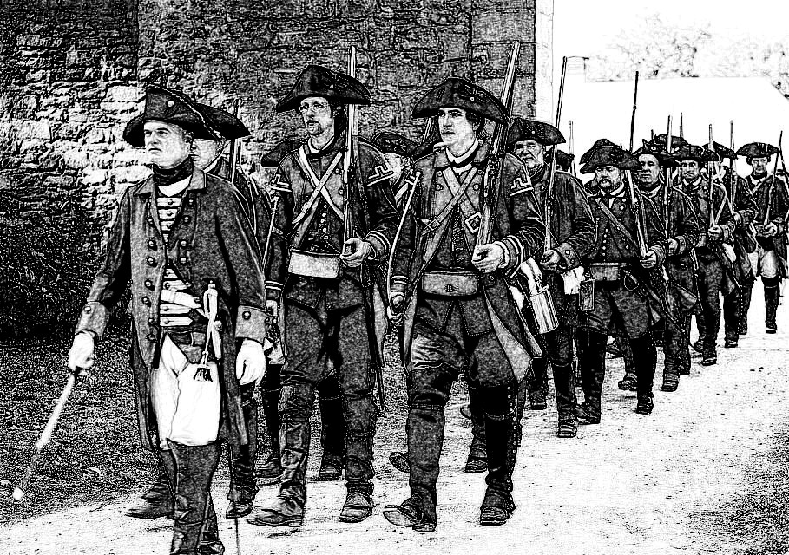

By that time just about everyone spoke some German, so they were not really taken by surprise.

“Dump kopf (meaning dumb head)” retorted Walden while the Wanderers exploded into action.

The fur trader was really scared and he just couldn’t believe it when Algoma calmly asked if he’d like another cup of coffee.

At first he thought she was kind of stupid, but looking around and seeing what was happening, he changed his mind. The entire battle lasted less than 10 minutes. At the end of it, most of the 100 Hessians were lying on the ground. A lot them were unconscious, but some were just moaning. Colonel Wolfgang was one of the ones standing and when Walden walked up to him, he pulled out his pistol and shot him. The bullet went through Waldencraft’s right biceps and he didn’t even break stride. As he got close enough, he slapped the Colonel’s left cheek leaving red finger marks.

“What is wrong with you? He asked him in German. I have left everyone alive, would you prefer that I kill all of you? You have no idea who I am. The men you have attacked are my pupils and each of them is worth twenty of your men.. Your pupils, if that’s what they are, have learned nothing. I could easily kill every one of them if I so chose. Pick them up, leave and never come back”.

The Hessians gathered their wounded and left in a hurry to join their British employers. It took six more years of fighting but the British with their hireling Hessian dogs eventually had to concede the fight.

“That was a new kind of weapon” exclaimed Octavio after the Hessians had left.

“It is one sad thing that we can always count on” replied Walden. “People are very bright and one of the main occupations for their brains, is inventing new weapons”.

While they were finishing their breakfast, and binding Walden’s bicep, Joshua was full of questions.

“Why did you not kill all of them? I think you could have”.

“We have decided to try hard to not kill” replied Walden,

“Who exactly are you guys?”

“Just some people, replied Nick”.

-%-

“I liked it” said Petunia.

“Hold on - that was just outside the town. The Battle of Doodletown is just coming”.

-%-

After a while, Joshua said that he was going to get going on to Doodletown. Apparently it was only about five miles away. Nick decided that he would love to learn more about where they were. Walden and Romulus said that they will accompany them. Nick gave Joshua a ride on his horse and they all ended up at Doodletown’s only saloon: The Rosette. Walden had a couple of old gold coins, so he figured they might be enough to buy them a few drinks. They sat down at a table and Joshua got them a bottle of whisky. Sadly, they had a little too much whisky and they were not used to this drink. They were just nodding off when the commotion started. Joshua had gotten into a card game and he was winning. One of the losers accused him of cheating and tried to hit him. Joshua ducked, picked up his winnings and came back to their table. The sore loser followed him and tried to make his point by pulling his pistol. He was actually standing too close to Nick when he did that. Nick just grabbed the back of his neck and smashed his head against the table. It would have ended just like that, but it seemed that Joshua had said too many things about his new friends. Walking out of the bar to get to their horses, they encountered some people who were not happy with what had happened. The one that Nick had knocked out, was awake once again.

“We’re gonna get you boy. Are you with the Brits?” he asked.

“Not sure what that means. I am with my friends and my family”.

“Well we are with Mad Anthony Wayne and we swore to kick the British off this land”.

“O.K. so do that, I am actually from Tuscany”.

It didn’t mean anything to any of those guys, so they formed a circle around Nick.

Joshua had come out with them, so he asked Walden:

“Are you guys going to help?”

“Joshua, there seem to be only twenty of them, they are the ones who need help”.

Yeah, it was a no contest whatsoever, fifteen of them turned tail and ran after only five minutes. Five were still out cold. Nick was walking back to his horse smiling drunkenly, when the first guy snuck up behind him and shot him. It was despicable. Nick turned around, dropped the guy to the ground and was going to rip out his throat when Romulus grabbed his hand.

“No son, we promised not to kill”.

“I’m not your son” replied Nick.

“But you are the son of my son and I love you. Don’t do it”.

“What is your name?” asked Nick of the man on the ground.

“My name is Anthony” he replied.

“Anthony, my grandfather has just saved your life. Don’t waste it”.

The fur trapper ran back in and came back with a bottle of whiskey which he gave Walden.

“It will come in handy when you take that bullet out” he said.

Nick stood up and they all rode back to camp. When Algoma noticed the blood on Nick’s shirt, she grabbed Lucius and they went looking for some yarrow flowers. The bullet was in Nick’s shoulder. He took a few swigs from the whiskey bottle, before Walden poured some on the wound, took the bullet out and stitched it. Algoma and Lucius came back with some yarrow flowers which Walden applied to the wound before binding it. Algoma insisted that she needed to look at Walden’s arm. The bullet had passed straight through leaving a clean flesh wound and Walden said it only needed a little healing time. Still Algoma put some yarrow on it and re-bound it.

-%-

“And that is that - let’s call it a day once again, good night Petunia”

“Good night Dougie”.

-%-

Petunia came over to Dougie’s house the next morning after breakfast. They had a few more free days so they could write some more.

“I know where Dahlia is going to go” she told Dougie “start writing”.

“I don’t think so” replied Dougie “before we continue with Dahlia I want to add some more things that will make it easier for our wanderers to get around. I actually had a dream about it and I think it will work”.

“O.K. but a little explanation would help” said Petunia.

“Well, we know that The Wanderers are eventually going to make it back to their castle and their families in the 12th century. I think, that the events we are writing about will be handed down to their descendants and of course they will be getting kind of confused as time goes by. But, they will not be forgotten”.

“O.K. keep talking and tell me why now?” asked Petunia.

“As time goes by, and things become more civilized and modern, The Wanderers will run into more and more difficult situations. They do not have much money and in the 21st century, using antique coins will raise all kinds of issues. So, they are going to need help”.

“Funny, I think this means that we will keep the Nick Carter in the 20th Century bit”.

“I think so, but let us get to that later. How about you write and tell me if you like it”.

Petunia opened the notebook without another word.

-%-

Back in Doodletown, Joshua finally decided to take care of his fur business. He took his furs to his usual buyer. Mario Pietrapiuma. Mario was sitting behind the counter looking over his account book.

“Good day Mario”.

“And a good day to you as well Joshua. What have you got?”

Joshua threw his bundle of furs and pelts on the counter.

“Not bad, but I expected more from you after three months”.

“Well, the winter was harder this year and I swear these animals are getting smarter and harder to trap”.

They went on dickering about the price, which was a usual kind of thing. In between, Joshua threw in bits and pieces about the strange fighters he had met.

“Tell you what” said Mario “you take me to these guys camp and we have a deal”.

It was actually more than Joshua had expected to get, so he readily agreed. They agreed to meet in the morning.

“Tell me Joshua, are you a God fearing man?” asked Mario as they were riding.

“Well, I figure, if He stays in His heaven and I stay in my forest, we’ll be just fine. Whenever He’d like to talk with me, I’ll gladly converse with Him, but I have no love for all these Bible thumping crooks. Most of them just trying to get my money”.

“I’m glad you put it this way. What we’re getting into might be a little bit confusing to a regular fella”.

They got to the camp just as Algoma was pouring coffee for everyone. Joshua introduced Mario, who wasting no time, jumped off his horse, walked over to Algoma and grabbing her right hand he placed the back of it on his forehead.

“Algoma, I can’t believe that you are real. The stories were true!” he said in Mahican.

“Take it easy you fool” said Lucius in the same language “you almost made her spill hot coffee all over you face”.

“Lucius” replied Mario in Italian “boy, is this a story that I will tell my grandchildren”.

It was really early, so most of The Wanderers were just stepping out of their tents. Walden was one of the first.

“Waldencraft, Sir it is an honor to meet you” said Mario in English “and I believe you may be Romulus and Octavio” he added when the two showed up.

“This is going to be fun” interjected Nick who was listening to it all from one side.

“And Nick Carter, my goodness” added Mario.

Joshua, was listening and watching all of it with a quizzical look on his face.

“Relax, Joshua” said Algoma after extricating her hand from Mario “have a cup of coffee. Strange things happen around these people, but I have learned that there is nothing to be afraid of”.

“So, Mario” started Walden “tell us your story”.

“Oh, I guess I will have to start in the year 1600. More than 100 years before that, an Italian named Cristoforo Colombo found a new world that he thought was India. Another Italian named Amerigo Vespucci eventually convinced everyone that it was a mistake. What Colombo had found was a brand new world. It is why this new world is named after him and not after Colombo. Anyway, my great-great-great whatever grandfather Luigi, was fascinated by it. There is a legend in our family about the 32 who went missing and came back after some fantastic travels. We had a very large family in Tuscany and most of them would listen to the legends and laugh. Every family has legends, most of them would say. Luigi, actually believed them. The way it was told to me, he was from the Pietrapiuma branch of our family and everyone thought that we were a bit cuckoo”.

Mario took a sip from his coffee cup.

“It is good to know that the Pietrapiuma are not insane” he said “I am so happy to meet all of you. So, Luigi knew that the new world was the one that has been spoken of in the family legends. It took him nine years, but eventually he managed to get a spot on Henry Hudson’s first expedition that sailed up the Hudson River. Everyone knows about Henry Hudson’s expeditions, but the history books, do not mention Luigi. When he disappeared somewhere around Albany, he was quickly forgotten. But he did not disappear, he just decided to stay when Hudson’s ship left.
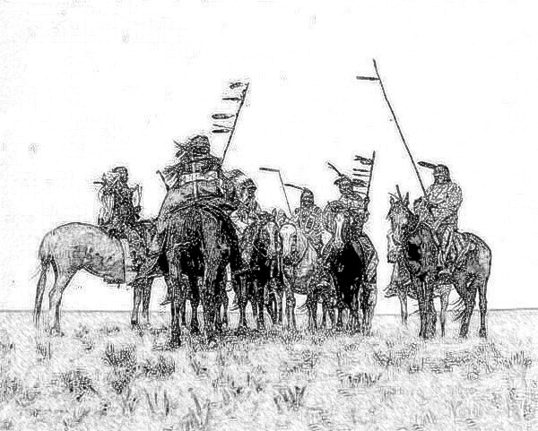

Luigi looked for the Mahican people and found them. He stayed with them and learned their language and their customs, got married and had children. He insisted that his children have to learn how to speak Italian, so that they could speak to The Wanderers when they came back again. The tribe was not happy with that, but he was stubborn.

Sometime around the year 1620, some Dutch merchants opened trading posts along the Hudson River. Luigi found out that a few of them spoke Italian. They were confused, but at the same time happy to find an ‘Indian’ who seemed more ‘civilized’. Around 1630, Luigi had saved enough money to buy a little piece of land from a Dutch merchant who was going back home. He moved his wife and kids into his new home, but his two sons could not get used to this kind of living so they moved back to the Mahican village. He also had a younger daughter, Adsila, who was too attached to her mom to leave. Luigi’s connection to the Mahican tribe was very good for business and his family thrived. Luigi visited the tribal village quite often and Adsila loved to accompany him. He would transact all kinds of business, while his daughter was just roaming around the village. One young brave was fascinated by her and he insisted that he’d like to learn how to speak Italian and could she teach him. So, she started giving him lessons. This went on for a while until eventually, the brave whose name was Chicago, asked her parents for her hand in marriage. Luigi was hoping that Adsila would marry a Dutch merchant, but his daughter insisted that they were in love and so they were married. It turned out to be a very lucky development. Chicago in Algonquin means wild garlic and Adsila and her husband turned into amazing cooks mostly thanks to the wild garlic that Chicago had a keen nose for. Chicago took the Pietrapiuma family name and he moved in with his in-laws. People in Doodletown were not too happy with an injun living in their midst, but Luigi was a very clever sort of individual. He eventually convinced just about everyone in town that Chicago was mostly Italian and that he was a descendant of an original crew member of Christopher Columbus’s sailors. It was far-fetched, but no more so than Luigi himself being part of Henry Hudson’s exploratory group. Chicago also had a very old looking silver cross that he wore around his neck and showing it to doubters would further confuse them. Luigi helped the young couple open a saloon. A lot of the protestant Dutch merchants frowned at the possible drunkenness and mayhem that would be caused by drunk patrons. Luigi managed to calm most of them down by suggesting that it was time they had some kind of law in town and that they should elect a Sherriff.

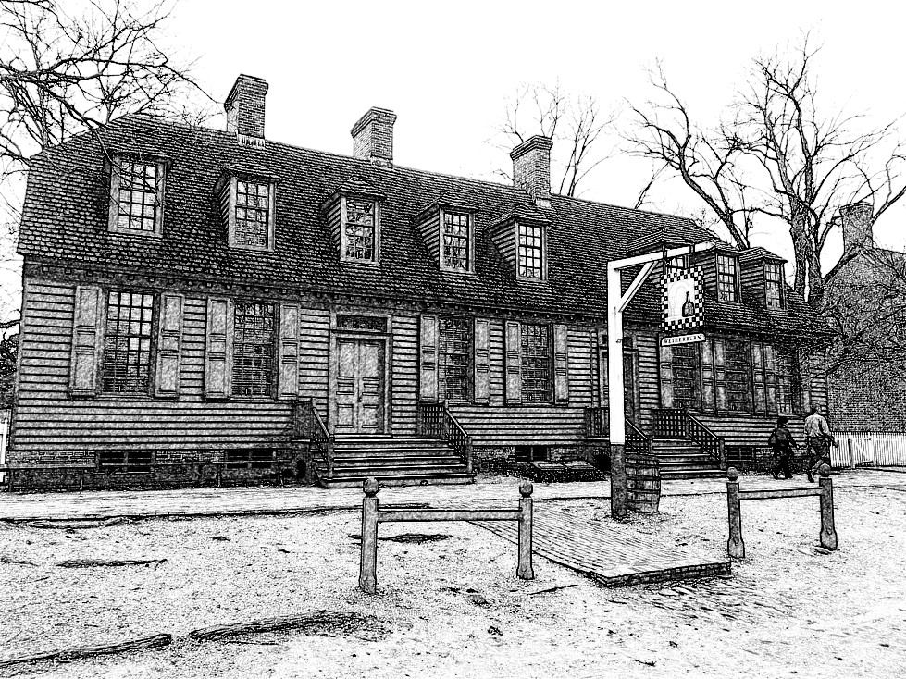

The saloon thrived, especially after they turned a part of it into a restaurant. Adsila and Chicago’s cooking skills eventually drew out a lot of the merchants and their wives for Sunday dinners. Actually, I understand that some of you have visited The Rosette – it is still in our family. If you decide to go back, you have to try some of their cooking”.

“That is quite a tale” said Romulus “but how exactly does that make a difference to us and to our predicament?”

“Well, first try to remember that we are family even if somewhat distantly related. I am one of your descendants and a family takes care of its own. We don’t know exactly how long it has been since you have visited our Mohican ancestors. We only know that you have done that on two different occasions. We also know what the legends say, but they were also not clear about the timeline. So, The Pietrapiuma family has been awaiting your arrival for one hundred fifty years or so. Now that you are here, you need to know that we can help you with anything that you need help with. For example money”.

Mario reached into his pocket and pulled out the two gold coins that Walden had used to pay for their drinks at the pub. He handed them over to Waldencraft while saying:

“You do not need to pay for anything at The Rosette. Also, you have been travelling fo a long time, if you need new garments, shoes, weapons or anything else, I will help you get them”.

“That is good to hear” replied Romulus “ actually some of us might need a few things. Though we have not been travelling for as long as you might think. Whatever happened to time, makes it seem to us as if no more than three or maybe four year have passed since Waldencraft and Fleur got us out of the time-spell”.

“Speaking of Fleur” jumped in Octavio “there seem to be three women following us. What do you know about them?”

“They are Fleur, Myrtle and Lilia” he replied “they seem to show up shortly after your group leaves”.

“Well, when they show up, please tell them what you have told us and help them as well”.

“Of, course” answered Mario “they are also a part of my family. One last thing that I know. It is a part of the legend that does not make much sense. It says that you have been – or should I say will be – someplace where people can fly. They can also talk to each other even if they are at opposite ends of the world. It is also said that after that, you went back home. A man named Elvis is waiting for Lilia in the year 2018 and he will go back with her”.

“Well, so far we seem to travel into the future of the world that we were living in” said Waldencraft “I guess, we will get there eventually”.

Mario reached inside his shirt and pulled out the cross that Romulus had given to the Mahican chief all those years age.

“The cross that Romulus had given Abooksigun has been in our family for a long time and I will pass it on so you will always know our family”.

-%-

“This is what I have this far” said Dougie.

“Actually, this is really good. It solves a lot of story problems also explains some things that we haven’t gotten around to explaining. How did you come by it again, a dream? That’s funny”.

“So, my mom loves 70’s pop music. One of her favorite songs is Tuesday Afternoon by a band named The Moody Blues. Yesterday evening she took out her vinyl copy with that song on it and placed in on the turntable – yes we still have one of those things. Somehow, I find her music quite interesting. I picked up the album cover and the name of it is Days of Future Passed. I started thinking and it occurred to me that what we need is legends and prophesies. And then I thought what if prophesies were actually stories about Days of Future Past? I fell asleep with that idea in my head and the things that we just wrote were pieces of that dream”.

“Good, let us sleep on that again tonight and see what we can come up with in the morning”.

-%-

On the next morning, Petunia insisted that they had to continue Dahlia’s story.

“Maybe, but first we have to write a few words about the Ladies” said Dougie.

“I guess that is fair” agreed Petunia “go ahead”.

-%-

It was becoming a routine. The Ladies always showed up just a little bit after The Wanderers were gone. The tracks were obvious and it did not take an expert to realize that a large group of men and their animals had been camped just in front of them. They looked around for clues, but didn’t find anything other than a trail that seemed more travelled than the rest of the place. They decided to follow it. It took them to Doodletown of course and Mario, who had been expecting them, came out to greet them.

“Good day, Ladies! My name is Mario Pietrapiuma and this is Doodletown. The year is 1777. Octavio and Waldencraft both send you their regards and the latter had actually left you a note Princess”.

“Just Fleur would be fine” she answered “is there a place where we can sit and talk”.

“Actually, my daughter Adsila and her husband Chicago are running a very nice place just around the corner. Let us go and have lunch there”.

They walked over and Fleur tied her horse in front of the saloon. Myrtle did the same to the ones pulling the carriage and they walked in. Adsila came out of the kitchen and showed them a basin behind a curtain where they could wash hands.

While waiting for the food Fleur unfolded the note from Walden.

“My dearest Fleur” it read “I know that Myrtle and Lilia are with you. From that I can guess that you must have placed the castle into a time freeze, so that Romulus and his sons will be of the right age when they get back home. Since they were frozen for almost nineteen years, I guess we still have a long way to go. I am not sure how that is going to work for Myrtle and Octavio, but I know you will figure that out. I wish you could all be with us, but then I guess Myrtle will age at the same rate as Octavio, so that will not quite work. I know we will all be re-united someday. After you listen to Mario’s story you will know that too, even though he is a little sketchy on the details. Many things have happened since we’ve last met, but I guess we’ll have plenty of time to exchange stories when we meet again.

Until then, forever yours
Waldencraft.”

She summed up the note for the others and then Mario told his story, while the Ladies were eating.

“So, just how long ago did The Wanderers leave?” asked Lilia.

“Well, I am surprised that you did not run into them while coming here. That’s how long ago” replied Mario.

-%-

“O.K.” said Dougie “so that was that and now we move on”.

“Yes” said Dahlia. The new chapter is:

14 ATTACK OF THE MONGHOULS

“Spell that m-o-n-g-h-o-u-l-s “ said Petunia.

-%-

Gabriel was tracking Dahlia when he came across a young woman dressed in black and wearing a black mask. A bow and two swords were swung around on her back and she was sitting on a large rock by the side of the road crying. Like most people that he grew up with he was quite superstitious, but unlike the others, he was not afraid. He pulled out an arrow and cocking his bow he aimed it at the woman in black.

“Who and what are you”? He asked her.

She was obviously quite distressed because she had not noticed him until he spoke. Looking up and seeing him she stood up and tried to walk towards him while saying:

“Gabriel, is it really you”?

“Do not take another step” he said pulling back harder on his bow string.

“Gabriel, it is me, Dahlia” she retorted. “Oh, sorry, I forgot about the mask” and she pulled that down.

He looked at her face without loosening the grip on his bowstring.

“You do look a lot like Dahlia, but she is younger than you are. You might still be some kind of demon”.

“No, Gabriel, ask me some question about our castle, about Nick Carter, or anything else”.

He asked her the names of her sister, her brother-in-law, Nick’s mom’s name, his dad and more about the minstrel and Vallonia and Romulus and the crusades. She knew all the answers.

“Sit back on that rock and do not make any sudden moves. I will lower my bow, but since you say you know me, you will know that if you make any sudden moves, I will put an arrow in your chest faster than you can say please don’t”.

She did as she was told.

“So, tell me what this is all about”?

“Nobody has ever come back from Vallonia, so I decided that staying at the castle waiting for Nick to come back was not my best move. I do love him. So I snuck out and went after him. The tracks were very old, but I knew the direction to Vallonia, so I went that way. After a week maybe, I thought that I had reached Vallonia’s border. It was a place where the flatlands gave way to a thick forest. I entered the forest and less that a few hours ride, I overheard a group of riders. I made my way quietly, the way you taught me and eventually I could see that it was Nick with his cousins, the minstrel and a few other people that I thought might have been his father, uncles and maybe his grandpa. I ran back quickly to get my horse and followed them. They rode out of the forest and I was only a few minutes behind them, but they were gone. I tried to follow their tracks but the tracks ended only a few feet outside the forest. As I was riding around I guess I was not paying attention, because my horse got spooked and threw me. It did not get hurt, but Nick was gone and suddenly I got very sad and I started crying. A very nice couple found me like that and they helped me up and took me to their home. They kept talking to me but I didn’t understand a word they said. Also they did not look like anyone else that I have ever seen. Well, they kind of looked like that, I mean they had feet and hands and hair and so on, but their eyes were like they were always squinting. I stayed with them and very slowly, I learned their language. It took me a while to believe them, but it was the year 1947 and I was in a country called Nippon. I stayed there for almost three years I think. Your archery training helped me. A kind teacher took me under his wing and trained me to become a fierce warrior. He said that it is not always necessary to fight, but some demons are inside people and knowing how to fight helps one conquer them. In these last three years I have become a shinobi, or as some people say a ninja. I thought I had become really tough and I had gotten used to the fact that I may never see Nick again and then today my sensei honored me more than anyone can ever imagine. He presented me with a real katana. As I was leaving the dojo, everything became kind of blurry and disappeared. I found myself here and thinking how the poor couple that took me in might feel I started crying”.

“There were some words I did not understand, but you can explain them to me later. I believe you. The day after you left, there was a big to do at the castle. We looked for you everywhere and eventually one of the stable boys told us that he saw you saddle your horse and ride off with your bow and a bag of provisions. There was no way, that I was not going to follow. I tracked you all the way to the Vallonian forest and then into it. I also found where you had turned around and started to follow a large group pf horse riders. I followed the tracks and just like you said, they just disappeared. Your tracks however did not. I just kept on following you until I found you just where you sit right now.”

“That is kind of strange. I guess for you only a few weeks had passed. Is that right”?

“Yep”.

“Then if I can go so far into the future and spend three years there and you can just follow me and find me as if I had just left, I don’t know - what does that tell us”?

“As weird as that might sound, it tells us that time is not at all what we thought it is. We can travel through it and also it does not pass the same way for everyone”.

“Thank you Gabriel. That makes me feel like I might still be re-united with Nick Carter someday”.

They set up camp for the night and Gabriel went out and shot a couple of hares which they proceeded to roast and eat for dinner. They buried the left-overs a bit away from the camp, so as not to attract any predators. Before going to sleep, Dahlia had to take care of some nature calls. Once again, she buried everything just the way Gabriel had taught her. You try to leave as little as possible that might help wild animals track you. In the morning, Dahlia showed off some of her weapons. The Japanese bow was nicely made but not much different from the one Gabriel was using. The katana and the wakizashi were a totally different story. Gabriel was most impressed. She then showed him her nunchaku, but he’d seen those before. The minstrel had taught Nick and his cousins how to use them. The shuriken were another impressive weapon especially when he saw the accuracy of Dahlia’s throws.

They spent a few months moving on with no particular goal in mind. Just following along a little stream. Dahlia would do her kata every morning and Gabriel decided to join her. The kata that she was performing was a special exercise designed by Takahashi-sensei. Gabriel proved to be a good student and by the end of six months, he could hold his own against many skilled opponents.

-%-

“That’s it for now. I’m going home for a late lunch and after that I have to catch up with some things. I’ll see you in the morning”.

-%-

“Good morning Petunia. You know I am wondering sometimes if we are straying too far with our story. I mean we are actually all over the place”.

“I really have faith in your mom’s abilities. I read some of her books and she is quite good, I do not think we should worry too much about that part”.

“That’s nice – then keep going” replied Dougie while opening the notebook.

-%-

One morning as they were following the stream which by now had become a little river, they were attacked by a strange looking beast. It was so quiet that they only noticed it when it pounced upon them with a loud roar. Dahlia’s Katana swung out of its holster as if of its own accord and slashed off one of the beast’s limbs. The beast shuffled off on its three remaining legs. It seemed to be shaped like a human, but it was naked, covered with a hairy pelt and walking on four legs. As it ran it made an awful racket. The noise attracted some others and about ten of them encircled Dahlia and Gabriel. They were certainly not of a friendly disposition so the two, strung their bows and started shooting arrows into the group. When Dahlia ran out of arrows she threw her shuriken, but those ran out as well. It seemed that for everyone they dropped, two more showed up. Dahlia had drawn her katana and Gabriel was using the wakizashi that she had given him earlier. The wakizashi is made in the same process as the katana only it is a little bit shorter and made for a one-handed grip. Gabriel made good use of it and they kept hacking at beasts for what seemed like hours. Luckily for them, when so many are trying to get at only two opponents, they keep getting in each other’s way and many fights got started amongst the beasts. Still, after two hours, they were getting a little tired.

“I don’t see any end to this” said Gabriel “I’m sorry that we will not get to go back to castle so that you can marry Nick Carter”.

“A ninja only fights if there is no alternative. But if fighting is necessary, a ninja never gives up. The only way I will give up is when I’m dead” replied Dahlia “please do not give up. Even in the darkest hour, there is hope, we only need to see it”.

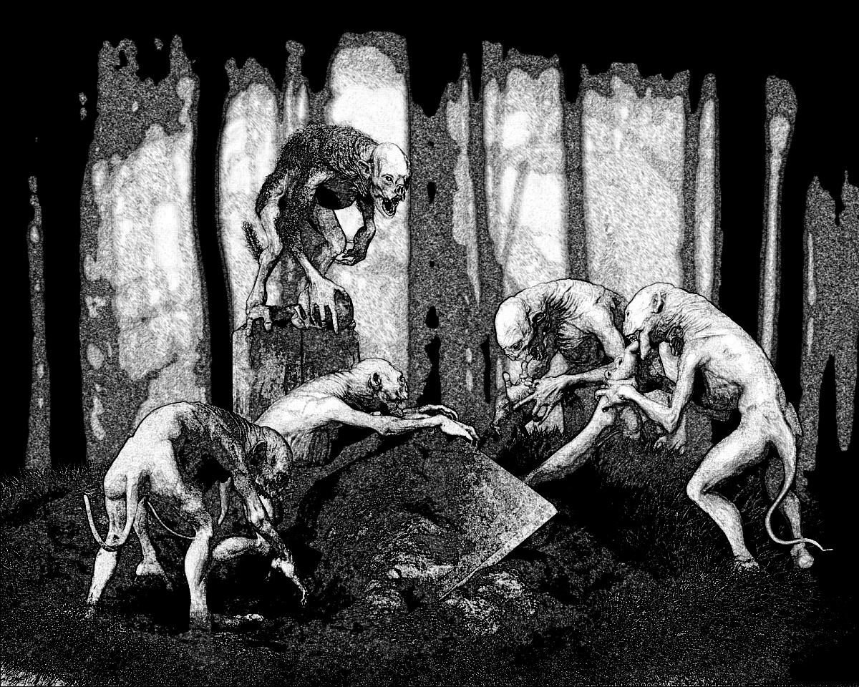

They were standing back to back when they had started fighting and they slowly inched over to a beautiful willow tree that was growing not far from the river bank. Eventually, they put their backs to the tree trunk. It made them a little more difficult to get to.

“If we climb the tree, we will become a much more difficult target” said Dahlia “let’s seize the next opportunity and jumped right up”.

That opportunity came only five minutes later when three of the beasts got tangled and started biting and scratching each other. Gabriel and Dahlia were up on that tree in a second and they climbed up to the tallest branch that seemed sturdy enough to hold them. The beasts did not give up. They had no problem climbing right after the two. But they now had a much better position and they could easily chop off heads or limbs that caused the beasts to lose grip and fall to their deaths. This went on for a couple more hours. The beasts had no strategy and they were very bad fighters, but they just kept on coming.

“I hope they will need some sleep or food or something, because I could really use a break” said Gabriel.

“Let us hope so, because we will also need some water pretty soon. My flask is almost empty” replied Dahlia.

“Yeah, so is mine”

“Well, we will keep on, for as long as possible” said Dahlia.

“You had a really great teacher” said Gabriel.

“Teachers” replied Dahlia “and you were the first and I thank you for it”

-%-

“I think I am finally stuck” said Petunia “I don’t know how to save Dahlia and Gabriel from their predicament”

“We’ll think of something, but even if we don’t, just don’t forget this is our book. We can just erase the whole ghoul episode and make it so that it didn’t even happen. But you know what, I don’t think we should do that. A fight scene makes it a bit more interesting and these were not even people so, it’s probably in keeping with our resolution. Besides, I have an idea. We will leave them up in the tree and get back to The Wanderers for a bit. But before we do that, I have a question. Do you mind if we add some pictures?”

“I don’t know. But why pictures?”

“I’m not sure” said Dougie “I just like pictures”.

“Well let me see some and we’ll talk about it”.

“O.K. how are your sisters getting along with the typing?”

“They’re just about caught up. I also had them type it up in Word, so we can add pictures quite easily”.

“O.K that is very good. So, here’s a new chapter:”

15 AN IMAGINARY TRAIN

Begonia was a young beautiful, intelligent girl. She had pretty much taught herself how to read at a very early age. Being a girl in the second half of the 19th century did not entitle her to an education. She also had a second and probably more serious handicap. She was born in Charleston, South Carolina and she was black – that automatically made her a slave. But her life was not really that bad. Though she was born on a plantation, she had never picked even one speck of cotton. The owner of the plantation also known as the planter, had only one daughter. His wife had died in childbirth and he never re-married. He loved his daughter, Flora with a passion, and he wouldn’t deny her anything. One day when Flora was perhaps three years old, she saw Begonia and pointing at her she said:

“I want”.

That was good enough for her daddy. From that day on, Begonia became Flora’s inseparable companion. They would play together, bathe together, and even sleep together. They were very close in age, but when they turned eight or so, some differentiation started to take place. Begonia was taught how to do Flora’s hair, how to dress her and how to groom her. She did not mind and she was happy - because of Flora she could read so many books. Books were beautiful, they could take her to places that she had never seen, and they made them seem so real. Walking around the estate grounds the two of them were quite a sight to behold. The blonde, white skinned Flora and very dark skinned, black haired Begonia seemd almost like the reverse images of each other, but somehow both very beautiful. One day, Begonia was by herself passing by the stables, when one of the stable boys jumped up and grabbed her.

“Kiss me, pretty Begonia” he said.

“No, you smell bad” she replied.

He was not very happy with that, so he slapped her hard across the face.

“You need to remember, that you are still a slave, just like me. Don’t pretend that you are any better”.

It made her think about her life. Eventually, she came to the conclusion that the stable boy, was right. She had always known that she was a slave, even though it didn’t come up in conversation, but she had overheard some things. It was only a matter fo time, before Flora got married, had children and went on with her life. And what about Begonia? There was nobody else who would really care. From that day on, she started mingling with the other slaves whenever she had an opportunity. Strangely enough, that stable boy who had tried to kiss her, was the one who gave her the idea. A few of them were talking behind the stables and he said:

“There are places in the North were black folks are free just like the white folks. If we could get out of here and maybe get on a train, we could ride all the way to freedom”.

She didn’t say anything, but she kept listening and slowly she learned about the Underground Railroad. It sounded unbelievable, but some of the books she read sounded even more outrageous. Like that story about the Gulliver fella. There were no such places - or where there? Maybe she needed to get out of there and find out for herself. She bided her time and kept her ears open. One day, her patience was repaid. A strange black man snuck into their stables and she was there to hear him talk.

“It is true” he told them “there are places in the North and also in other parts of the world, where people like us are free. You can have your own farm, your own family and that might even be next door to a family of white folk, and they would be fine with it”.

“But, who are you?” asked Begonia.

“My name is Justus Solomon and I used to be a slave just like you. But now I am a conductor. I am a conductor on the Underground Railroad, so I can get you on board that imaginary train to freedom. Only it is not imaginary, but it is not always a train. If I get caught they will probably hang me, but I would like to help as many slaves as I can before that happens”.

And so it was that on that night, Begonia and three other slaves, left with Justus. One of them was her stable boy. She still did not know his name and didn’t care to learn it. As much as he was a fellow slave, there was something about him that she did not like. The Underground Railroad travelled a long and winding route. They went by horse and buggy, horseback, and even by real train a couple of times. That was exciting though a little bit scary – she had never done that before. It took them a few weeks, but eventually they ended up in the cellar of a saloon named The Rosette in Doodletown, NY.

Justus told them that it would take a couple of days before they would move on to Canada.

The couple who owned the pub were very nice people. They were also really good cooks and the food that they prepared for Begonia and the others was delicious. Three days passed and the couple, Julius and Marigold came down to the cellar and told them that Justus had been apprehended by a posse from South Carolina. Apparently, though New York was a slave free state, there was a law that said that Southern slave owners had the right to get their slaves and take them back South. Their suggestion was that the four fugitive slaves, split up and try to find their way North and into Canada where those things did not matter. Slavery had been abolished in Canada and all the other parts of the British Empire a long time before that. Marigold had prepared provision bags for everyone and they all left under cover of the night. Begonia kept walking all night, but as soon as it started to get light outside, she saw a bunch of horsemen in the distance. They seemed to be following her. She panicked and started to run, but it was not an equal contest, they had horses. Running on blindly, she didn’t notice that she had stumbled into some kind of encampment and she tripped over a tent pole and fell.

“You don’t have to run, take your time” she heard a voice “come have a cup of coffee and some breakfast”.

Looking up she saw a young American Indian woman smiling at her.

“There are some people after me. I have to keep running”.

“No, you do not. You are now our guest and I promise no one is going to harm you”.

The slaver posse had actually come within earshot so their leader overheard that.

“That’s not true. This here young girl is the property of a planter in South Carolina and she will come with us”.

It was very early and The Wanderers were just waking up. The first one out of his tent on this day was Domenico.

“Good morning Algoma” he said in Italian and she answered in the same language.

“We have guests” she added.

“Oh I am sorry, I forgot my manners” he continued in English.

“We don’t have time for small talk” inserted the leader of the posse while getting off his horse. He walked over to Begonia and Domenico stepped in front of him.

“You are interfering with a legal posse” said the man.

“I am sorry, I didn’t quite catch the meaning of all this. Can you please explain”.

“This is a paper from Judge Warren in South Carolina. It says that this here girl belongs to the Solomon plantation and we have the legal right to take her back”.

Begonia tried to sneak out while everyone was busy, but Algoma caught her arm.

“Please stay for breakfast” she asked.

“But, they are going to take me back” answered Begonia.

“No they are not, just watch, it will be fun”.

Some of the others were coming out and getting coffee, they all found some place to sit and observe.

“I am not sure I understood what you are saying” said Domenico “are you telling me that this young woman belongs to anyone other than herself and her God?”

“That’s right, read the paper”.

Domenico ripped the paper into four quarters and let the breeze fly them away.

“You are now in my territory. An here in this place, a human being cannot be bought or sold. Take your henchmen and leave at once”.

Domenico stood up and pointed dramatically. He looked really good, shirtless and very muscular, Begonia’s heart went out to him.

“Why is he so silly?” she asked Algoma.

“Shhh, just watch”.

The posse leader reached for his gun. He didn’t even see Domenico move before he was out cold on the ground. Some of the other guys reached for their guns, but they were all quite slow. Domenico was not happy with their slaver mentality. He knocked them all out in seconds flat. He picked them up one by one and tied them to their horses.

“What, who are you people?” asked Begonia.

“See, I told you it will be fun”.

“But, who are you anyway?”

“Well, we’re on your side, isn’t that enough?”

There was coffee and bacon and eggs and Begonia told them her story while they ate. When she got to Julius and Marigold, Nick suggested that they pay a visit to The Rosette. Octavio, Romulus and Walden joined him.

“Are they going to be O.K.?” asked Begonia.

“Come on, you saw what Domenico can do. Two of these guys are his teachers:”

The four of them rode into town and the posse horses followed them. They tied their horses in front of The Rosette, walked in and got a bottle of whiskey. Nick paid with some of the money that Mario had given him. The young kid that served them looked at the coins and asked:

“Are you by any chance Nick Carter?”

“Yep, that’s me” said Nick.

“Wow, it is an honor sir. My name is Nicholas and I was named after you. My dad told me that this day might come. Please don’t leave before I get him. And your money, is not good in this place. I mean we will not take it. Never mind, let me just get my dad”.

He came back a few minutes later with his father.

“My name is Julius Stonefeather, and I am very happy to meet you” he said.

“What happened to the Pietrapiuma?” asked Romulus.

“Same name, only in English” answered Walden.

“Yeah, we thought we might blend in a little bit better. Not sure but doing O.K. Let’s walk over to the dining area. It’s lunch time and I was thinking we could all eat something”.

It was about then that the Sheriff walked in.

“Good afternoon Sheriff” said Julius “is there a problem?”

“Well there are twelve men tied to their horses right outside. One of them said that these gentlemen might have something to do with that. So what’s the story?”

“These men rode into our camp just as we were having breakfast and they were very rude. We asked them to leave and one of them tried to pull out his gun, so we had no choice”.

“Just the four of you?” asked the Sheriff.

“No sir, it was Domenico, but he didn’t feel like coming to town today”.

“Just one guy?”

“Yes sir” answered Nick.

“I sure would have loved to have seen that. We don’t really like these slaver posses, but it’s the law. Let’s go out and talk to them”.

Nick went over to the leader and untied him.

“This one seems to be their leader Sheriff” he said.

“State your name and your business in Doodletown” addressed him the Sheriff.

“My name is Bill Carter and I have come to catch a girl named Begonia and return her to her rightful owner”.

“Let me see the paper” demanded the Sheriff.

“One of these people tore it up and then he knocked us out”.

A crowd was gathering around the group.

“Is it one of these four men?”

“No, I don’t see him”.

“But it was one man who knocked all twelve of you out and tied you to your horses?”

The crowd was cracking up and making jokes about the posse and Bill Carter didn’t say a word.

“Well, I understand that you rode into these people’s camp and disturbed their breakfast. They also say that you drew your gun first, is that right?”

“Yes, I was trying to fulfil my legal job” replied Bill Carter.

“Sir, from what you are telling me, they had every right to shoot each and every one of you. You’re lucky to be alive. If you have no paper signed by a judge, you have no legal right to take anyone away. As far as I am concerned you’re just a bunch of troublemakers. Tell you what, I will let you all leave as long as you promise to never come back to Doodletown. You can untie your men and be on your way. Don’t try anything funny, I have a few deputies on the rooves and they are pretty good shooters. Or else, I could send someone to get Domenico and watch how he beats you all up again. That would be fun”.

Bill Carter gave the Sheriff a dirty look, but he did as he was told.

“We were just about to have a bite, why don’t you join us Sheriff?” asked Julius.

“Why thank you Julius, that would be very lovely. Let me just send my boys away” he said signaling his deputies.

They took their glasses and Nick snagged the bottle of whiskey. As soon as they were seated, a woman walked out of the kitchen with a large pot that she proceeded to place on their table.

“I will get plates and silverware right away” she said.

And she was back with the stuff and an extra glass very shortly. She proceeded to ladle stew into the plates.

“It is an old world recipe that I learned from my mother” she said.

“You have an interesting accent” said Walden “Russian or maybe Ukrainian?” he added.

“Ukrainian” she responded “I have heard many stories about you but I didn’t know you have been in those parts”.
“Well, I have been alive for a very long time. So, I have certainly been there”.

“This is my wife, Marigold” said Julius and he pulled a chair for her.

“It is nice to meet you” they all replied almost in chorus while standing up which made her crack a little smile.

“So, what is the year” asked Romulus.

“It is 1861” replied Julius.

“I guess, a little less than 100 years have passed. We didn’t pay attention to it last time, but slaves? There are people who own people in this time?”

“Sadly, that is true. But we have a new president who wants to put an end to it. It is going to be very difficult”.

“I wish him luck. You know. we come from more than 700 years ago. There were no slaves in our time. We thought those were very barbaric kind of things. It is sad to see that in some ways the world is moving backwards”.

The Sheriff didn’t know what to make of all that talk, so he jumped right in.

“So, I guess some of the legends that you hear in these parts might be true. Are you by any chance The Wanderers?”

“I guess that is what some people call us”.

“That explains how one of you could beat up a dozen people. It is said that you are the greatest warriors that have ever lived. Is that true?”

“It’s like this Sheriff – we have had the fortune of meeting Waldencraft” said Nick pointing at Walden “he is the greatest of us all and he thought us some of his skills. So are we the greatest? No one can say, but we are very good at fighting with a variety of weapons as well as our hands and feet. We did however promise not to use our skills to kill anybody and so far we didn’t have to. Also, we are not wanderers by choice. Somehow we got lost in time and we are trying to find our way back to the year 1148 which is where we hope our home still exists”.

“One Hell of a story, boys. I wish you luck in your travels and hope that you’ll make home again someday” said the Sheriff “Mrs. Stonefeather, thank you so much for the delicious stew. Good day!”

And with that he took his hat and walked out the door.

“Listen up guys” said Julius as soon as the Sheriff left. Things are changing fast in this world. A group of thirty-two warriors with swords and bows is already attracting a lot attention. I have a nice cart in which you guys can pack your weapons and your camping equipment when you travel. I think Algoma would be quite comfortable driving it. One other thing, I have also bought a little farm in Tarrytown. It will be so much easier for you guys. A place to rest your horses and relax for as long as possible. Let me show you a map of this area.”

He spread out a map of the lower Hudson Valley on the table. Romulus was the one most fascinated by it and he couldn’t stop asking questions.

“It is a drawing of this area as it would look to a bird flying high in the sky” said Julius.

“But, how do you know which way is what?” asked Romulus.

“This is the Rose of the Winds” replied Julius pointing at it on the map. You always align the map with the true North. It makes it easier to read”.

“How do you know the true North?” asked Romulus again.

“It is not that difficult” interrupted Walden “I will show you later”.

Julius marked the spot where his farm was located somewhere between Tarrytown and Sleepy Hollow.

“About a mile to the East of us, there is a very large river called the Hudson River. The Hudson is flowing North to South which makes things easier yet. Just remember, we are here” he made a mark in the middle of Doodletown. “If you find yourselves on this side of the river be careful crossing. I would recommend looking for a ferry. There are a few ferry crossings and it should not be too difficult. Do not try to cross the river without a ferry. Many people have drowned when misjudging the Hudson River. Just a few last words. Business in Doodletown is not as good as it used to be. A lot people are leaving. I am hoping to buy a building suitable for a saloon / restaurant in Tarrytown. So next time I will probably see you there”.

“Thank you so much” said Romulus “can I also possibly keep the map?”

“Of course: replied Julius handing it over “the cart of which I spoke is waiting for you in back of the Rosette. Good speed and good luck”.

It became obvious to all that Domenico had a crush on Begonia. She didn’t encourage him, but she didn’t send him away either. In a different kind of situation his father Quintus should have talked to him about it, but Quintus had been frozen in time for nineteen years. He was only four years older than Domenico. Walden felt that perhaps he should be the one.

“Hey Domenico, I’d like to talk to you” he approached him one morning.

“What about?” asked Domenico.

“Well, I was told that you have a fiancé back at the castle” answered Walden.

“Yes, I did. Her name is Tulip. But, I don’t know when we are getting back there and she does not know that either. I would like to believe that she has found someone else. And I really like Begonia. Do you think that will be a problem?”

“No, not really, just wanted to make sure you know where your head is at. And while we are on that topic, can you please try to explain to her something about us. Don’t wait until we jump a hundred or something like that. By then it would be a little too late”.

-%-

“All right, let us call it a day. I want to watch Jeopardy with the folks”.

“Good, I’ll see you in the morning” replied Petunia.

-%-

In the morning Petunia insisted that they needed to catch up with The Wanderer Ladies as she decided to call them. Dougie tried to argue but she wouldn’t budge, so he opened the notebook and started writing.

-%-

Once again, the Ladies missed the Wanderers by less than an hour. This time they arrived in Doodletown to be met by Julius Stonefeather, who invited them in for lunch. Julius related the story about Nick, Octavio, Romulus and Waldencraft. When asked how long since the four had left, he told them that they were eating stew from the same pot that they had been fed from. He repeated the information about the Tarrytown farm and gave them a map as well.

“How come we keep missing them all the time?” asked Myrtle.

“Look, there is a reason for all of this. Trust me, we are getting very close to the time” answered Fleur.

“Excuse me Marigold, we’ve been on the road for a long time now. Is it possible somehow to take bath?” asked Lilia.

“Absolutely. Come with me and I will set it all up”.

-%-

“O.K. that’s what I got. I think that brings the Ladies about up to date. So where to next?”

“How about that 20th century?” asked Dougie.

“Should we erase the page and bring it here?” asked Petunia.

“No, I like it there. It’s like a little teaser”.

“O.K. so were where we?” asked Petunia.

Dougie flipped back the page until he found the right one.

“So, Nick walked into a club to meet Mike the Gumshoe. Tony Albano and his goons showed up . I like how you wrote this sentence:

Nobody moved except Nick Carter. I guess no one in the 20th Century has ever seen a berserker. It took Nick all of 45 seconds to disarm and disable all of Tony Albano’s men”.

-%-

16 NICK CARTER IN THE 20TH CENTURY – pt. 2

“So, you were saying?” prompted Nick.

“Wow that was something! Anyway I was saying thank you for meeting with me Mr. Carter. I might have some information about your missing relatives and their friends. I think it also has to do with why Tony Albano is so nervous. Two dames that looked a lot like you described to me, showed up last night at one of Tony’s pick-up locations. They just seemed to pop-up out of thin air. They tried to keep going, but the boys would have none of that. They stop unloading and Johnny Garolfo starts making some stupid passes at the ladies. He always thinks he’s so hot.

‘Boys, said one of the Ladies ‘just go on about your business and we’ll go on about ours and we’ll pretend that none of this has ever happened’.

Johnny just laughed and he tried to slip his hand over the lady’s shoulder. My contact tells me that he could hear Johnny’s fingers crack very loudly as she broke them while throwing him over her shoulder.”

“Yep, sounds just like my sister. What happened next?”

“I think the boys didn’t quite understand what had happened because they grabbed some implements like crow bars and stuff that they were using to open crates and formed a circle around the two ladies. They had all left their Tommy guns in their cars so that they could move the crates easily, but the way those ladies moved, I’m not sure Tommy guns would have helped. These guys were goons. Some of them were dock workers loading and unloading cargo all day - I mean tough, muscular guys. My informant said he was going to help, but there is that about informants, they are usually yellow-bellied chickens. But he also says he wouldn’t have had time. Those two ladies went through the ten goons as if they were little children. There were punches thrown and people thrown and the whole thing lasted less than five minutes. At the end of it, there were eleven goons on the ground (we gotta include Johnny). They were all moaning, complaining about broken ribs, and a few of them were spitting out bloody teeth. The ladies didn’t even seem winded, but one of them was a bit upset. She picked up a crow bar and started opening those cases. The other lady picked up a crow bar as well and before you know it there was a river of booze running down the street. The ladies just laughed about it and left. A third lady joined them and they were telling her what happened. She didn’t seem too pleased. They passed quite close to my informant’s hiding spot and he could hear one of them say ‘Well, we didn’t kill anyone. And we sure needed the exercise’ added the other”.

“Good stuff. Thank you Mike” said Nick handing over a few hundred dollar bills. “I need a location though. Find out where they are staying and you can sing a brand new song to the tune of five more G notes”.
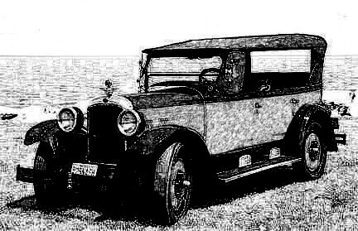

Nick got out of the speakeasy and walked over to his 1926 red and black Nash Touring car. He was not named Nick Carter in vain. He took to driving motor-cars as if he had been born in one. Of all the other Wanderers, Lucius was the only other one who liked to drive. He drove up to Tarrytown and told the others what he had learned.

“Interesting” said Walden “looks like we are starting to cross time tracks with the Ladies. Not sure what it means, but I hope that we may be getting closer to the time we meet”.

The farm that Julius had purchased in 1861 was an excellent rest and hiding place for The Wanderers. When they showed up outside Peekskill in 1928. the map that Julius had given them came in very handy. They were able to make their way to the farm outside Tarrytown in just a couple of hours. Julius and Marigold were still living there and they were very happy to see them again. They had moved the Rosette to Tarrytown only a year after The Wanderers had visited. Business was good and their son Roberto was the owner of the Tarrytown General Store. Their other son Nicholas was now running The Rosette assisted by his son Adriano. Marigold still liked to go help in the kitchen once in a while and Marigold’s Sunday Brunch had become quite the event. Nicholas also had a second son named Toto and a daughter Violetta. The two of them had moved to the Bronx in New York City and opened their own restaurant.

Domenico asked to borrow the car and drive down to Greenwich Village on a Friday evening. Begonia had decided to stay with them after he had explained their situation as best as he could. Still, she did not seem too attracted to him so after asking Adriano for advice, he convinced Begonia to go out with him to a nice club. Lucius overheard the conversation and asked if Algoma and he could join them. Domenico was quite happy, because he really wasn’t looking forward to driving a car. They found the place easily enough even though the entrance door had no sign and there was no awning of any kind. Everyone knew Chumley’s and it was quite the happening place. They were told to show up before ten o’clock when the late crowd was not there yet. It was very nice and they had a very decent ragtime piano player. Everything was fine until a little after eleven when a bunch of gangsters showed up with their floozies. Domenico tried not to pay attention and he was happy that Begonia did not understand Italian. The gangsters kept making nasty comments about her. Sadly, for them, Algoma’s Italian was very good by then. She kicked Lucius’ shin under the table and said in a loud enough voice:

“Lucius, these guys are saying things that are not so nice about Begonia. Are you going to let them get away with it?”

“Look Algoma, I am having a good time, I like the music and Begonia does not understand what they are saying”.

“Lucius, don’t be an ass. Begonia does not understand, but I do” replied Algoma

“You’re right Algoma, I do not feel this place anymore. Let us go somewhere else” said Domenico.

“All right, if that’s the way you want it” added Lucius.

“Hey guys, why are you speaking in another language?” asked Begonia.

“We just wanted to make sure that these morons next to us understood” answered Domenico.

They understood all right and they also understood English. One of them looked Domenico straight in the eye and made a throat cutting motion with his hand.

Domenico gave him his best smile. They paid their bill and walked out the back door. It was closer to where they had left the car. It was also a dark alley and the gangsters were waiting for them. The one who had made the throat cutting gesture walked out in front of Domenico, and pulled the left lapel of his jacket aside. The moon was shining right on him and they could all see the glint of cold steel in his shoulder holster. Dominico jumped up and kicked that gun so hard that it shattered two of its owner’s ribs and knocked him out cold. Two of the other gangsters managed to pull out their guns. But not as fast as Lucius pulled out his nunchaku. He hit their wrists knocking the guns out of their grip and probably breaking some bones in the process. The three other gangsters where much slower, but Domenico was not in a forgiving mood. He jumped up and executing a perfect split he kicked two of them in the head knocking them out instantly. The last standing gangster turned tail and tried to run, but Lucius threw his nunchaku at his legs causing him to fall flat on his face. He walked over and pulled out the gun from the guy’s holster.

“You should never mess with strangers. You can never know what they might know”. Saying that he just walked away and so did the rest of their little group. The guy on the ground was too terrified to do anything so he waited until they were out of sight before moving.

The Wanderer Ladies showed up the next morning. As usual, they missed by a very narrow margin. Julius came to greet them and once again he had a note from Waldencraft.

Marigold made grits and bacon and eggs for everybody and Fleur read the note while they were drinking coffee and waiting for breakfast to be ready.

‘My dearest Fleur,

It seems that there is some kind of change in the pattern. We almost ran into each other, a few days ago. Also I think we were actually at some place after you had already been there. Still, I think we have almost nine years more before we shall meet again. Romulus has become fascinated with calendars and he is keeping one. I don’t know how accurate that thing might be, but he says that he is only trying to keep a calendar of our lifetimes. According to his calendar, only ten years have passed since we have seen each other. As always, I am a patient man. I have passed millennia without you. Nine more years are as nothing compared to that. Tell Myrtle that Octavio sends his love.

As before
Eternally yours,

Waldencraft.’

-%-

“That was pretty good” said Dougie while closing the notebook “Good fight scenes, where did those come from?”

“I’ve been watching some action movies lately. I like Jason Statham so this week I watched his Transporter movies”.

“Well, that worked out. I guess this is it for today?”

“Yes, that’s it. See you tomorrow”.

-%-

“Good morning Petunia. I’ve been thinking about Dahlia. How long can we leave her in that tree?”

“Just remember, time does not pass the same way for everyone in our story. When we get back to her, only an hour would have passed for her and Gabriel. Also I have an idea about how they are going to be saved.”

“So, let us get to it, our readers might be losing their patience waiting for that rescue and so am I”.

“The problem is that even though time does not pass the same way for everyone, we have to make it pass in such a way that their ages are getting closer to each other. Now, Romulus and his sons, need to age about nineteen years to match their spouses who are still frozen in time back home. Myrtle should not age anymore and indeed, The Wanderer Ladies do not spend much time in any one place. So for Myrtle and Lilia only a few weeks will pass while The Wanderers need to spend nineteen years travelling. Which, I just realized, is where we made a mistake. All of Nick Carter’s cousins will age nineteen years while their girlfriends and fiancées will not age at all. I don’t know how we’re going to fix that.”

“I have an idea” said Dougie “we could go back to where The Wanderers start their time travel. We will change what we wrote and make it so that Nick’s cousins keep riding home and only Romulus, his sons and Waldencraft get swept up in time. Oh, sorry, that’s not good, Nick is featured a lot”.

“Also Domenico and Lucius” added Petunia “they’re featured too”.

“Well maybe we’ll have them stay with the Wanderers” said Dougie.

“I don’t think so. We already wrote quite a lot and making such a big change will probably leave a lot of holes in our story”.

“Yeah, I guess you are right. And this is just a story, imagine how much more difficult it would be if it was real time travel”.

“O.K. let us recap a little. At this point in our story, Romulus is about fifty-nine, Gabriel is probably fifty, Myrtle and Lilia would be about forty, Octavio is twenty-nine, Nick Carter is twenty-eight and Dahlia is twenty”.

“So, Romulus needs to age another nine years to catch up to his wife Laura, Octavio needs another nine years as well to bridge the gap between Myrtle and himself. Gabriel, Myrtle and Lilia are not going to age anymore and Octavio’s brothers will also age nine more years to catch up to their wives. Nick Carter and Dahlia are a little further in age, but it is not such a big time span. Fleur and Waldencraft are immortal, so their age is not important at this point. That still leaves Nick’s cousins. We’ll have to figure something out about them” said Dougie.

“O.K. here’s what we will do” added Petunia “start writing”.

-%-

One minute, Dahlia was fighting a ghoul that seemed craftier than the others and the next, he was gone. She looked down and she couldn’t see any other ghouls anywhere. Even the body parts that they had chopped off had disappeared. A woman was standing at a short distance from the willow tree.

“You can come down now” she said “they are all gone, I promise”.

Dahlia and Gabriel climbed down, wiped their swords and placed them back in their sheaths.

“Thank you” said Dahlia “who are you?”

“My name is Fleur de Lys and I am the queen of the elves. I am trying to correct some things that have to do with time. Somehow the two of you got dragged into it and for that I apologize. How did the two of you happen to cross the border into Vallonia?”

“I was looking for my fiancé Nick Carter and Gabriel was apparently worried about me, so he came looking for me. I knew that Nick went to Vallonia with his cousins to look for his father and his brothers, so I followed him there”.

“From the way that you look, I guess you have spent some time in Nippon. What was the year?”

“It was in 1947. The world had become a terrible place, but two very kind people took me in and took care of me”.

“So I guess, you already know about the future. It is not always so horrible. But if you like I can send you back home to your castle”.

“I prefer to keep looking for Nick Carter” replied Dahlia.

“In that case, I will send you to the place and the time where you can find him. And you Gabriel, would you like to go home?”

“I’d rather stay with Dahlia” he replied.

“Actually, that is not a great idea. It would be better for you to stay with me. We will be reunited with Dahlia and the rest in only a few weeks’ time”.

“How come?”

“It has something to do with time and aging. Trust me on this”.

“O.K.”

-%-

Just like that, Gabriel, Fleur, the trees and everything disappeared. She was standing in a large room with a lot of tables and chairs. A man came in from another room and walked over to her.

“Hello” he addressed her in Italian “I think you must be Dahlia”.

“I am, what and where am I and who are you?”

“My name in Nicholas and this place is The Rosette, my restaurant and pub. Please have a seat and I will bring you some food and something to drink. And let me say that you look fabulous in this outfit”.

“Is Nick Carter around here somewhere?”

“As a matter of fact, he should be here in about ten minutes”.

He sat her down at a table by the window and brought a cup of coffee. He couldn’t help but notice that tears were coming out her eyes and he offered her a napkin.

“Are you all right?” he asked.

“I just find it hard to believe that I am really going to see Nick again”.

There was a loud noise outside her window and looking out she saw a little house on wheels that was moving very fast. It stopped right outside the window and a man got out of it. Took her a little while to recognize Nick Carter in his zoot suit and Borselino hat. Nicholas walked out to him and after exchanging a few words they both walked in.

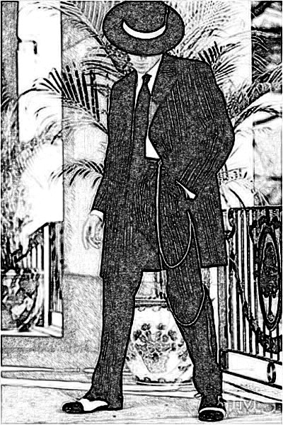

“Dahlia? You look so different” he said.

“Well, so do you” she replied standing up.

He seemd unsure,, so she walked over and gave him a big hug. He responded and looking at her face he asked:

“Are you crying?”

“I don’t know how that happened. I have turned into this person who is always crying when important things are happening” she replied.

“I am really happy to see you. I have so much to tell you”.

“And so do I” she replied.

“Let us sit and get something to eat. They make really good food here”.

They started telling each other about all that had happened. Julius and Marigold came to say hi and they left again. It took a couple of hours, but then they were pretty much caught up.

“So, it’s been ten years for you” she said “did you find somebody else to take my place in all these years?”

“There is nobody. I kept thinking about you and about how I am going to keep my promise. When I left I was eighteen and you were only fifteen. I think we are going to spend another nine years bouncing through time. So I thought that by the time I got back to you I would be thirty-seven years old and you would still be fifteen. I didn’t think that could work very well. So, if five years have passed for you and ten for me, then you are twenty and I am twenty-eight. It’s not as bad as fifteen and thirty-seven. If you still want me, I am totally yours”.

“You are so funny. What year is this?”

“It is 1928”.

“Well, I have been to 1947 which might make me older than you. I don’t think that these numbers matter at all. For five years I have been looking only for you and now that I have found you, I do not intend to ever let you go. If you go to war, I will be right by your side. If you go back home and just make wine and olive oil, I will be there too”.

“Then, if we are to spend the next nine years travelling through time, we should get married as soon as possible” said Nick.

They kissed again and it was just as spectacular as the first time.

-%-

It was the last day of the December recess, so Dougie and Petunia didn’t write anything else for a week. They talked about it and kept some notes, but not much happened until the next Saturday.

-%-

“So what do you have?” asked Dougie.

“I have an idea about where the ghouls came from. Also what they are, but I think we might want to save that for the second book. I also think that in addition to Nick and Dahlia getting married, so should Lucius and Algoma as well as Domenico and Begonia”.

“That’ a good idea. I have a character for our second book. His name is Enoch and he is the seventh son of Septimus. Enoch was the seventh descendent of Adam and Eve and one of very few in the Bible who were taken into heaven. But I kept thinking about the cousins and their age problem. We need a stratagem that will have them together in one place, but separated from the rest of The Wanderers. I also think that Lucius and Domenico with their wives should stay with Walden, Romulus, Octavio, Nick and the others. Took me a while but then I found the perfect answer - baseball”.

“Sounds interesting, shall I start writing?”

“I think so”.

-%-
17 THE LONGEST BASEBALL GAME EVER

Passing by a school-yard in Tarrytown, Absalom saw a bunch of kids playing some kind of stickball game. He liked the way the game moved and from there it was only a short time before he found his way to Yankee Stadium.

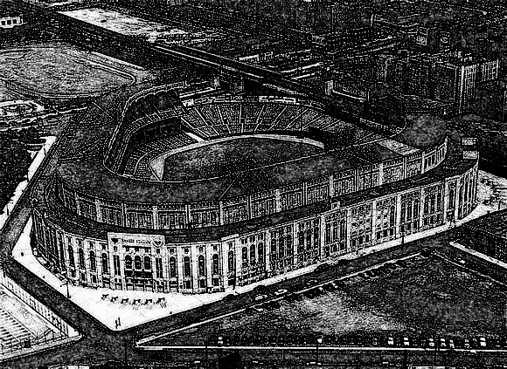

That was a lot more exciting. The baseball bug grabbed him big time. But he didn’t just want to watch, he wanted to be in it. He figured out the rules in no time at all and he even managed to get a pamphlet that was describing the measurements of a ball field. The barn where they kept their cart with the equipment and weapons, was way out of town. There was a huge empty field right next to it. Absalom spoke to Nicholas about it and before you know it, he had everything needed to put together a baseball game. Chalk for the lines, bags for bases, bats and balls. He started bending his cousins’ ears about baseball and some of them even went to a game with him. They were not doing that much anyway, so some of them started to come out to his field and try to hit a ball. Eventually, he got most of them to come out and play. After a couple of weeks, they were all quite into it. Of course, as is the case, there were some who were better at pitching, others who were better at hitting and others who were better at catching. Nick, Lucius and Domenico showed up a couple of times, but they were more interested in hanging out with their wives. Absalom did not mind that. He was actually left with the perfect number for a baseball match : 19. That would make two teams of nine each and an umpire who of course, could only be Absalom.

-%-

“Hold on right there. You said ‘their wives’ but they did not yet get married”.

“Yes they did, I just thought it would slow the story down so I skipped it. When Dahlia and Nick told everybody that they were going to get married, Waldencraft said that he had married many couples in his long life and offered to officiate. Romulus asked if he was a priest and Walden said that he was in a way, though not a Catholic one. Romulus was unhappy, but Nick promised that when they got back home they will get married once again properly. When Lucius and Domenico heard that, they also proposed to their ladies, so all three couples got married on the same day.”

“So, I did a little research myself. I thought that a wedding should be fancy. It’s O.K. that Walden officiates, but Nicholas who was a romantic at heart, reserved three suites at the Parker House Hotel in Boston.

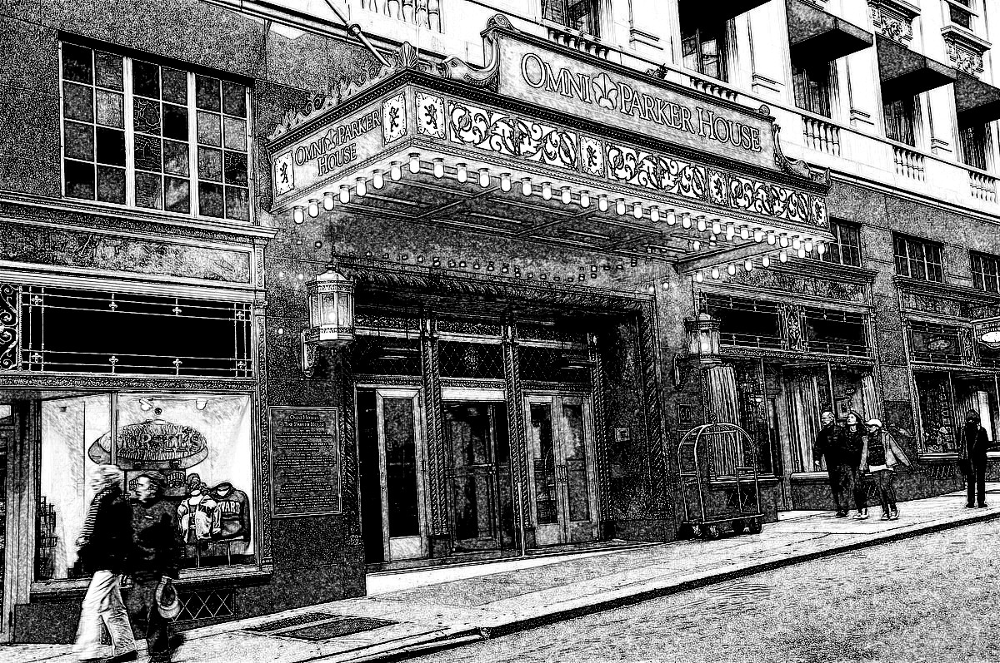

He got a white Ford stretch limousine to drive them there, and gave them $1,000 each as spending money.”

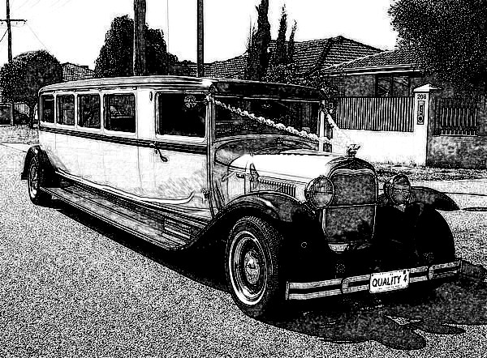

“Well, that sounds really fancy, but do you think we need to write a chapter about their time in Boston?” asked Dougie.

“No, I guess you’re right. It would just slow the story down”.

“One more thing” added Dougie “The Stonefeather family are very nice, but where is all that money coming from?”

“Well, Begonia who knew something about money, had the same question. Nicholas told her that she did not need to worry. They had a money tree. We will write about that after your baseball game”.

-%-

You might think that a couple of weeks of training would not turn anyone into a professional baseball player. And you’d be right. Except for one thing, these were not your average people, they were berserkers. Many years of training went into developing muscles and strengths that most people never get. On the other hand, both teams were equally trained. That made for a very fierce and strong game. When everyone can throw a ball at 90 miles an hour, run like an Olympic runner and hit like they were wielding Thor’s hammer, the game is not the same as the one we are used to. When someone hit a home run the ball was truly gone. Which is why they had about a few hundred balls.

They had also gotten uniforms. The ‘Yankees’ had the pinstriped ones complete with the NY logo on shirts and caps and the ‘Dodgers’ had that logo across their chest and caps, just like the originals. There was no one to see the game, but any baseball fan would have given a lot to see it. It was almost like a game in the 1947 World Series (Yankees beat Dodgers) which was still in the future only faster and with a lot more home runs. The game lasted for less than two hours at the end of which the ‘Dodgers’ had won by a score of 132 to 123.

The ‘Yankees’ were batting at the bottom of the ninth, so eight guys were sitting on a bench awaiting their turn at bat. Just about the time that the last batter got struck out, a mini-van drove up and stopped next to the barn. Princess Fleur and two other people walked out.

“Hello” said Fleur.

“Hello” they all answered.

“I have finally fixed some of the problems that my time spells have been having. So, I thought that I should correct a little discrepancy. As you might know by now, your home castle is frozen in time. Ten years have passed in your own lives since you had left. But your parents and Romulus had previously been frozen in time for nineteen years. I would like for them to age nineteen years in order to match their wives. The nineteen of you on the other hand, do not need to get that much older. So though your game seemd to last only about two hours, we are now in the year 2018. We will all go home in a few weeks, so just relax. All of your equipment, tents, weapons and so on is still in the barn. The barn still belongs to the Stonefeather family and the rest of your family will join you in a few days. In the meantime, Daphne and Luigi have brought you dinner. You might be a bit hungry after your game”.

“Thank you” said Absalom “this is good news and yes, I am starving and I guess so are the rest of the boys”.

The boys made all kinds of noises to support that statement . Luigi brought out a large pot that he placed on one of the tables. There were eight of them, kind of like what you find in a rest stop. Sturdy and with benches that could easily sit eight people. Daphne brought some disposable bowls, cups and dinnerware. She also got some pre-sliced baguettes and placed them in a couple of bread baskets.

“It is really nice to meet you finally” said Luigi while ladling stew into a bowl. Daphne kept passing them to the guys.

“It is a bit of last moment meal, so we didn’t get a chance to organize it better. I hope you like my goulash. We are the current owners of The Rosetta and I hear you will all be here for a while. Please come by and we will feed you more properly” added Daphne.

“I heard that you’re all coming from 1928” said Luigi. “It was a bad time for our country’s economy. Also, you couldn’t even have a proper glass of wine. But this is 2018, so we do not have those problems”.

While talking, he went into the van and came out with four bottles of red wine. He opened them and started pouring it into glasses that he lined up on the other table. When he had twenty-two of them he picked one up and motioned to everyone else to do the same.

“Cent' anni” he said and everyone answered in the same language.

“This wine is excellent” said Absalom “what is it?”

“It is a Pietrapiuma of Tuscany” answered Luigi “The whole world knows that some of the best winemakers are in Tuscany. Pietrapiuma is of course the Italian part of our family”.

“Many things have changed a lot since 1928, so try not to get too put out. It is the way of the world. Anyway, I spoke to Luigi and Daphne about you and we have come up with a good cover story. You are the pupils of an Italian martial arts school. You have won a minor regional competition the prize of which was put up by the Pietrapiuma winemakers. It is how you ended up in the converted barn of the Stonefeather family. This will make it easy for you to walk over to The Rosetta in a group. We got you all martial arts uniforms. They are called gi’s and Luigi is going to show you how to put them on properly. Do you still practice every morning?”

“Sure do!” answered Absalom.

“I see that you are pretty much the leader of this band Absalom, so you should act as their teacher, or as they say in Japan, which is what everyone around thinks martial arts come from, sensei”.

“Go sensei” yelled out Tinto.

“So about those mornings, do not be surprised if a bunch of kids and maybe some older people stop by to watch you. Also don’t get too upset about Daphne saying you will be here for a while. Fleur tells me that it is only a matter of a few weeks” added Luigi. “so just relax and have fun”.

Luigi brought out four more bottles of wine and he left them two cork pullers. Absalom picked one up and it was obvious that he didn’t know what to do with it, so Luigi showed him.

“O.K. guys, we’ll be back in the morning with some breakfast and then maybe you’d all come to The Rosetta for lunch. There is a path that leads right to The Rosetta’s back door” he said while pointing it out. “So have a good evening”.

With that, the three of them got in the van and drove off.

They got to The Rosetta and Fleur went in and sat at the bar. It was still early, so Daphne sat down with her and Luigi mixed them a couple of frozen strawberry daiquiris. Fleur had never had anything like it before and she really liked it.

-%-

“O.K. I think we can let them enjoy their drinks while we write about the money tree. It’s not really a tree of course” said Petunia.

“I knew that”.

-%-

18 THE MONEY TREE

One day after the honeymooners had returned, Begonia asked Daphne a question:

“Listen Daphne, I wanted to ask you a question and I hope you will not be upset”.

“No, go ahead, what is it?”

“Well, when The Wanderers first met your great-great, so many times great grandfather Mario, times were simpler and they could just hunt and travel and take care of themselves and I mean the ladies as well as The Wanderers. By the time they first met Nicholas, it was still sort of doable though things had changed by then. But by the second time we met Nicholas (I was there for that one) things have changed a lot more. It seemed to me that Nicholas went to a lot of expense to help us. And now, I think everything is getting even more expensive. So, where does all this money come from? Is your business that good?”

“Actually, business is O.K. though there were some hard times. But we have a lot of help. Just about a year before The Wanderers showed up in 1928, Nicholas’ daughter Violetta met a young accountant, fresh out of school. John James Van Leuwenhoek was the son of Dutch merchants who actually lived not far up the Hudson from our family. They fell in love and before the year ended they were married. Turns out J.J., as everyone called him, was a brilliant financier in addition to being a top-notch accountant. By the beginning of 1928 he had a very successful business. Violetta had of course told him about The Wanderers and the connection of the Stonefeather family with them. So one day he opened a very large bank account in Nicholas’ name and told him that from that day on, he will take care of the financial needs of the Stonefeather family and their occasional guests. I don’t know how he managed it, but when we were trying to figure out how to minimize the appearance of The Wanderers, it was his idea to buy a piece of land out of town, and build a large barn on it. When The Wanderers showed up, money kept pouring into Nicholas’ bank account, so he could buy anything and give them plenty of money to spend. Around June 1929 Violetta stopped helping her brother run The Rosetta. J.J. took her to Tuscany. Before they left Nicholas asked Violetta how did they become so rich in such a short time. She told him that Princess Fleur had helped, but that she did not know the details. He then confronted J.J. and asked him the same question. J.J. told him that Fleur had asked that he not tell anybody about it, but that nothing illegal was involved”.

“So this is how Violetta told me the Tuscany story some years later when they got back”.

In Tuscany J.J. had re-connected with the last descendants of the Pietrapiuma family - Clorinda, her husband Maurizio and their two sons, Vittorio and Marcelo. Maurizio had a tiny vineyard that was not producing enough wine to support him and his family, so he was doing all kinds of odd jobs. Strangely, the vineyard was located next to the stream where Octavio had first seen Myrtle bathing. J.J. bought out as much land as he could around the ruins of the old castle. He moved into a villa on one of the estates that he had purchased. The first thing he did after that was hire Maurizio to oversee his vineyards and olive groves.

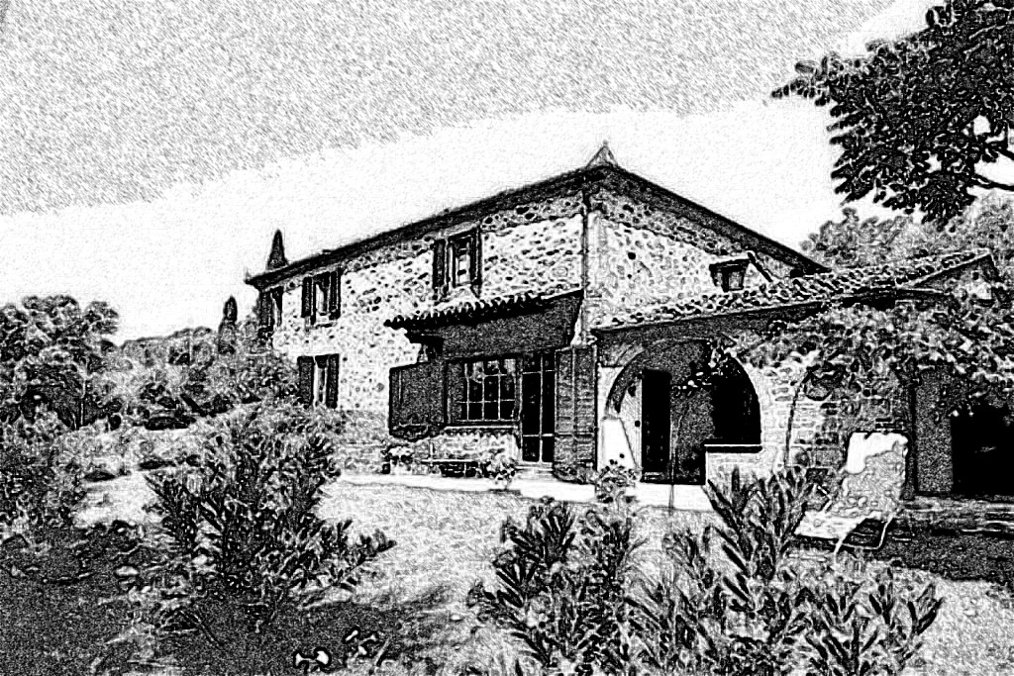

A month after they settled in, Violetta invited Clorinda and her family to a dinner at their villa. They had set up a nice big table in the shade of a big old chestnut tree. They had a nice dinner with some local wine. J.J. had grown up speaking Dutch so he was learning Italian quite rapidly, but he didn’t speak enough of it yet, so he asked Violetta to translate.

“Before I say anything else, Violetta please tell them how we are related”.

“Do you know of a legend that says some people from the castle went to a faraway land and then they came back?”

“Yes, there was a silly story about a guy named Luigi who went to look for them hundreds of years ago and never came back” said Maurizio.

“Well, he did not find them. But, he married a nice American Indian girl and he had children with her. And one of them, had children and their children had children. And one of them named Mario Pietrapiuma, found them. And Mario had children and his children had children and so on. Sometime in the past they changed their name to Stonefeather, to sound more American. Well, I am one of those Stonefeathers and I have parents and two brothers in America”.

“That’s pretty incredible” said Clorinda.

“Wait ‘til you hear the rest of it” replied Violetta. “My husband wants to send your kids to school. I understand that they do not have that much education, but we will work around that. They both seem like bright kids, so we will hire some private tutors for them. In a year Vittorio will go to the University of Bordeaux to study agriculture and winemaking. Marcelo will go to the University of Lausanne in Switzerland to study economics and business management. We will live here for a few years while we take care of our business investments in Europe. In the meantime, Maurizio, I have opened an account in your name for 1,000,000 Italian lire to take care of expenses. We will incorporate in the coming weeks and we’ll talk about money some more. The money is not a loan. It is for your future services as well as funds to pay the people that you will hire to help with the wine and oil making”.

“That is ridiculously unbelievable” said Maurizio.

“Wait ‘til you meet Nick Carter and his twelfth century cousins before you say that. I have a feeling that we might need their help in the future”.

-%-

”That’s it for now. It’s getting late. Tomorrow is Sunday so we can finish it up” said Petunia.

“You know, it is getting to where we might have stories that we have not told and perhaps people might be curious. I think we should write at least two more chapters: Nick Carter in Boston and Nick Carter In Tuscany”.

“We could do that later on. Like maybe we can have a sequel named Nick Carter in the Twelfth Century. In one chapter Algoma, who loves children, could be telling them the story about Boston”.

“And in Tuscany, when the Pietrapiuma winery gets famous they have problems with the Italian Fascists. Nick, Domenico and Lucius come to the rescue” added Dougie.

“We’ll see”.

-%-

“Good morning Dougie, Let’s wrap this up”.

-%-

Van Leuwenhoek & Sons was located in one of the oldest buildings in FiDi (Financial District of downtown NYC). It was also one of the strongest financial companies in New York and perhaps in the entire world. Unlike many of its competitors, it had not been touched by any of the major financial crises that have rocked the world since it was founded by John James Van Leuwenhoek in 1928. The company was still privately owned by the Van Leuwenhoek family, with some shares allotted to the Stonefeather family. Since it was not publicly traded, no one knew very much about their wealth and stability. Well the government knew some, but not everything. VLS. as the insiders liked to refer to it, had holdings on five continents and subsidiaries in Malta, Hong-Kong, Buenos-Aires, Kyoto, Montreal, Durban, Ankara and Sofia.

Elvis’s private secretary Daisy, walked into his office to say good morning and announce a visitor.

“Hey Elvis, good morning to you, you got a visitor. She says her name is Fleur de Lys and you are expecting her”.

“Oh yes, please show her in. I have been waiting for her for many years. This a very special occasion, so after you show her in, make us four Irish coffees and get my bother. I need you to listen to everything we talk about, because a lot of things are going to change.”.

Daisy brought Fleur and went to get the coffee.

“It is an honor to finally meet you Princess”.

“Let’s not be too formal, Fleur would just do”.

“O.K. Fleur, is Lilia with you?”

“No, she’s still in transit somewhere, but not to worry, she’s coming”.

Elvis’s brother Cliff W. walked in and kissed the back of Fleur’s hand.

“This is an honor. I guess the time of prophesy is upon us”.

“Don’t get so dramatic Cliff. By the way what does the W stand for?”

“Well, mom got into all kinds of music so the W stands for Webern a composer that she admired. It just doesn’t ring out too well. And the, she and our father were having this dispute about some 1950’s/60’s singers. She was much in love with the music of Elvis Presley, and he was all for Cliff Richard. They were going at it about their son’s name up until she gave birth. Luckily for them there are two us so than they could use both names”.

Daisy walked in and Elvis pointed to an empty chair.

“I want Daisy to be up on this. I hope you don’t mind Cliff”.

“Well, if you think she can handle it, it’s fine by me”.

“Are you a religious person Daisy?” asked Cliff.

“Not particularly, though I have been to a temple a few times with my parents”.

“Well, some of what you are going to hear will be well outside what most people consider normality”.

“I guess it should be interesting” replied Daisy.

“This is a very nice coffee” said Fleur “anyway, I need to figure out how to boost up the Stonefeather family finances. They told me that your firm takes care of all of that, but somehow, I think I need to be in on that”.

“Very true” said Elvis “but you are already involved - it was you who gave our father the papers that led to our massive fortune, as well as the capital that got it started”.

“O.K. that sounds logical, but unfortunately, I have not done it yet. As you say, I have given him papers, so I think I should do that. Do you still have the papers?”

“Of course - they are in my safe, and what they are is a list of the best 100 companies in the 20th and 21st centuries up to 2018. It was obvious that something was going to happen in 2018”.

“O.K. here’s how we are going to go about it. You will compile a new list for me. I will take it back and give it to J.J. in 1927. It will be a wedding present”.

“Why can’t you take the one that is in the safe?’ asked Elvis.

“I have a feeling that some things are a little askew. Our tampering with time may have caused some problems. I don’t know what they are, but at this point, we are still kind of travelling. I will try to figure it out when I get back to Vallonia”.

“Very well, but it will take me a couple of days”.

“We do have some time. What about your parents? How are they doing?”

“They really love Tuscany and they have been courting the Italian government. I am not sure how they are hiding their true age, but they say there are no problems. Currently, they are trying to buy back Romulus’ castle. I think they will succeed. Anyway, when is everybody going to finally get here?”

“Myrtle, Lilia and another friend will get here sometime next week. The others, next month, probably around the 15th of August or so”.

“I have an idea” jumped in Cliff “being that there are quite a few of you, we could charter a flight to Tuscany. The company jet is a bit too small”.

“Help!” cried Daisy “I think I saw enough sci-fi movies, but is this for real?”

“Every bit of it” answered Elvis.

Daisy just kept quiet.

They sipped their coffee in silence for a few minutes before Daisy asked a question.

“Like it or not, I will accept whatever it is, but perhaps someone fill me in on the details”.

Fleur summarized the travels of the Wanderers and their ladies.

“O.K.” replied Daisy “so we have something like maybe 35 or 36 or something people from the 12th century. Cliff proposes to put them on a plane to Tuscany. Did any of them fly before?”

“Actually, no. But considering the way that they have reacted to technology over their pretty short but eventful trip, I think they will be just fine. I believe they will think it will be a fine ride”.

“O.K. let’s get back to reality” said Elvis. “Fleur, how did you get to our offices?”

“Metro North to Grand Central and then I took a cab”.

“You know, I have heard tales about you and the others, and I always wondered how you all managed to take it all in stride. This answer is just almost making me understand. Anyway, there is no need for you to take the train again. Please let us put you up in a hotel, until I finish compiling the papers”.

“I think that will be fine. Maybe Daisy could stay with me and show me around town”.

“I guess I could. I don’t have any urgent things to take care of” answered Daisy.

-%-

J.J. and Violetta had their wedding reception at The Rosetta on February 14 1927. Fleur showed up just a little before the party got started, so of course they added a chair to the family table. Fleur had of course picked that date by design and she had gotten herself a fancy dress for the occasion. The party was nice and everybody had fun. After all the guests left, Fleur asked the newlyweds if they had a private place where they could talk. She apologized to the family and explained that her gift was a private thing. They went into the kitchen and sat down.

“Violetta, J.J., your family has been very good to me and my companions over the years. Things are going to get a lot more expensive in the future, so I want to help”.

She presented Violetta with a little velvet pouch.

“I always pack a little bag of diamonds when I travel. At this point I do not think I will need any of them anymore, so they are yours. I also have a present for you J.J. It is a list of the top 100 companies up to 2018. If you use it wisely, you will become very rich. Sell some diamonds to get you started. Please do not tell anyone other than your children about this. It might create all kinds of time paradoxes. Congratulations once again, and don’t worry, we will see one other again”.

They went back out into the dining area and of course everyone was curious about what had happened. Violetta told them that it was a magical present and that it would not work if they told anyone. She also told them that it was given to them, but it was actually a present for the entire family.

After a month long honeymoon in Cuba, the young couple moved into an apartment in Greenwich Village. They sold about a third of their diamonds for one million dollars. Back in 1927 on million dollars could buy the same as $14,000,000 could buy in 2018. J.J. bought the barn that will house the Wanderers in the future, and he gave $100,000 to Daphne and Luigi. He used some more of that money to start his financial business. The rest of the diamonds and the printout went into a bank vault. He used the information wisely, and one year later, his business was getting a good reputation as well as some very rich clients. He hired a good manager, a secretary, a few accountants and some financial experts. They all did what other financial institution were doing, with the exception of some acquisitions that were mandated by J.J.’s office.

On the one year anniversary of their wedding, J.J. felt that his company could do just fine without him being in the office constantly. That is when he got his wife and went to Tuscany. He kept in touch with his office through telegrams until sometime later when the teletype became available. Seven years later, after having established the start of one of the best wineries in Italy, he returned to New York City. He and his lady had spent a lot of that time travelling, and they had opened branches in Malta and Hong-Kong. 1935 was about the middle of the Great Depression. Everyone in the world was losing money, properties and so on. Van Leuwenhoek & Sons did not feel any of that. Actually, a few days after J.J. returned, he bought the building that his offices were located in. We could keep going, but obviously, Fleur had picked the right man to manage the Stonefeather finances. While in Hong-Kong, Violetta had bought a money tree, which they put on J.J. desk in his office. On the few occasions that some jealous rival would ask about the secret fo his success, he would point at the plant and say:

“I owe it all to the money tree!”

-%-

“I don’t know” said Dougie “I guess we’re done with the money tree. But isn’t it a little boring?”

“Let’s just leave it for now and figure that out later” replied Petunia.

“O.K. then, we’ll call it a day. I have some ideas about the next chapter, but let’s talk about it tomorrow”.

“O.K. until tomorrow then” said Petunia.

-%-

The next Saturday morning, Dougie dictated and Petunia wrote.

“New chapter” he said.

-%-

19. TUSCAN WINE

Harry was an experienced limo driver. He had been driving for more than ten years and never had a problem. This time, he couldn’t figure out what happened. One moment he was driving just fine and the next he hit some kind of pothole that made the car seem to jump. He pulled over and slid the passenger window open.

“I apologize. I don’t know what happened. There was a shimmer in the air and all of a sudden we are on a bad dirt road. This is weird, even the trees look different”.

“Don’t worry” said Algoma “these things happen once in a while. Just stay calm and we will get you back home”.

“Why don’t you drive ahead slowly until we come to a town or something and we’ll figure it out” added Domenico.

It took about 20 minutes before they came to a little town. The dust road became cobblestoned so apparently they were driving on the main street. They came to some kind of food place that had tables on the sidewalk so they stopped the car and got out. The sign on the place said La Rosetta which was kind of strange. A man walked out and moved a couple of tables together and invited them to sit down. He was speaking Italian so they replied in the same language. Domenico translated for Begonia and the guy asked if they were English. Domenico explained that two of the ladies were American.

“I like the name of your place” said Nick “how did you come by it?”

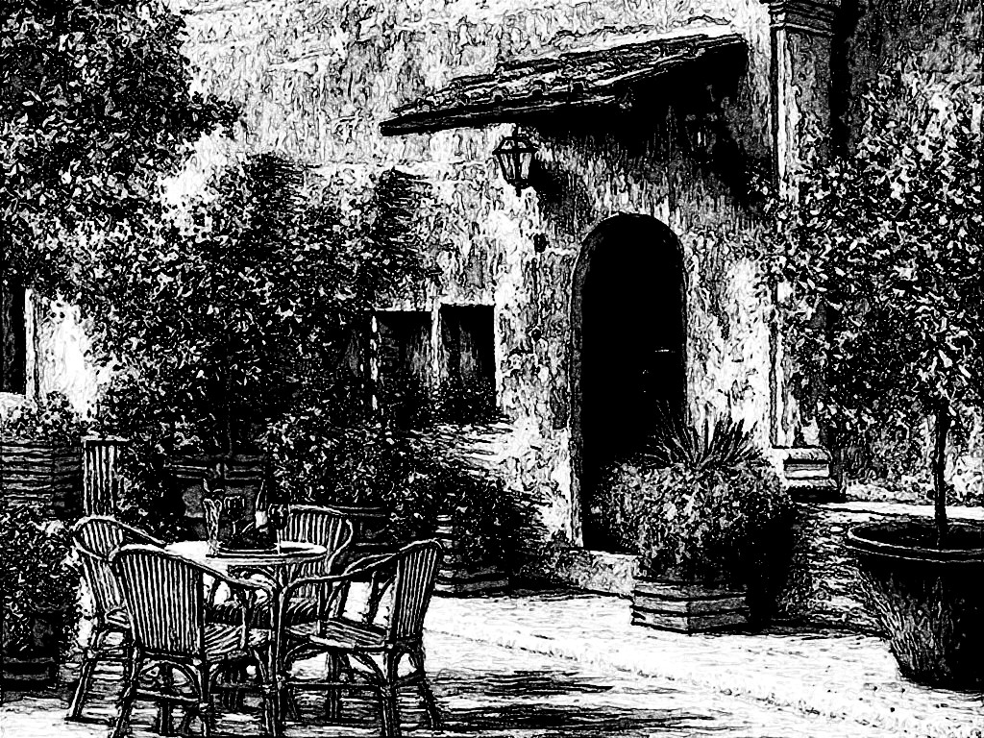

We have some relatives in America who have a place named The Rosetta, so we liked the name and decided to use it”.

“That is funny, we were actually driving back to The Rosetta when we got lost. I have a strange feeling about this. I am Nick Carter and these are my cousins Lucius and Domenico and our wives, Dahlia, Algoma and Begonia”.

“Holy mother of pearls, I have heard so much about you, I can’t believe you are actually real. Just a second”.

He walked back into the place and came out shortly with a woman and a young boy.

“My name is Umberto Pietrapiuma and these are my wife Camilla and my son Alberto”. He introduced Nick and company to them and they were obviously quite impressed.

They went back inside and Umberto came back out shortly with two bottles of wine.

“Did you have lunch yet?” he asked.

“No, not yet” answered Nick.

“That is good. My wife makes the best pasta in Tuscany and she is preparing it for you right now” he said while opening the wine.

His son showed up with glasses so he poured everyone a drink.

“I’m not sure I should drink” said Henry “also my Italian is not very good, I thought this guy said we are in Tuscany”.

“We are in Tuscany” replied Domenico “as a matter of fact I think that castle in the distance might be the place where I was born”.

“How is that possible” asked Henry.

“Look Henry” said Begonia “ you do not need to be afraid. It took me awhile but I got used to it. I was born about a hundred years ago and Algoma a lot earlier than me. And no we are not witches or anything it’s just that time misbehaves around these people”.

Two guys in uniform carrying rifles were just passing by and they probably heard some of the dialog. One of them took out a whistle and blew it real loud.

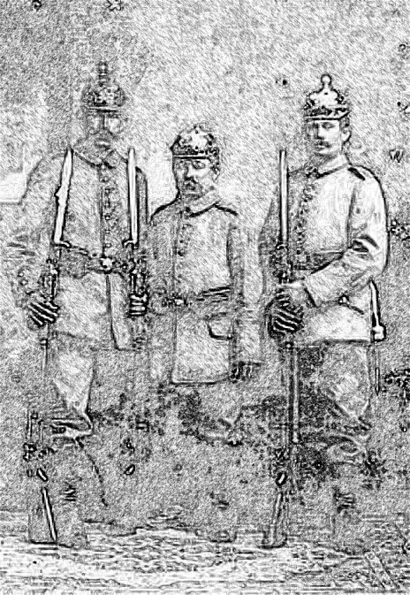

“Can you please, stop that noise?” asked Dahlia.

The other guy took the rifle off his should and pointed it at her.

“Stand up!” he commanded “and walk towards me. The rest of you don’t make a move if you value your lives”.

Dahlia did as she was told while two more uniformed guys showed up.

“What’s happening?” asked one the new ones.

“I think these people are English spies” replied the one with the rifle.

“We’re not English you idiot, unlike you we are Tuscan” said Dahlia. While saying that she sidestepped him and delivered a blow to the side of his neck that dropped him like a sack of potatoes. The other three were trying hard to get their rifles off their shoulders, but they had no chance. She dropped two of them with hard kicks to the knee and the last one got a flying kick to the head.

“I needed the exercise” said Dahlia while sitting down and taking a sip from her wine glass.

“Not bad” said Nick “I guess you learned some good moves in that Nippon land. You’re just about ready to train with the rest of us”.

“Don’t make me spank you husband” she replied “the one thing I did not learn was how yo be an obedient wife”.

Umberto got up and collected the rifles while two of the guys were trying to stand up.

“Carabinieri” he said “they’ll be back with more guys”.

“Do not worry, as I said my wife still needs some training, but if they bring less than fifty more, we’re good to go”.

The Carabinieri sergeant was extremely upset for losing face in front of his men, so when he reported the incident to headquarters, he built it up a lot. As a result they sent out an assault unit of 200 men to deal with the large group of English spies. In addition to their rifles and handguns, the unit also included 3 mortars and two machine guns mounted on assault vehicles. It was going to be a very unfair fight.

-%-

“That’s it for today” said Dougie.

“Not fair, leaving me hanging like this” said Petunia.

“Well, I have an idea, but I am not sure where I am going with it, so I need to think about it a little more. Hopefully, I will have something by morning”.

“O.K. see you then”.

-%-

“Good morning Dougie” said Petunia “I looked up Italy in 1940 and I have an idea that might help:.

“O.K. let’s hear it”.

-%-

Under the leadership of Benito Mussolini, Italy was headed for a rough ride for the next four years. Mussolini made all the wrong choices and Italy was defeated every step of the way. As is always the case, a lot of people were not happy with his leadership, or his alliance with the Axis powers. Lino was an old man who had gotten a job as a janitor at the Tuscan Fascist headquarters. Nobody paid much attention to him, so he overheard a lot of conversations that should have been confidential. He liked to hang out at La Rosetta when he was home, so when he found out about the coming attack, he sent one of his nephews to warn Umberto. They were sending for an assault unit from the North. It would take them two days to get to La Rosetta, but they were 200 strong and they had some heavy weapons. Umberto shared all of this with Nick and his cousins and they sat down and tried to plan a strategy. There was no way that they could abandon Umberto and his family.

-%-

Back in 1928 outside Tarrytown, while Absalom was setting up his game, Walden, Romulus and his sons decided to walk over to The Rosetta for a snack and a couple of drinks. They ended up at La Rosetta just as Nick and the others were starting their planning session.

“Good timing dad, Walden” said Nick “it looks like there are 200 unfriendly soldiers heading our way”.

“Do we have time for introductions?” asked Walden.

“Oh, sorry, this is Umberto. Umberto, these are my father Romulus, my brothers, Primo, Secondo, Tertio, Quartus, Quintus, Sextus, Septimus and Waldencraft”.

“It is an honor and a pleasure to meet all of you. Can I get you something to eat? A little wine?”

“That will be very nice thank you” replied Romulus.

Umberto went inside and returned with two bottles of wine.

“My wife is preparing something to eat” he said while pouring the wine.

“What is the year?” asked Walden.

“It is 1940” replied Umberto.

“I assume that there are some new weapons that we may not be familiar with. Do you know what these soldiers are going to bring with them?”

“I was told that they will have a few mortars as well as some assault vehicle mounted machine guns” replied Umberto.

“Can you describe them a little?”

“The mortars look like metal pipes. A mortar is dropped into the pipe and it shoots out going some distance, before it falls to the ground and blows up. The explosion can kill someone close to it, or hurt them very badly, but they are not very easy to aim. The machine guns shoot a lot of bullets one after another very quickly and because they are mounted on vehicles, they can move around and cause a lot of damage”.

“O. K. so, do you know when they are going to get here?”

“They are coming from somewhere up North and it will take them about two days or less. They will of course have to make camp somewhere. Because they have vehicles, they can only use one route. The same one that Nick and company have driven on”.

“Thank you Umberto, I think we can handle this” said Waldencraft.

Camilla and Alberto came out with some antipasto and dishes. Umberto introduced everybody.

“You know, you could all just leave. We have managed to live with these idiots so far, we will manage some more” said Umberto.

“That is not an option” replied Romulus “they will probably take out their anger on you”.

“But there are so many of them” protested Umberto.

“Their numbers do not matter so much. It is their rifles and machine guns that make things difficult. Also we have promised our teacher, Waldencraft, that we will not use what he has taught us to kill anyone. That makes it more difficult but not impossible. We just need to come up with a solid strategy”.

“Here’s what we shall do” said Walden. “If they need two days to get here, they will have to camp somewhere. We will find their camp, observe it for a few hours and decide how to proceed. If they start walking tomorrow morning, we will do the same. We will send Domenico and Lucius in advance to observe and report back to us”.

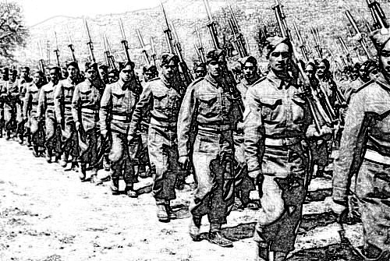

Umberto wanted to join them, but Romulus told him that it would be much better if he stayed out of the way. He was not trained the way they were and besides, they were leaving Algoma, Begonia and Harry under his protection. Domenico and Lucius left just before dawn the next morning. They took to the hills on both sides of the only road into the village and were just about invisible. Two hundred men with all their weapons and equipment are a lot slower than two men so they noticed their column of dust a little after noon. They trailed them until sometime in the late afternoon when the column halted and started putting up their tents. There was a large one that was probably going to shelter their commanding officer and opposite that a lot of four men tents. The soldiers stacked their rifles in pyramids of four next to each tent. The two assault vehicles were parked on the sides of the command tent. The commanding officer assigned four sentinels, one to each cardinal point and a little further from the encampment. Domenico and Lucius decided that they had seen enough and they headed back to meet with the rest of the group.

They described the lay of the camp and a course of action was decided upon. They will attack at dawn. First they will take out the sentinels. Domenico and Lucius would each climb on an assault vehicle and point the machine guns toward the main tent area. Walden and Romulus would stand to the sides of the command tent. Walden would start to bang a large spoon on a pan that he had borrowed from Umberto. The soldiers would jump out of their tents only to see the machine guns pointed at them. The officers would also jump out, trying to aim their pistols at anyone that seemed to be an enemy. Nick Carter and Dahlia would be awaiting them and they would throw shuriken at their pistol holding hands. It all went down just as planned. The officers, some with bleeding hands were made to stand in front of the men and Romulus walked in to face them all.

“My name is Romulus de la Montagna” he said. “I am the Lord of these mountains. The village of Pietrapiuma and everything in it, belongs to me. You are matching to Pietrapiuma to look for some spies. There are no spies, only me and my men. I could tell my men to kill all of you right were you stand, but I will not. I do not like unnecessary killing. Who knows, one of these days some of you may come and work for me. I would also like for you to tell everyone you know about what has happened and will still happen here today. I want all of you to do an about turn and march. I will follow and tell you were to stop. And about turn! Forward march!”

The military training took over and everyone obeyed the commands. Ten meters beyond the last tent, Romulus issued the halt command. There was a large field to the left so Romulus ordered them to turn left and march once more. Everyone kept looking for more enemies to pop out, but couldn’t see anyone else – still, they waited. Romulus commanded them to halt once again.

“I can see that you are looking for the rest of my men, but this is it. It is me, my eight sons, three of my grandchildren, the wife of one of them and our teacher and mentor Waldencraft. If you are Tuscan, you should know who we are. You might still want to test us and that is fine. To recap, there are about two hundred of you, and only fourteen of us. We are going to fight, but I would recommend that you do not all try to attack us at once. It will be difficult for so many of you to get to so few of us. Perhaps you might want to break up into smaller groups”.

“Do not listen” said their commander “attack and kill them all, this is an order”.

Romulus and his family formed a ring with Waldencraft at its center.

“That one, the one in the center, kill him first” yelled the commanding officer.

Most of his soldiers obeyed, but about twenty or so just stood aside.

“I am going to have you court-marshalled and shot” yelled the commander “Go, fight! What are you waiting for?”

“You are an idiot” replied one of them “If you were a Tuscan, you would know that these men are unbeatable”.

The commander fumbled at his holster forgetting that he had dropped his pistol when Dahlia had thrown a shuriken at his hand.

“I will deal with you all later” he barked.

Turning around he noticed that ten of his soldiers were already knocked out and the rest could only get to the enemy two or three at the time. He had to admit grudgingly that Romulus was right.

“Halt” he commanded. “Can I have a few minutes?” he asked addressing Romulus.

Romulus just nodded. The commander gathered his troops around him. He got one of them to bandage his bleeding hand while he picked his best fourteen fighters

“You were right” he told Romulus “doing the math I guess it comes out to about fourteen of us to each one of you. So pick one of yours”.

“Nick, you’re on”.

Addressing the commander he said:

“This is my grandson Nick Carter. He has a bit of a temper so you all need to fight fair. No fire arms, so if anyone has a hidden one, please drop it now”.

No one did, so Nick took off his shirt and moved about ten meters to one side. The fourteen chosen soldiers formed a loose circle around him. If they were intimidated by Nick’s muscles they did not show it. One of them pulled a large commando knife from his boot grinning. As strange as it sounds, in a fight of many against one, the many are at a disadvantage. At the most four of them can get to the one at the same time and even then they are a little in each other’s way. Nick kept turning around while the soldiers were trying to pick a good attack. They were actually quite well trained because without any visible signal four of them jumped at Nick. Nick dropped the one on his left with a hand edge blow to the neck while kicking the one on his right in the chest. The kick had so much force that it knocked him out and sent him flying into one of the other soldiers. One of the attackers in the back, managed to land a good blow on Nick’s left side, but it did nothing to slow him down. Nick jumped up and summersaulted behind the two who were in back of him. While still in the air he kicked them both in the head knocking them out. As he landed he was quite close to the one with the knife who did not hesitate and he managed to slice Nick in the back. There was a gash that started behind Nick’s shoulder and ended in the middle of his spine. It was quite deep by the shoulder blade where the attacker had first stuck his knife, but getting shallower as it approached the spine. No one paid much attention to the fact that there was very little blood. Nick dropped to the ground instantly and using his legs in a scissoring maneuver, he broke the man’s arm. He caught the dropping knife and while jumping high into the air he sent it flying to stick into the trunk of a tree that was about fifty feet away. More soldiers were attacking and Nick dispatched them easily. A palm blow to the chest for one stopped his heart for a few seconds and knocked him out. A kick to another’s head, a knee to a groin, a kick to another’s knee and four more were out of the fight. The commandant was watching and obviously getting quite upset, so he joined the fight. Pushing one of his men aside he got closer to Nick and assumed a boxing stance. It seemd that he had had some experience boxing because he was throwing quick punches and ducking, apparently warming up. His men let him get closer to Nick and Nick feeling playful, let the commandant hit his midriff. There were some serious blows, but Nick had trained a long time for this and of course none of that bothered him. He just wanted the soldiers to see what kind of fighter they were engaging. After a while he thought that was enough, so he smashed his right palm against the commandant’s nose breaking it. He followed that with a few right and left hooks knocking out some teeth and finished with an uppercut that lifted the commandant off his feet and sent him flying. He fell down unconscious. Two soldiers in what used to be a circle were still standing, but they made no move to attack and no one else seemed interested.

“So listen up” said Romulus “we are going to take your vehicles, but you can go back to your camp and pick up whatever you like. You have until noon to disappear. Go back to wherever you came from and never come back. It does not matter how many man you might send. Just remember what my grandson did and keep in mind that the rest of us are at least as good and that includes his wife Dahlia. I also have nineteen more nephews who are equally as fierce and well trained. You should also listen to the Tuscans who chose to stand aside and just watch. They know who we are”.

-%-

“So, this is it for now” said Petunia.

“That was really good” said Dougie.

“Thank you. I think we can wrap up the Tuscan Wine chapter next week. I want to think about it for a while”.

“O.K. see you at school”.

-%-

The next Saturday when they met Dougie raised an interesting question.

“I think we missed a little something. In the beginning of the chapter, we wrote that J.J. and Violetta met with the last descendants of the Pietrapiuma family. So where did Umberto come from?”

“You are right about that and I was trying to find a place to write about it. Umberto’s great-great aunt was a Pietrapiuma who changed her name when she got married. J.J. eventually tracked down her descendants and helped Umberto open La Rosetta. Umberto eventually decided to take back the Pietrapiuma family name”.

“I guess if we leave this in here, it will do as an explanation” said Dougie.

“I was thinking about that too and I think we mentioned that somewhere. It could be fun to leave some unanswered questions. So let us not explain every little thing. I actually have a good example of that which will fit nicely into the end of the Tuscany Wine chapter”.

“O.K. let’s hear it” replied Dougie.

-%-

The assault vehicles were a little too small, but they all managed to fit in and on top of them somehow. They got back to Pietrapiuma and Umberto got in touch with someone from the Italian resistance. Two men came and took the vehicles the same evening and made them disappear. There were not enough rooms for everyone at La Rosetta, so Umberto called Maurizio. Maurizio sent one of his men with a truck to pick everybody up. J.J. and Violetta were away on business, and Maurizio was watching their place. There were plenty of rooms if the brothers did not mind sharing, which they did not. In the evening, Clorinda showed up with their cook and her assistant. They fed everybody and plied them with Pietrapiuma wine.

The next morning, the same truck took them back to La Rosetta. They had a late but delicious breakfast and sat chatting and drinking wine with Umberto and Camilla. They mentioned that Maurizio’s two sons had studied abroad and were currently taking care of business; one in Switzerland and the other in Portugal. Their son Alberto was sitting there just listening quietly until at some point he asked for permission to speak.

“Mom, dad, we have been blessed with an amazing family. I would like to somehow take my rightful place in it, but there are not many opportunities here. I respectfully request that you allow me to go with The Wanderers and learn from them, if they will have me”.

Alberto at that time had just turned fifteen, but he was already as tall as he would ever be and that was quite tall, taller than any of The Wanderers.

“What do you think, Romulus?” asked Umberto.

“Not a bad idea. By the way, I guess calling us The Wanderers is as good a name as any, but there are nineteen more of my grandsons somewhere in America”.

“O.K. then, when they leave, you may leave with them” said Umberto.

“Take good care of my baby” added Camilla.

“Do not worry, he will be just fine” answered Romulus.

A uniformed policeman showed up just about that time. He stood just off the sidewalk, clicked his heels and bowed his head.

“Don Umberto, Donna Camilla, ladies and gentlemen. My name is Federico Fantini and I am the new head constable of this region. I have come to pay my respects and to inform you that for as long as I am head constable, no one is ever going to bother you again. I was born not far from here, so I do not need to be reminded of who you all are. Also as a point of interest, the battalion that you have defeated, has been sent to Africa. Their commandant has been stripped of his commission and sent with them as a private”.

“That is good to hear constable. Would you like to join us for a glass of wine?”

“I assume you only serve the Pietrapiuma brand so I will be honored”.

-%-

“We need to stop a little earlier today. I promised Begonia to help her with her math homework. I do have some idea as to where I am going with this, so I will continue in the morning”.

“O.K. have a good day then” replied Dougie.

-%-

“Hello Dougie, let us continue” said Petunia.

-%-

Three weeks after Alberto had left, he walked into La Rosetta around lunch time. His mom saw him first and she ran over and hugged him while making all kinds of motherly sounds. His father heard the commotion and came out of the kitchen.

“What happened? Why are back so soon?” he asked “Did Romulus change his mind?”

“Pops, I have been gone for three years” replied Alberto.

“Wow, let me take a better look at you. Yes you do seem a little bit different. For us it has only been three weeks”.

“You know that time does not pass the same way around The Wanderers”.

“Well, sit down son, mom will fix you some pasta. Let’s uncork a bottle of wine and you can tell us all about it”.

Camilla had just about finished preparing lunch, so she came out with a delicious platter of pasta primavera. Umberto poured her a glass of wine and she sat down with them.

“It was hard and sometimes annoying. I had to learn how to sit still and do nothing for hours at the time before my real training started. Even though it was slow starting, after a while they taught me so many things, that I wonder how they managed to that in only three years. Today, I am a better fighter than anyone in this country, other than The Wanderers of course. I also learned how to speak French, German, Spanish and English. I can probably manage Portuguese and Dutch if I have to. This war that Mussolini has gotten us into is a horrible thing that Hitler should not be allowed to win. I did see the future and it seems that he has lost, but we now know that time is a very strange dimension. Even though I know what I know, we still need to fight and win ”.

“Are you going to be safe son?” asked Umberto.

“I think we will all be fine, but there will be scars on our souls, because of things that we will do and others that we will fail to do”.

“You sure don’t talk like my little Alberto anymore” said his mom.

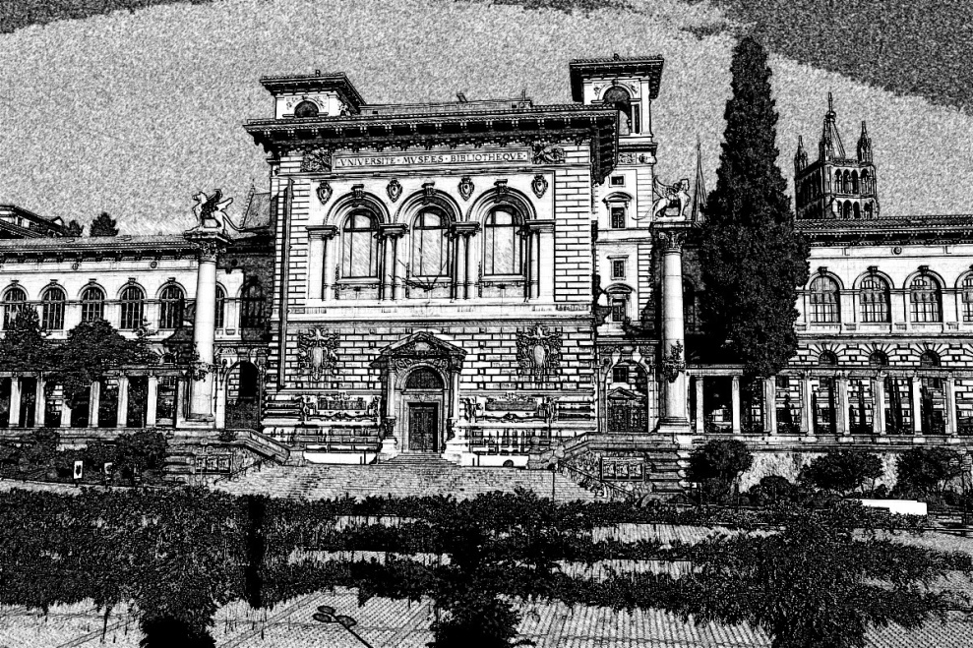

“In some ways, I am not him anymore, but don’t worry mom, he is still inside me somewhere. Anyway, I missed you, so I just came by to say hello. I am leaving in the morning for Switzerland. Uncle Marcelo has helped me get into the University of Lausanne. I am going to study international law. I also have a Swiss passport so I can travel pretty much anywhere I please”.

Alberto spent the rest of the day with his parents. In the morning, a young man and a girl drove into the village in a Mercedes-Benz. Alberto introduced them as his friends Florinel and Florica. They were twins, born in Romania but living in Switzerland with their parents. They were also going to study at the University of Lausanne. Camille made breakfast for everyone and they sat chatting for an hour. The twins Italian was not that good so once in a while Alberto was talking to them in French. The time came when Alberto said goodbye to his parents. His mom was wondering how he didn’t have any luggage.

“Don’t worry mom, I have a change of clothes in the car and the rest of my stuff is already in my room at the university campus”.

They hugged, kissed and Alberto and his friends drove away.

-%-

“That wraps it up nicely” said Dougie “I think I’d like to get back to the ladies.

“O.K. so how are they doing?”

-%-

20. THE PIPES OF EXILE

Myrtle, Lilia and Fleur came out refreshed after bathing at The Rosette in 1861. Lilia wanted to thank Marigold and perhaps have a glass of wine, but the place that greeted them was not the same as the one they had just left. It did have tables and a bar, but they were arranged very differently. They went to an empty table and sat down. There were only two other people at the bar, but apparently there was no waitress. Myrtle got up and walked over to the bar.

“Good day” she said “can I please have a bottle of wine and three glasses?”

The bartender looked at her kind of funny and she realized why when he addressed her in Italian.

“There are a lot of Frenchmen in town. What happened did the British decide to send someone? And women at that?”

“Sorry” replied Myrtle in the same language “I am learning English and sometimes I get my languages confused”.

“Hmm” said the bartender “here’s your wine”.

Myrtle took the bottle and the glasses and went back to the table.

“I just realized that we don’t know where or when this place is. I have a few coins but they are from the twelfth century” she told the others.

“Don’t worry” replied Fleur “I have a few diamonds”.

Myrtle filled their glasses and they toasted this and that. The bottle only held about four and a half glasses, so they finished it quite quickly. The bar was getting crowded and a lot of the newcomers were wearing a blue kerchief with a the same design.

“I am going to get another bottle and settle with the bartender” said Fleur.

While she was walking towards the bar some kind of musical instrument was sounding out in the street and getting louder. The door opened shortly and a man holding some kind of bag with pipes walked in followed by ten more men. They took over the three empty tables that were still available. Fleur got to the bar and asked for another bottle of wine.

“This time you will have to pay me” said the bartender.

“We’ve run out of coins” replied Fleur “but I have a diamond that will more than cover the bill”.

She produced a little bag out of which she pulled a diamond and placed it on the counter. The bartender looked at it and pushed it back.

“As far as I can tell, it’s just a piece of glass. You better figure out how you are going to pay me”.

A man standing on her right side joined in.

“I will take care of the ladies bill. Add another bottle and a glass to it”.

He put some coins on the bar and apparently there were enough of them because the bartender took them and he put another bottle and a glass on the counter.

“Thank you stranger, seeing that all the tables are taken, perhaps you’d like to joins us”.

“I guess I could, thank you”.

Fleur walked back to the table and the stranger doffed his hat and sat down.

“I am Fleur de Lys” she said “and my companions are Myrtle and Lilia”.

“It’s a pleasure my ladies. My name is Lorenzo Pietrapiuma”.

He poured wine into everyone’s glasses and raising his he toasted them with a :

“Well met, my ladies”.

They drank and he continued:

“Fleur de Lys is an interesting name. It happens to be the flower of the Bourbon royal family. The blue kerchief that some of these men wear has that design on it. They want to make sure everyone knows they are royalists who support king Louis XVIII. There is also a French ship by that name sailing these waters. They are keeping an eye on The Little Corporal, trying to make sure he does not escape”.

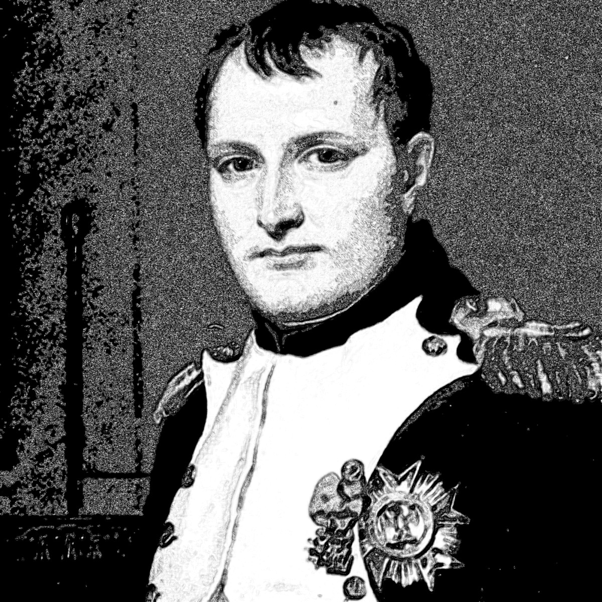

“And the ones that followed the piper, they are not wearing those kerchiefs” noticed Lilia.

“They are the supporters who wish that he did escape”.

Three of the kerchiefed men walked over to their table.

“I saw that diamond and I think it is real” said one of them “hand over the bag and no one gets hurt” he added while pulling out a knife.

Lorenzo tried to stand up but one of the other men pulled out a knife as well and placed it against Lorenzo’s throat. Lorenzo was starting to feel a bit panicky and he couldn’t understand why Lilia was smiling.

“Boys” she said “go back to your table before someone gets hurt”.

The one holding the knife looked at her with a strangely quizzical look on his face.

“I have no problem hurting a woman if there’s money in it” he said.

“And I, could use some practice” said Lilia while jumping into the air and kicking him in the forehead.

The one holding the knife against Lorenzo’s throat tried to cut her but Myrtle grabbed him by the neck and slammed his head against the table top knocking him out.

“It’s the Bonapartists” yelled out the third guy.
All of his buddies with the blue kerchiefs got up and started to come over. The other group that had come with the piper got up as well and intercepted them. Lilia hit the third guy’s neck with the side of her hand and sat down again. The bar erupted into a collective fight that lasted all of ten minutes. Lorenzo wanted to get up and join but Fleur put a restraining hand on one of his saying:

“It’s just a silly fight. You don’t need to participate”.

They sat there drinking while the Bonapartists kicked the Royalists butts. The bartender eventually got tired of it and he brought out a musket from below the bar which he fired into the air. The brawlers stopped.

“I have two more muskets below this bar” he said “I will shoot the next person who tries to fight. If you want to fight, go outside. If you want to drink, sit down and drink”.

Everybody went back to their tables, licking their wounds.

“You are The Wanderer Ladies” aid Lorenzo “at first I thought it was strange coincidence, but I know now”.

“O.K. Lorenzo, so where are we and what is today’s date?” asked Myrtle

“We are in a town called Piombino in Tuscany. Today is the 26th of February 1815. The Emperor Napoleon Bonaparte has been exiled here for the last nine months and a lot of his supporters think that he is going to escape today, go back to Paris and recapture his glory”.

“So, it that why you are here? Who’s side are you on?” asked Lilia.

“The truth is, I am not that interested in sides. These are things that do not affect little people too much. It is only important for the rich”.

“And yet, here you are, where it is all happening” responded Fleur.

“Last week I have turned eighteen year old. My parents are very poor and barely managing to survive working for the Marquis who owns most of the land in our area. I have saved some of my money and I thought that if I left, I might find my fortune somewhere in the world. I met some people who were coming to Piombino and they let me ride in their cart. I really don’t have any idea about what I should do next”.

“I know this might sound funny, but I have a feeling that we are here for you. Things will be just fine”.

The man who had been playing the bagpipes approached their table with a bottle in his hand. He placed it on their table and asked if he could sit down and talk to them. Fleur indicated that he could.

“I couldn’t help but notice that you ladies are some fierce warriors. I just wanted to complement you” he lifted his glass in admiration and took a sip.

“You are the one playing that instrument” said Lilia “what is it?”

“It is called a boha and people in my country play it sometimes”.

“Interesting sound – not unpleasant just different she added “anyway, why have you come here? From your accent I can tell that you are not from these parts”.

“True, I am from the Languedoc. Napoleon’s greatest knight, Joachim Murat came from the same place. Napoleon called him the ‘premier chevalier’ and he is now the king of Naples. Since Napoleon came to Elba, he is in all kinds of trouble, so a few of his landsmen and I came to see if we can help him in any way”.

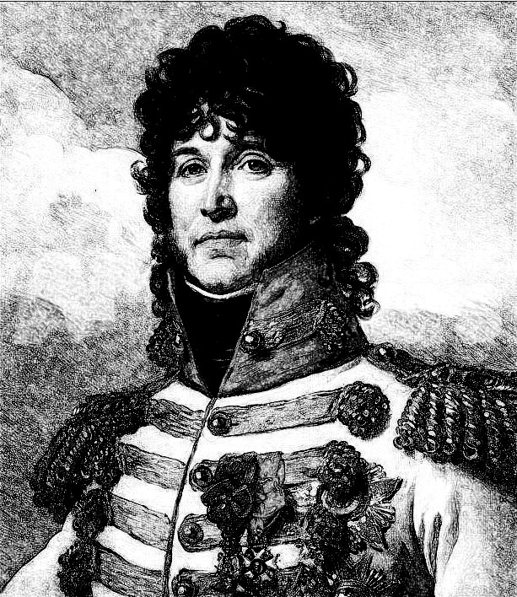

“Nice sentiment and thank you for the wine. Good luck to you” said Lilia raising her glass.

The Gascon toasted her and went back to his table.

“Listen Lorenzo” said Fleur “I am not going to tell you the long story, but for some reason, I am watching out for Myrtle and Lilia’s family. You probably do not know this, but the Pietrapiuma family is related to theirs. Your great-great many times great uncle Luigi went to America and his descendants are doing well in that country. Sometime in the future they will come to Tuscany looking for your great-grandchildren. They will only be there if you have some children first. It would be really nice if you went back to your parents. Do you have a pouch where you keep your money?”

“What?” he sked surprised.

“Well do you?”

“Yes, I do”.

“So, here are five diamonds that should bring a very nice price when you sell them. Take that money and buy a little vineyard. Someday, your wines will be famous all over the world”.

-%-

“That’s it for now. Let’s continue next week. See you in school”.

“Good bye Dougie”.

-%-

The week was uneventful and they met again on the following Saturday.

“I’d like to write a little more about something that we mentioned before” said Petunia.

“An what is that?” asked Dougie

“Time! We have some problems with time”.

“O.K. shoot!” said Dougie while opening the notebook.

-%-

The air in the bar shimmered for a few seconds and Lorenzo disappeared together with all the other patrons. They were still seated at the same table, but Newton, the science fairy had replaced Lorenzo. The table had some really good smelling food on it.

“Ladies” said Newton “I need to talk to Fleur about certain issues. I hope you don’t mind being included”.

“No that’s just fine” replied Myrtle.

Lilia just nodded while picking a piece of Jerusalem artichoke from her plate.

“This is tasty” she said after chewing and swallowing it.

“Chef Tony thought that vegetarian cooking might not always be great where you are travelling, my lady Fleur”.

Fleur had been sampling a few things herself.

“Tell him that we thank him very much and as usual, everything is delicious”.

“I will, but of course there are other things that you should know about”.

“Thank you, for coming. I know that you do not like to travel, so I assume this is important”.

“Well, I did not actually travel. I am sitting in the palace kitchen while you are still in that pub where you have met Lorenzo. We are in an ex-temporal pocket of convenience that I have created”.

“Well, thank you anyway – what is happening?”

“I have become aware of a disturbance in the space-time continuum. There were a few instances when I had lost track of The Wanderers. They seemed insignificantly short glitches, but I have just learned that they were actually quite long in their duration sometimes even one or two years”.

“I thought that was the case, but it afforded them a way to catch up with their contemporaries. It also gave Romulus and his sons an opportunity to acquire some of their children’s skills”.

“That is true, but as it was uncontrolled it made me worry, so I have been developing some more sensitive instruments. As of yet, all I can find is that there is some kind of tremor that has unexpected results. For instance, the times that I lost track of The Wanderers, they ended up in a parallel, unpopulated dimension. That is not a problem, but there are other dimensions that are not very friendly. I have a feeling that the Monghouls that Dahlia and Gabriel had fought have snuck through from one of those. It is also entirely possible that they are the of same kind that had attacked Waldencraft’s realm all those years ago”.

“So, where do we stand with this issue?”

“I will keep working on better instrumentation and I will let you know of new developments. I just wanted you to be aware just in case you end up in some unforeseen situations”.

“Well, thank you for that. Where is everyone else for now?”

“Romulus with his sons and three of his grandchildren with their wives have just left La Rosetta in 1940. Alberto went with them. The other nineteen grandchildren are having lunch at The Tarrytown Rosetta in 2018 and the three of you are still in 1815 Piombino”.

“Very well Newton, thank you once more. Keep us posted” said Fleur.

-%-

“I like it!” said Dougie. “Do you mind if I add something to it? It just popped into my head”.

“Go for it” replied Petunia while reaching for the notebook.

-%-

The air shimmered once again and Lorenzo was visible for a split second before being replaced by someone else. It / he /she was conforming to the usual human shape, but at the same time, there was a cloudy appearance to the air which made it difficult to resolve the exact form of the being sitting across from them”.

“My ladies” it addressed them in Italian “my name is Aviolar. I exist a distant time. You may think of it as the future , though that would not be precise. We do not view time in the same way that elves, humans or fairies view it. Still your science fairy, Newton has a correct idea. There is some kind of disturbance in the space-time continuum. A few of my colleagues as well as myself, have been, are, will be investigating. I just thought that this might be an appropriate time to introduce myself. I will get in touch again sometime in the future / past. Have a lovely day!”

“That was interesting” said Lilia “I guess the world is a lot stranger than I have previously imagined”.

-%-

“I thought we were keeping Aviolar and other aliens for our next book” said Petunia.

“I just couldn’t resist” answered Dougie “it is a nice teaser and I don’t think he will show up again in this book”.

“Well, let’s see if your mom likes it”.

“O.K. then, see you again in the morning.

-%-
21. LILIA MEETS ELVIS

“Good morning Dougie. There are some things that I keep thinking about. I’d like to talk about them a little”.

“O.K. let’s talk” replied Dougie.

“First, there are Pietrapiuma and Stonefeathers throughout the story, but now that we have given Romulus a surname, how come we have not run into any ‘de la Montagne’ descendants?” And by the way, I was re-reading the stuff and we forgot to mention that ‘de la Montagne’ means of the mountain in Italian and Romulus only came up with it when he started to realize that all the people in later times, had surnames”.

“I do not know why there have not been any descendants of Romulus. But, so far it seems that all the issues resolve themselves somehow. I think this will be explained later on. I was also thinking that with so many Pietrapiuma and Stonefeathers throughout the ages, some of them are obviously dead. But if we can travel and visit them in their time anytime we please, are they really dead? Does death mean anything in a Universe that has time travel?”

“That is a very good observation. I think we should keep that in mind and expound on this subject in the next book. But in the meantime, we still need to finish this one. What we have so far is quite good, but we need another 18 – 20 thousand words. I looked it up and the general recommendation for a young adult book is somewhere around 60,000 words. Also The Wanderers still need to age at least another four to five years to match the ages of their mates”.

“Hmm, I thought we needed more time” replied Dougie.

“Well, we just skipped three years while Alberto was training with them, There were quite a few other things happening in between so, I think we can round it up to fifteen”.

“O.K. when you put it that way, it makes sense. So, what else do you think we need to achieve, before we close this one?”

“Let us start with the easiest one: Absalom and his cousins in 2018 - they only need to wait two more weeks, so we will find something for them to do. Next: The Wanderer Ladies – Only a few months have passed for them and they do not need to age anymore at all, so I think we can send them to 2018. There are some things between Lilia and Elvis that need to be resolved. So what we are left with are Romulus and his sons as well as the three grandchildren and their wives. Romulus and his children need to age, but the others do not. I think we should split them up again”.

“That’s a pretty good summary, Petunia. Here’s what I was thinking. For the most part, the action took place in the Hudson Valley and in Tuscany. But we slowly sent characters to other places. I think it’s about time we followed where they went. I really want to know what is happening with Vittorio and Marcello. Also how is Alberto getting along at the University. And one more thing, whatever happened to J.J.?”

“So, let’s keep going” said Petunia “write”.

-%

“Very well” said Lorenzo “I will heed your advice. Thank you Princess Fleur, and goodbye to you ladies”.

With that he got up and walked out the door. They were getting quite used to the shifting sensation and they found themselves seated on a large sofa in some kind of office. There was no one else in there, but in a very short while, Daisy walked in.

“Why hello Princess Fleur” she said “please let me announce you”.

She walked into Elvis’ office saying:

“Princess Fleur and two other ladies have just appeared in the waiting area. I don’t know how they got there, but I am not going to question it”.

“Please show them in” he said.

As soon as Daisy showed them in, Elvis jumped up and went over to kiss the back of Fleur’s hand.

“Elvis, I’d like to introduce you to Myrtle and Lilia”.

As they were introduced, Elvis walked over and kissed the back of the other ladies’ hands.

“Please have a seat” he said pointing at some chairs. “Daisy can you please make us some Irish coffees and ask my brother to join us?”.

Cliff W. walked in and got introduced. Daisy followed shortly with a tray. There was a pitcher, a bottle and some cups. She proceeded to assemble Irish coffees for everyone.

“Oh, sorry, this is my secretary Daisy” said Elvis.

They drank a little coffee which both Myrtle and Lilia thought was very tasty.

“The time is drawing near” said Fleur.

“And speaking of time, there was a guy in the seventeenth century, I think, who told me that someone named Elvis is waiting for me in 2018. I guess it must be you. He also said that you are going to come with me when I leave here” said Lilia quite undiplomatically.

“I would prefer that we talk about these matters a little later, if you don’t mind”.

‘I guess so. Fleur said that we will be here a few weeks, so we have time”

“Daisy, please reserve another suite at the hotel”.

“O.K. I will”.

They got settled into the hotel and the next day Daisy took them on a shopping spree. Well, there was not much that they were interested in, but when she tried on a pair of dungarees, Lilia was fascinated. Myrtle seemed to like them as well. Elvis continued to take care of his business, but he made sure to have dinner with them every evening. On the coming Saturday, he got a stretch limo that drove them to Tarrytown. They had lunch at The Rosetta and Elvis introduced them to Daphne and Luigi. After lunch they drove out to the barn to watch the grandchildren play baseball. Absalom came with them to The Rosetta after the game. Elvis put on some music on the jukebox and asked Lilia to dance with him.

“I don’t know this dance” she replied.

“It’s real easy, I’ll show you” he said.

The melancholy notes of Love Me Tender filled the room.

“What is this song” she asked “I like it”.

“It is Elvis Presley, the guy that I was named after” he replied.

“You know, ever since I heard that you were waiting for me, I kept wondering. I was never interested in boys very much. Please don’t get me wrong, you are a very attractive man. But it strikes me as sad that things are out of my control. If people in the seventeenth century already knew that you are going to go back with me to the twelfth century, I may not have any say in it”.

“I know exactly what you mean” he replied “but, I find you strangely attractive just the same. As much as I sometimes think that I should try to resist my fate, I also wonder if perhaps it is not such a bad one. Living in twelfth century, is supposed to be a lot more difficult than living in the twenty-first. But, that is not even the real issue”.

The song ended and Elvis, the jukebox one, went into Are You Lonesome Tonight. She looked into Elvis’ eyes, the one she was dancing with and she thought that she could see a scared little boy somewhere in there. For a moment she felt like she wanted to shelter and protect him. Perhaps it was not such a terrible fate, she thought. Fleur and Myrtle were chatting with Daphne and Luigi, but at the same time they kept an eye on the dancers. When the song ended and they sat back down, Myrtle commented that they looked real good together. Lilia gave her a dirty look.

Back at the hotel, Myrtle wanted to talk about it.

“You know Lilia, I have married Octavio when I was very young. I barely know him anymore and I even carried his child. Back when he was making all those paintings of me, I was very happy. I still love him, but so much time has passed that I hope it is not just the idea of him that I love. After all,, it’s been almost nineteen years. It is a little scary, you know. But at the same time, it is also exciting. You are my sister and my best friend and I wish for you to feel those thing as well”.

“That is sweet” replied Lilia. “But, you just fell for him of your own free will. How do you think it feels to have to fulfill a thousand year old legend?”

“I can’t say much other than it has only been nine-hundred or so”.

Lilia punched her playfully and they gave each other a hug.

“Nothing has been the way it was before Octavio and his brothers went to Vallonia” continued Myrtle “ I just hope that it will be over soon and we can continue our interrupted lives. And Elvis is quite fetching”.

“Let me sleep on it. It was quite a tiring day” replied Lilia “good night”.

“Good night”.

-%-

“O.K. we’re really getting there” said Dougie “see you in the morning in class”.

“Yes, good night”.

-%-

22. NAZI SPIES & CHOCOLATE FONDUE

“Hey Petunia, are you there?”

He waited a few minutes and tried again.

“Hi”.

A couple of minutes later she texted him back.

“What’s up?”

“I just thought of a good title for the next chapter: Nazi Spies & Chocolate Fondue”.

“What’s wrong with cheese fondue?” she asked “I love cheese fondue”.

“Yeah, me too, but it does not have the same ring”.

“O.K. so then what?”

“Romulus and the grandsons are splitting up, just as we discussed. It is 1941 and Alberto has been going to UNIL for a year now. He is doing well”.

“What is UNIL?”

“Oh, acronym for University of Lausanne”.

“Oh, all right”.

“Switzerland is neutral and rife with Nazi spies. Alberto is helping his uncle Marcelo in spying for the Allies. He gets in trouble with some of the Nazis and Nick with his cousins come to the rescue”,

“Sounds interesting. But it’s late, let’s talk about it on Saturday”.

-%-

“I did some research over the week” said Petunia. “You probably know that WWII was a horrible war. Writing about things that happened during that war will not be easy”.

“The United States only joined the war on December 7th of 1941 after the Japanese bombed Pearl Harbor. I wanted to write about something that happened around May and had to do with spies. I also did a little research and I think I have a good idea”.

“O.K. let’s hear about it”.

-%-

Marcelo was having a cup of coffee in the library. Alberto and Florin should have been back a couple of hours ago, but they were very late. In addition, he had sent Florica to trail them and she hadn’t returned either. The silence was broken by someone using the knocker on the front door. His manservant went to check and came into the library shortly after.

“There are some people who claim that they are lost. One of them addressed me in English, but when I replied in Italian he had no problem with that”.

“Thank you Enrico. I will talk to them”.

He placed a revolver into his house coat pocket and went out to the foyer.

“Good afternoon” he said “how may I help you?”

“Good afternoon replied one of them. My name is Nick Carter. These are my cousins Domenico and Lucius and our wives Dahlia, Begonia and Algoma. We seem to have lost our way”.

“My name is Marcelo Pietrapiuma, but I did not hear any vehicles. Where you hiking? You do not seem dressed for the occasion” he replied while sticking his hand into his pocket.

“Well if you are a Pietrapiuma then we are not lost. As a matter fo fact, we are probably here to assist you resolve whatever issue you currently have. I hope you are not going to pull that thing out of your pocket. It will not work very well against us”.

“Interesting, however I would need some more information, in order to make my own decision” replied Marcelo.

“If you are a Pietrapiuma, than you should have heard about us. We are some of The Wanderers. You probably also know Umberto and his son Alberto. We were there some time ago straightening things up a bit”.

“That was last year – I heard all about it”.

“So tell us, what can we do to help?”

“I guess, we’ll have to sit down for the story. Please follow me. Enrico” he said addressing the manservant “please have the cook send a pot of coffee, a pot of chocolate and all the fixings into the library”.

“To start with, I guess the first thing that you’d like to know is that we are currently in the city of Zurich in the country of Switzerland. The date is May 15, 1941”.

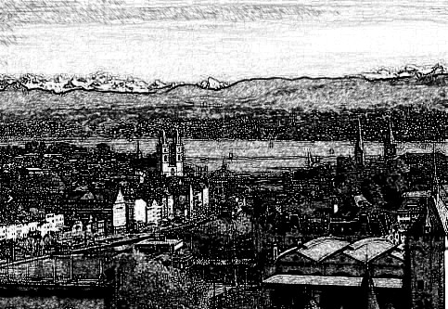

Enrico walked in to announce that Florica was just driving into the yard. She walked into the library shortly and Marcelo made the introductions.

“Florica and her twin brother Florin are friends and classmates of Alberto. He told her a lot about The Wanderers though I think she is quite skeptical about it all. Anyway, the entire world is engaged in a brutal and useless war. There are very few countries that are not involved. The number one warmonger is a man named Adolf Hitler. Though he was originally born in Austria, he is now the absolute ruler of Germany. Italy’s dictator, Mussolini, has decided to be his ally. At this time, the German army controls most of Europe and parts of Africa. Japan who is their ally in the Far East has made some serious roadways into Asia. The United States of America, has so far stayed out of this war. Germany has been trying hard to keep them out of it. The part that concerns us has to do with a German American named Fritz Kuhn, who has started a party in the USA that is friendly to the German Nazi party”.

“I’m sorry Marcelo. I don’t think we have time for this long story” interjected Florica”.

“I’m guess you’re right. I apologize, I thought they need to know what we are fighting for” replied Marcelo.

“We are fighting for our family” jumped in Algoma. “I’d actually like to hear the rest of happened, but if Alberto is in trouble, Nick and the others have to move.”

“I followed Alberto and Florin, as you instructed. They were picked up at the designated street corner and driven to some kind of warehouse. I followed the pick-up car and I stayed way back so they did not spot me. I waited for an hour and they came out. Alberto and Florin had their hands tied behind their backs, so I guess their cover was blown somehow. There were three men with guns and they got into a large van and drove away. I followed them to another warehouse and then I took off and came back here”.

“Did you see how many men were in the other warehouse?”

“No, I did not” she replied.

“But you know where it is, right?”

“I do”.

“O.K.: said Nick “take us there”.

“I can give you a few guns” said Marcelo.

“No, we don’t want to kill anybody. Besides, we never learned how to shoot a gun”.

“Are you sure about this?”

“Did Alberto demonstrate some of the things we have taught him?”

“Yes he did” replied Florica “it was quite impressive, I don’t know how they caught him”.

“Well, he only trained for three years. I trained for eveleven and my cousins here trained for about eight years. We will not have any problems”.

“But they did catch Alberto” she replied.

“Maybe he let them. Anyway, you just drive, we’ll do the rest”.

“I’m coming with” said Dahlia.

“O.K. let’s go”.

Dahlia, Domenico. Lucius, Florica and Nick Carter went out, got in the car and drove away.

“I’m still curious about the rest of your story Marcelo “said Algoma “please go on”.

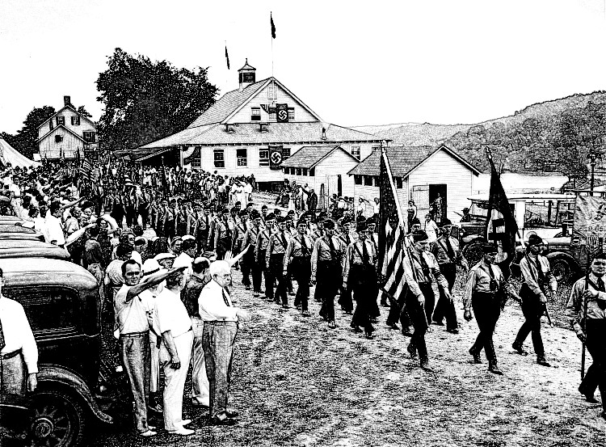

“The German American Bund as Fritz Kuhn called it, has been quite successful from 1936 until 1939. Hitler was not too happy, because it seemed that the Bund was turning American public opinion against him. The American government was not happy with him either, because he caused a lot of trouble and rioting when he had one of his rallies. They decided to investigate him and they found that he stole a lot of money and he did not pay his taxes, so they put him in jail. Apparently, Hitler was O.K. with that situation until a couple of months ago. On March 11 of this year, the American lend-lease act was signed into law. What it says is that the United States will help the Allied forces with weapons, money and other things. That effectively ended the USA policy of neutrality. There is an organization called the America First Committee (AFC) that is very unhappy about it. Some members of the AFC have started a campaign with the final purpose of releasing Fritz Kuhn and reinstating him as the head of the Bund. That’s about where we come in. Through my banking connections, I became aware of a group that was forming in Zurich. It was comprised of some AFC members, some Nazi sympathizing German-Americans as well as various French, Italian and Turkish members. This is where we came in. We were trying to get the names of all members as well as freeze their money”.

Florica pulled the car off the road and stopped.

“The place is just around the next bend, but if I drive, they will see me” she said.

“That’s O.K. just stay here. We’ll call you”.

There were some trees that offered some cover, but they ended some fifty meter from the building. The four of them stayed and observed the place for about fifteen minutes. The place was a large hangar-like building, built on the side of a mountain, so they had only three lookouts to take care of. Dusk was falling, so they waited fifteen more minutes before tackling the lookouts. The guys knocked them out quietly and efficiently, while Dahlia was making sure that no one else was coming out. Looking through the windows they saw two men tied to the chairs they were sitting on. There were six other men standing around watching while a seventh was picking up a pair of pliers from a table with tools on it. The rest of the hangar was filled with a variety of boxes.

Moving to the side a little Nick and company tried to come up with a plan. They needed to get in and close enough to those men to engage in hand to hand combat before any shots were fired.. Dahlia suggested that she walk in and tell them her car had broken down and she was looking for help. Nick was not happy with the idea, but he couldn’t come up with a better one, so that’s what they did.

Dahlia opened the little door cut into one of the huge sliding doors and walked in. Right away two of the men pulled out their guns and aimed them at her.

“Halt” yelled one in German “hands up”.

Dahlia stopped and raised her hands. The two men with the guns walked over to her and one of them stuck his gun into her back pushing her forward towards the one with the pliers.

“Who are you and what are you doing here?” he asked in German..

“I don’t understand. Please, my car broke down and I was just looking for help” she answered in Italian.

One of the other men translated and the plier man instructed the man with the gun in her back to search her. He put away his gun and walking around her he tried to search her. As soon as he put his hands to the sides of her body she slapped him yelling out:

“Don’t touch me you pig!”

The other men thought it was funny and started laughing. That distraction was all that Nick and his cousins needed. They ran into the hangar while Dahlia knocked out the guy who had tried to search her. The other guy with the gun aimed it the attackers, but Dahlia threw a shuriken at his hand making him drop his gun. Two other guys pulled out guns and she did the same to them. By then Nick had reached one of the conspirators and he knocked him out with a blow to the heart. Domenico and Lucius knocked two others out with jumping kicks to the head. The last one was standing too close to Alberto. His hands were tied to the chair arms, but his legs were free, so he sent a serious kick into the last man’s groin doubling him over in pain. The one with the pliers tried to hit Dahlia with it. She sidestepped the blow easily and smashed his nose with the palm of her hand. He tried to hit her once more and she knocked him out with a knuckle to the throat. Nick picked up a knife from the table and cut the ropes that were tying Alberto and Florin to their chairs.

“Good to see you guys” said Alberto “This is my friend Florin. Florin, there are Dahlia, Domenico, Lucius and Nick Carter. They are some of the guys that I had trained with, that I have told you about”.

“Nice to meet you” said Florin.

“So, what happened? How did they get the drop on you?” asked Nick.

“I guess I let down my guard. We had brought a lot of money to help with their cause and I assumed that it was a good enough cover. We had planned this for more than a month, during which time I had met with Heinrich and some of his men three times. Heinrich is the one who was holding the pliers. He was going to pull some of our nails to get information out of us”.

“What were you trying to accomplish with your mission?”

“We need names of everyone involved in this conspiracy”.

“Do you think Heinrich knows them?”

“I’m sure he does. He seems to be the leader of the German faction”.

“O.K. let us tie him to your chair. Florin please find some water that we can splash in his face”.

Florin came back with a tin can filled with water and he threw that into Heinrich’s face. It didn’t do the trick so he had to do it two more times before their prisoner finally opened his eyes.

“Who are you people?” he asked.

Nick slapped his face rapidly five times leaving red finger marks. It was so fast that Heinrich only managed one scream. Nick placed his pointer finger over his own lips in the Universal sign of silence.

“I was not happy with the pliers scenario. I think I can do the same to this guy and get him to talk”.

“It’s too messy and time consuming” said Dahlia “I can do much better. My sensei has taught me pain inflicting techniques that will be much more efficient”.

“That sounds good. Let’s give him a sample” said Nick.

Dahlia did something to Heinrich’s elbow that made him scream in agony.

“What do you want” he asked.

“One more time Dahlia”.

This time she used a pressure point just above his left clavicle. It was probably just as painful or perhaps even more painful judging from Heinrich’s scream.

“Florin” asked Alberto “look for your notepad and pen. I think he’s going to sing”.

The notepad that Florin usually carried in his pocket was on the table. He picked it up. Nick pulled up the other chair to face Heinrich. Heinrich’s face had turned white and he was obviously still in pain.

“I’ll tell you everything you want to know”.

“Names” replied Nick in German.

Heinrich rattled off some names and Florin wrote them all down.

“That sounds like the Germans” said Alberto also in German “we also need the Americans, the French, the Italians and the Turks”.

“ I do not know all of their names” answered Heinrich.

“I’m sure you know who the leaders are and probably their assistants, so let’s hear it” said Alberto.

Heinrich gave them some more names.

“What should we do with them?” asked Florin.

“Just leave them here. When the others wake up, they can untie Heinrich and they can all try to run. I don’t think they will get far, especially since the two of you are going to take their van”.

“Why not kill them?” asked Florin.

“Florin, you are a young boy” replied Nick Carter “killing another person will leave a mark that will never rub off. Also, we promised never to kill another person and though it is a hard promise to keep we’ve done well so far”.

When they got to their car, Florica was there waiting patiently.

“You seem quite calm” said Dahlia “weren’t you worried?”

“Not really, especially since I saw everything you all did. I was not going to get involved, but if anything went wrong, I needed to know what to tell Marcelo” replied Florica.

“I guess you’re a pretty good spy. We did not notice you”.

They drove back to Marcelo’s villa. The money that Marcelo had put up had been in the van so Alberto brought it with him. Two more people had shown up since they had left. Marcelo introduced them as Max and Spencer.

“Not their real names obviously, but good contacts to have”.

When they spoke it was obvious that they were British. Marcelo gave them the list that Florin had compiled and they said good night and left.

“We don’t usually do this so late, but I wanted to show my appreciation and leave a better impression of Switzerland with all of you. So I have asked my cook to prepare a chocolate fondue. I hope you enjoy it. We’ll have to move to the dining room”.

Everyone sat around the large table. There were little desert plates for everyone as well a few trays of peeled fruits cut into bite size segments. There were also a few bowls of banana bread. A servant brought out two fondue pots filled with hot chocolate. The chocolate was kept hot by some burners that were placed under the pots. Marcelo showed them how to use the long two pronged forks to spear a piece of fruit, dunk it in the melted chocolate and eat it. It was truly delicious.

-%-

“This was not bad at all. I think we are getting near the end of it. The only thing is, I’d like to end it all with a bang, you know. Something spectacular that will be the last hurrah of The Wanderers. I was thinking some kind of war” said Petunia.

“Not a bad idea. How about it happens after they are all re-united in 2018” answered Dougie.

“O.K. let’s think about it, Good night”.

-%-

They met on the next morning,

“I have a few ideas” said Dougie.

“Me too” replied Petunia “I’ve been thinking about this for a while now”.

“O.K. I have a good name for the next and last chapter and a story to go with the name” said Dougie.

“And I have some cool names for the time travelers from the future who come to talk to The Wanderers and their entourage. I guess you get to start because you have the name. Let’s hear it”.

-%-

23. THE WAR TO END ALL WARS

The Kizilrmak is the longest river flowing entirely within the land of Turkey. Kizilrmak means the Red River and before the 27th of May in the 585 BC it used to be called the Halys river. It also used to be the border between the lands of Lydia and Media. The Median and Lydian armies had been fighting for more than six years and the Halys river ran red with blood for most of that time. On that particular date a solar eclipse took place. It was interpreted by both kings and their armies as a sign from their Gods so they stopped the fighting and reached some kind of agreement. People started referring to the Halys as the Red River because of the blood and that name stuck. Also everyone agreed that a war like that should never happen again and that it was surely The War to End All Wars.

-%-

“Let me take this for a couple of paragraphs” asked Petunia”.

“Go on”.

-%-

That was how Gunther Steinfeder had started his explanation. But we are jumping ahead. Let us get back to the Tarrytown of 2018.

Absalom’s baseball teams were battling it out once more. Everyone was watching this time. Even J.J. and Violetta who looked really well for a couple that was supposed to be over one hundred years old. They had showed up just a week before and they were telling a tale of flying over the Bermuda Triangle in 1947 and finding themselves in 2018 without experiencing any kind of time passage. The game was exciting as usual and the score was getting really high when Begonia noticed some strangers amongst them. She poked Domenico who looked at her annoyed. She indicated the strangers with a move of her head. The game had just ended and he didn’t notice who had won. Not that it made much difference they usually took turns. Domenico walked over and addressed the strangers:

“Good day! My name is Domenico, and who might you all be?”

“My name is Gunther said the tallest of them. But it would be easier if I explained this to everyone. It concerns all of you”.

All of a sudden some more people appeared as if out of nowhere. Gunther walked out front followed by his group.

“Hello everybody. Please allow me to introduce myself. My name is Gunther Steinfeder. These are my colleagues:

Francois Pierreplume
Abner Ebennotza
Samir Hijerrisha
Chang Shi-Yumao
and
Athumani Jiwe-Manyoya

I guess some of you recognize the surnames. They all mean Stonefeather in German, French, Hebrew, Arabic, Chinese and Swahili respectively. Let me tell you about the Kizilrmak. Please have a little patience and all will be explained. He then told them that story about the Halys river and The War to End All Wars.

“You may have noticed some other people that you do not recognize. They are your family. Luigi form the seventeenth century and Luigi from the twentieth. Mario and Chicago and Adsila and Daphne. In any language, we are the Pietrapiuma who were entrusted with assisting The Wanderers in their quest”.

-%-

“My turn” jumped in Dougie.

-%-

“The War to End All Wars had the opposite effect. It was actually the beginning of a struggle that has lasted for two and a half millennia of your time, but in other dimensions it has been going on forever. The six of us have come here form periods that range from three to six hundred years in the future of our world. A confrontation that will take place later this year, is going to be critical to the future of the human race. Some of you know that Fleur de Lys is an elf. She is however a very close cousin of the humans, as are the fairies. So the outcome is just as important to them as it is to us. We are here to train and teach you about modern warfare. It is true that The Wanderers are the finest fighting force that ever was, but that may not be enough. We know that you promised not to kill and that is admirable and we support that sentiment. But the enemy does not have the same limitations. We would like very much, to find a way that will help all of you stay alive as well. We cannot bring future weapons into the present – it would cause a major disruption and that is something that neither we, nor our enemies want to see. We can however use current technology and that is something that most you are not familiar with. Which is why we are going to set up base in this field and train for the next six months”.

Romulus raised his hand waiting to be acknowledged. Gunther pointed at him and gave permission.

“Can you explain what we are supposed to accomplish and why does it sound so difficult?”

“We are going to rescue one individual from a ruthless and illogical enemy whose numbers are much larger than you can defeat with your primitive combat methods. It will take a lot more than that even though at the end it will still come down to face to face combat. The man that we are looking for is the grandson of J.J. and Violetta Van Leuwenhoek. Their family is newly allied with ours, but Nathaniel is a critical player in this ridiculous war”.

-%-

“I gotta add some stuff” interrupted Petunia.

“I was just warming up, but go ahead” said Dougie.

-%-

One of the others tapped Gunther on the shoulder indicating that he’d like to say a few words.

“My name is Abner Ebennotza. Gunther didn’t tell you that just like all of you, our families insisted that we have to speak Italian. So all us speak Italian fairly well. But that’s just an aside. What I wanted to say is that some of you seem bewildered. You all know about time travel and the exploits of The Wanderers, but you’re thinking: ‘I’m not a fighter - I’m not sure I can help with any of that’. That’s not true! Everyone will have some kind of role. A war is not fought by the soldiers alone. There are usually more people who support the soldiers than there are actual fighters. In order for a soldier to be able to train as much as possible, he needs people who can cook for him, launder his clothes, set up his camp and training facilities and many other things. In addition, sometimes we need to be reminded what we’re fighting for. Also the companionship of our family makes it easier”.

“It takes time to build a good kitchen” interjected Chicago.

“Not to worry, time is something that we have plenty of. You just let us know how you’d like your kitchen to look. In addition, we will of course supply any ingredients that you need”.

Chang tapped Abner on the shoulder and had this to add:

“Hi, I’m Chang Shi-Yumao. Some of you are familiar with Chinese cooking methods. Let me just add that I am an amateur cook and I will gladly teach some of you about our way as well as our spices”.

-%-

“Can I continue now?” asked Dougie.

“Yeah I’m done for now”.

-%-

Gunther took over again.

“So, we will split into a few groups and start putting our base together in the morning. In the meantime, we will all sleep in this field. We have sleeping bags for everyone which might be a little uncomfortable, but starting tomorrow morning we will make better arrangements”.

Building a secret military style facility may seem like a very difficult task in 2018 and it really is. There are many government agencies watching for that kind of activity. On the other hand, having all the time in the world at your disposal makes it a lot easier. The first thing to do was erect a very large air supported structure.

They bought army style cots for everyone in 2010 China. The modular partitions erected around the cots to add some privacy, came from 2005 Chicago. The cooking and refrigeration equipment came from 2015 Korea. The idea was that even if someone was tracking them, they would disappear without a trace. There were a lot of other details involved in putting together such a large operation. Things like, propane tanks, generators, water supply and so on.

Half of the huge structure was a turned into a command and intelligence gathering hub. It was a lot more difficult to hide those purchases. They needed the latest tracking, surveillance and computing equipment. Elvis decided that the best policy, might be to involve the New York FBI office. Cliff W. was actually dating one of their agents. Zinnia was younger than him, but they had dated quite a few times and he liked her a lot. Apparently, she liked him as well because one evening over dinner, she told him that there seemd to be some interest in a field outside Tarrytown, and that he apparently was involved in that somehow. She wanted to know what that was all about. He hesitated for only a moment.

“I am indeed involved and I’m glad you asked me about it. I intended to tell you when the time was right. Anyway, join me tomorrow morning and I will show it to you. Just for the record, it is a large private operation that is pro-American and is intended to strike a blow against our enemies”.

“Tell me more” she asked.

“Tomorrow” he replied.

He picked her up the next morning and drove her to Tarrytown.

“Our base of operations” he explained when they walked into the command tent.

“So, what is this all about?” she asked.

“I will let Gunther explain” he replied and introduced them.

“I’m pleased to meet you. I realize that it is difficult to keep an operation like ours secret. I just hope that you will not be adverse to our objective. Which is quite simple. We need to rescue someone from an ISIL base in the Sinai”.

“That is a very lofty goal” she replied “also I don’t see how that can be possible without a very large military operation”.

“We have some resources that are beyond what your military is capable of. I will gladly have you working with us, if you’re interested. Cliff W. speaks highly of you”.

“As long as we are not going to break any laws, nor try to overthrow our lawfully elected government, I think I wouldn’t mind”.

“Well then, the question is, did you so far see anything that might make you think otherwise?”

“So far, nothing that you are doing is illegal. It is however strangely irregular. I might have to report this to my superiors”.

“Just so we understand each other, I hope that they will not try to interfere. We will take no action against them or you, but this operation can disappear in a matter of hours. We will continue somewhere else. I’d rather have some kind of support from your government. Please relay the message correctly.”.

-%-

“Hey Dougie, my turn” said Petunia.

-%-

Even in the secret corridors of spydome, bureaucracy takes its regal place. It took almost a week before Zinnia’s message got through to the proper places. In the meantime, the training was going on. More contemporary family members were brought in as necessary:

Aarav Pattarpankh - India - IT expert.
Marin Piatrapana - Romania – cryptologist.
Alexander Kameni Perov – Russia - surveillance analyst.
Constantin Petraftero - Greece - electronics master.
Thijs Steenveer – Netherlands - terrorist profiler.
Marion Stonefeather – Australia – drone expert.

Zinnia kept coming by every day to observe the developments. At the end the week, she showed up with three other men.

“James, Joe and Jack” she introduced them “were sent by some government agency that prefers to remain nameless. They will observe and report to their bosses”.

By that time, there was a mock-up of a possible ISIL base a little bit away from the two tents. Simulations had been started. The fighting forces consisted of The Wanderers with Alberto, as well as Myrtle, Lilia and Dahlia who could of course not hear otherwise. Fleur was not going to fight and Waldencraft preferred to observe. They took turns every day, but basically it was ten attackers versus twenty five defenders to give them the impression of uneven numbers. Of course it was unfair. There was no way that the real defenders were going to be as good as these ones. Samir, who was in charge of the simulations insisted that what they needed to learn were the possible reactions of the defenders. James, Joe and Jack watched for the first day and the next day they came back with some criticism. They were wondering why the attackers had no weapons. The defenders were shooting rubber bullets at them and they were not shooting back. Samir explained that there was a no kill kind of situation. It baffled the three, who secretly were actually some black-ops killers. They also pointed out some things that they thought were unrealistic. Some points that they made about the defenders sounded logical. The ones they made about the attackers, not so much. At some point, Nick Carter got hit with a barrage of rubber bullets which did not slow him down very much. James, Joe and Jack kept laughing at it saying that this looked more like a Hollywood movie set than a combat simulation.

Nick heard about it and he challenged them. They thought it was funny so of course they agreed. Nick got them rubber bullet pistols. The three of them were fifty meters away from Nick when he started running towards them. They emptied their pistols into him without missing even one shot, and he kept charging. Dropping their pistols they went into defensive martial arts stances. It was a bit longer than Nick had anticipated, but they were no match. He knocked them all out in less than five minutes. When they came to, they were not happy, but they had to give credit where credit is due.

“Hey where did you learn those moves?” asked James.

“My teacher is standing right there” answered Nick pointing at Waldencraft”.

“Any chance you can teach us?” asked Joe.

“I might, if you promise to give up killing” answered Walden.

“All that aside, you are going about this all wrong” said Jack. “I don’t understand the purpose of you simulations”.

“The main purpose is to acclimate everyone with the sound of gunfire as well as the force of a hit against their Kevlar vest, or limbs” replied Romulus.

“Well, I still think you should do some night simulations where everyone gets to practice stealth moves with their night vision goggles on”.

“That’s a good point, we will do that starting tomorrow”.

One other important part of the plan was to disable all machine guns and assault vehicles. Which is where Marion came in. As Alexander was already working with drones, he would also help in that task, but Marion did not want to have any potential errors or glitches, so Zinnia started training as a third drone operator.

-%-

“Hey, it’s my turn again” said Dougie.

-%-

Six months after the first tent was raised, Gunther decided that they were ready. The previous day, he had a private meeting with Zinnia, James, Joe and Jack.

“Zinnia, Cliff W, asked me to apologize for him. He felt that this will be easier coming from me. So, I have come here from the 24th century. I have one task to accomplish and this is it”.

“What?” said James.

“Give me a few minutes to explain” answered Gunther. “First, I saw you guys training with Waldencraft and I have a good feeling about it. As for you Zinnia, I know that you are going to do the right thing. But, just in case you change your minds, I said some time ago that we can disappear in a matter of hours. That was true, but also a bit misleading. We can actually disappear in a matter of seconds. Other than that everything else is absolutely true. We still have to rescue Nathaniel. Are we O.K, with this?”

Having nothing to say, they all nodded.

“Good, tomorrow is the big day. Let’s get some sleep”.

Everyone gathered outside in the morning.

“Good morning everyone” greeted them Gunther “this is it. For James, Joe, Jack and Zinnia this might seem strange, but we are going to move our command center to the Sinai peninsula. It is going to be the 12th of September 2017 and we have confirmation that Nathaniel is there”,

“Hold on a second” said Zinnia “you say you are from the 24th century, so we have to assume that you used some kind of time machine. You further say that you will move the command center to the Sinai peninsula some 6,000 miles away. The date is sometime last year?”

“That is correct. We have that kind of technology. The groundwork for all of it was laid by Nathaniel Van Leuwenhoek which is why this mission is so extremely important”.

“But if you can travel in time, why can you not go back further, to a time before Nathaniel was kidnapped. Actually, I don’t understand why that is even necessary. After all you already have the time machine or whatever that device is called”.

“That is a very good observation, except that time does not want to behave in a logical manner. The understanding of time mechanics and the philosophy of time travel have not been properly understood as of yet. We could talk about that for a long time, but now that everyone is ready, we need to get on with our mission”.

Zinnia seemed more confused than she was before, but she kept quiet.

“While I was talking to Zinnia, the move has been accomplished. The ISIL base is five kilometers away on the other side of a large dune. Good luck to all of us. Romulus, it’s all yours”.

“What does satellite surveillance say?” asked Romulus.

“There seem to be about four to five hundred people in the base” replied Alexander. ”Most of them are women and children. There are three machine guns mounted on vehicles in addition to three more in various positions. There are ten guards posted around the base, but the machine guns are not currently manned. It appears that they do not expect an attack”.

“Good, did everyone get a Kevlar vest? Just to reiterate, they are the latest in personal armor, but will not guard your head or your legs so be careful. We will wait until dark. Francois tells me that everyone is familiar with night vision equipment. Marion, are the drones ready for action?”

“Yes sir, they are”.

“Good, you will wait for my command. In case I am unable to, Octavio will give that order”.

As soon as night started creeping in, The Wanderers started creeping towards their target. It was imperative that Nathaniel be rescued alive. Luckily, the enemy wanted him alive as well. Though the enemy seemed to be ISIL, there were hidden forces behind it. But as Gunther had said, they had the same limitations. They also had to work with current technology. Their biggest asset was their brain washing capability. The ISIL terrorist did not care about life or death. Also their capacity for ignoring pain was enhanced by their fanaticism. It was one of the things that Athumani had tried to explain. He also said that though The Wanderers would not kill, they should inflict the most serious wounds on the enemy. Wounds that will incapacitate but not kill. It was also always a good strategy. The seriously wounded used a lot of resources.

The ISIL base was surrounded by a fence topped with barbed wire, but the few lights around the fence left a lot of it in the shadows. The attacking force was split into three. James, Joe and Jack insisted that they join in the attack, so they were split amongst the three units. They cut the fence in three different places and crawled in. Their black clothing and blackened faces made them very difficult to see in the dark and they managed to knock out all ten guards without raising any alarms. Everything went according to plan and they got to the building that housed the prisoners without any incidents. Romulus, Octavio, Nick Carter and Waldencraft entered the building while the rest of the force took defensive positions around it. There was a guard room with three guards playing cards in it. They took them by surprise and knocked them out. The corridor was dark so they used their night vision equipment. The cells had little windows cut into their doors and they identified Nathaniel and opened his cell door quietly. He was sleeping so Octavio walked over to his bed and placed the palm of his right hand over Nathaniel’s mouth. Nathaniel walked up surprised and tried to struggle, but Octavio shushed him. Nick put night vision goggles over Nathaniel’s eyes so that he could see them. They tried to convey that they were trying to rescue him and he understood because he nodded his head. He seemed to be undamaged so they helped him stand up and Romulus helped him put on the spare Kevlar vest that they had brought for him. They walked out of the cell but Nathaniel stopped at the next cell and opened the door. There was no arguing without making a commotion, so they let him do it and they walked in with him. There was a couple sleeping on the floor so Nick and Octavio went and covered their mouths.

“We’re getting you out of here” said Nathaniel softly. “Just nod if you understand me”.

Apparently they understood and they tried to stand up. The man had a hard time standing and the woman helped him, but they were not going to get very far like that, so Nick picked him up and put him over his shoulder in a kind of fire-man carry. They walked out slowly, but apparently someone had heard them, because just as they were getting out the door, a loud screaming came out of one of the other cells. It was in Arabic and they did not understand what the guy was saying, but it didn’t matter, they were blown. Nick started running toward the fence and Octavio pushed Nathaniel and the woman after him. Romulus ran next to Octavio and behind Nathaniel and the woman trying to form some kind of shield for them.

“Now Marion, fire!”

Terrorists started pouring out of another building and The Wanderers ran up to them and engaged in hand to hand fighting before the terrorists could fire a single shot. It was not a fair fight of course. Every blow that The Wanderers struck, knocked out an enemy. This went on for a few minutes before someone else came out of the building. Domenico was closest so he tried to kick him in the head and got parried, and hot counter kicked. The kick hit him in the chest and though it didn’t knock him out, it sent him flying. Lucius, James and Joe attacked from different directions and were hit by a flurry of blows. James was quite stunned and Lucius seemed very surprised. Waldencraft jumped in and tried to inflict some blows, but the other evaded them.

A few terrorists ran toward the vehicles and the machine guns but they were too slow. Marion’s drones were hovering just out of hearing, but right over their targets. Every operator was assigned a vehicle and a machine gun station. They took their targets out with a single shot for each.

“Lucius” said Walden while parrying blows “Get everyone out right now. I will join you later”.

“Everybody, time to leave” yelled out Lucius.

“Go, now!” added Waldencraft loudly.

The rest of The Wanderers were not ready to go, but Myrtle, dropping her opponent yelled out:

“We need to listen. Let’s go”.

They all turned their backs and started running towards the openings in the fence. Some of the terrorists that were still standing finally got a chance to use their weapons, so they started shooting at the retreating force. Luckily for the two civilians, Nick and the rest were already out of range. The rest of The Wanderers were not a s lucky and they were hit numerous times. Most of the hits were in their torsos, so it didn’t slow them down at all. All that training with rubber bullets had gotten them used to the pain. James, Joe and Jack were not as resilient, but luckily for them, The Wanderers let them run in front. Still, Tinto got hit in the left arm, Absalom caught two bullets in his right thigh and Lucius got one in the left calf. The ISIL command finally got their stuff together, but without vehicles or machine guns, there was very little that they could. They kept shooting after the attackers, but having no night vision they were just shooting wildly and didn’t manage to hit anything else.

Everybody made it to the command center. Gunther greeted them and asked for a brief synopsis.

“We will have a full debrief later, but I need to know if there are any loose ends”.

“We encountered an enemy who is a match to our fighting training” said Domenico “Waldencraft engaged him and he ordered us to leave”.

“Very well, I think he knows what he is doing so we are leaving right now before the ISIL forces reach us”.

-%-

I don’t know where the couple that Nathaniel wanted to rescue came from. Also the enemy that was Waldencraft’s equal – I didn’t expect it, He just popped up somehow” said Dougie.

“That’s O.K.” replied Petunia “It is actually challenging. Let’s stop for now and take the week to try and work this out:.

“O.K. see in class. Good night”.

-%-

24 LOOSE ENDS

It was Saturday once more. Petunia and Dougie had exchanged a few messages during the past week and they felt ready.

“O.K Petunia, do you mind if I start?”

“No. Go ahead, let’s hear it”.

-%-

Back in 2018 Tarrytown, Gunther presided over the debriefing.

“So, I got everybody here all together so that we can listen to each other and add details that someone may have left out. I will ask some questions and some of you will answer. After I have done questioning, anyone of you may add some detail, as well as ask more questions. For the record, for Nathaniel and for our two unexpected guests. We are currently located in Tarrytown a city in the state of New York in the United States of America. The date is the 13th of September 2018. Yes we have time-space travel. So, guests, I know who you are, but can you please introduce yourselves to the rest of us?”

“I am Buck Jones and this is my wife Yolanda. We are from Madison Wisconsin and we wanted to see the pyramids. Not a great touristy location I guess. We were captured by, I believe some ISIL group and we were prisoners for a couple of days and then your force freed us”.

“That is a good cover story” said Gunther “but your names are Gilead and Sigal Ebennotza. One of your relatives, or I should say descendants is here today - say hello to your great-great and so on child Abner. Also just about everyone you see around here, is related to you somehow”.

Abner got up and waved.

“Gilead and Sigal are working for the Mossad, but they are also part of our family. Gilead, Sigal, as I have said, almost everyone you see around you is a relative of yours. We can talk about it later. By the way, I hope you understand that you are free to leave anytime. I would like for you to stay to the end of the de-briefing, but that is not mandatory”.

“We’ll wait and hear some more about it” said Sigal.

“Good. Now, I am glad to see that you are all here. Some of you needed medical attention, but everyone came back alive and Nathaniel came with you. I consider that a major success. I can’t think of anything else, so I’d say I’m done”.

“What about Waldencraft?” asked Fleur.

“I assumed that you knew all about it since it was your science fairy Newton who got him out of there. Again, just so that we all know what happened, here is a video of his encounter”.

A large screen popped up and Waldencraft’s fight showed up on it. For a while he exchanged blows with his opponent. Neither of them connected. They were quite evenly matched.

“Waldencraft” said his opponent “I have been waiting for this opportunity for a very long time. I’m happy to find that you are even better than what I’ve been told”.

“That is interesting” replied Waldencraft “from the context of your statement, I gather that your masters did not tell you anything about the real issues. Anyway, do you have a name?”

“My name is Mordenjaws, and I have only one purpose in this life and that is to destroy you”.

The two kept trying to hit each other while conversing, but without much luck. Waldencraft switched styles at random, but his opponent seemed to almost read his mind. In a surprise move, Waldencraft dropped all martial arts. He just stopped and stood still accepting a tremendously powerful kick to the chest. The kick was only partially successful because he bent over backwards allowing Mordenjaws to pretty much fly over him. He then followed with a backflip that allowed him to connect with a two foot power blow to his opponents spine. Mordenjaws flew even further and had a slow time getting up. The circle of ISIL terrorists who were watching took the opportunity to open fire on Waldencraft which is when he disappeared.

“That is what we have for now. As far as I can tell, Newton extracted him and he will be with us in the next couple of days. We still have a few loose ends that need tying up before we go back to our respective time periods”.

-%-

“I know you want to take over so go ahead Petunia”.

-%-

There were a few meetings between some of our protagonists. There was one between Cliff W. and Zinnia.

“Zinnia, I hope you know by now that I care for you. I’m hoping that you might join our family someday. But for now, please do not feel that you have to hide anything from your superiors”.

“I care for you too Cliff. I don’t think that I can disclose much about what has happened without being suspended, pending some psychiatric observation. So, I will have to think about it, but they are not going to hear the entire story”.

Another meeting took place between James, Joe, Jack and Waldencraft.

“There appears to be an ages long struggle between some enemies that we do not understand” said James.

“We do not even know the things that they are fighting for or against” said Joe.

“But we have seen what you and your friends can do and we want to be on your side” added Jack

“So, will you train us some more?” asked James “when the time comes, we want to be at your side”.

“We’re leaving here shortly” answered Walden “You may come with me. Just remember, if you train with me, you will have to keep your promise. No Killing!”

Gunther had a talk with Gilead an Sigal, but Mossad or no Mossad they were first and foremost Pietrapiuma.

The more complicated meeting took place between Lilia and Elvis.

“There are some strange happenings that involve our families” said Elvis. “There is no question that we are in this together. I think I would like very much for the two of us to join forces”.

“Even if we are giving in to a predetermined and predicted outcome?”

“Listening to Gunther and witnessing some things, I am not sure that predetermination is true. It seems like there is a lot of wiggle room in there, or else everything that we have done so far, was unnecessary”.

“It is a good point, but anyway, I was just talking. The reality of it is that I thought about it quite a lot and marrying you appeals to me”.

“Then it is set. We will do it soon, so that all our families that are here and now can join the celebration. How about next Sunday?” asked Elvis.

“O.K. let’s do it!”

Elvis talked to Gunther about it and they agreed to keep everybody around until after the reception. He also talked to Waldencraft who agreed to be officiating. Lilia was quite a rebel so she was just fine with Waldencraft officiating.

“After all that we’ve been through so far, I cannot see how that makes any difference. I think the most important part of getting married, is what the two people going through it mean and promise to each other”.

The party was a big and beautiful affair. The only outsiders were Zinnia, James, Joe and Jack.

-%-

“That should just about do it” said Petunia.

“True, we just need to get The Wanderers back home” replied Dougie,

“O.K. why don’t you do it?”

-%-

EPILOGUE

Standing outside the castle Romulus found it hard to believe that their adventures were just about over. His sons and their sons were standing right behind him. He was wondering what Laura would make of Elvis and Begonia and Algoma. Fleur de Lys and her science fairy were standing beside him as was Waldencraft. They were all waiting for his sign. He turned his head to the left, to the right and then he turned all the way around facing his children, grandchildren and his newer family members. They all nodded at him so he said:

“Let’s do it!”

ABOUT THE AUTHORS

Petunia McTavish & Douglas Sturmeyer are two high-school students who are also neighbors and good friends. Their first book Octavio & the Lotus has had a moderate success even making the New York Times best-seller list. In that book they hinted at a second story that might take place in the future and probably somewhere in outer space and/or other planets.

They also happen to be the products of the fertile mind of N. Pojk who is himself an imaginary being. En Pojke actually means A Boy in the Swedish language. Mr. Pojk also sometimes refers to himself as N. O. Pojk. His full name is actually Nicolai Octavian Pojk, Of course NO Pojk could be interpreted as Not a Boy which may or may not be true depending on your definition.

